ADDENDUM TO BUSINESS CASE INCLUDING FOR BRIDGE FUNDING AND SCALE-UP COST EXTENSIONS

SUMMARY INFORMATION
Project Name | Powering Sierra Leone’s Hospitals
Country or region targeted | Sierra Leone
Type of cost extension (if applicable) | Cost Extension
Original project budget | £4,950,000
Original project start and end dates | 25th August 2022 – 31st March 2025
Cost extension value (if applicable) | £15 million, increasing total to £19,950,000
New reduced budget (if applicable) | NA
New project end date (if applicable)
Business Case Quest Document No. | Powering Sierra Leone's Hospitals Business Case - FINAL APPROVED.docx

INFORMATION
What is the project’s purpose?
To improve the delivery of critical health services in hospitals with poor electricity provision by installing solar energy systems and to strengthen the role of the private sector in delivering off-grid energy solutions in Sierra Leone. The project will ensure the availability of obstetric and children’s referral services critical to ending preventable deaths of women and children for around 2 million people.

What is the objective of the cost extension or other changes?
The cost extension will allow the scaling up of a successful intervention to provide solar energy systems to improve energy supply to, and health outcomes delivered by, public health facilities in Sierra Leone.

The original intervention, which began in August 2022, installed primary energy systems at regional hospitals in three locations (Kabala, Kambia, and Bonthe), a backup energy system for the Ola During Childrens’ Hospital and Princess Christian Maternity Hospital in Freetown, and a capacity increase for an existing solar system at Masanga Hospital. All of these systems are completed and providing electricity to these hospitals. Our implementing partner is Sustainable Energy for All (SEforALL), an international organisation with close links to the UN and a track record globally in the use of solar to improve healthcare delivery.

The extension will allow solar energy to be extended to a further 12 hospitals and around 25 Community Health Centres. The additional hospitals expected to receive systems are hospitals at the district capitals in Kailahun, Port Loko, Pujehun, Kenema, Koidu, Magburaka, Makeni and Moyamba and four sites in Freetown (Connaught, Lakka, Rokupa and King-Harman Road). The Community Health Centres will be selected on a competitive basis taking into account need but also evidence of their ability to sustain the equipment and systems provided.

The proposed funding will also cover:
- energy audits and designs for the second round of installations;
- the cost of private sector operations and maintenance of all the systems delivered under the project until April 2025;
- support to the Ministry of Health to develop a ‘sector-wide approach’ for operations and maintenance of solar systems being used in Sierra Leone’s health sector.

An agreement has been signed with Sustainable Energy for All to conduct this work,

The initial round of installations has improved the delivery of secondary healthcare available to the target population of around 2 million people The additional facilities are intended to improve healthcare available to a further c.5 million people based on the 2015 Census. An improved energy supply (reliable 24/7, uninterrupted) is important for many aspects of secondary and tertiary care but is particularly important in areas such as special care baby units for premature and sick infants, intensive care units and for surgery, including oxygen supply. In all of these areas, unreliable power supply has led to avoidable deaths in hospitals receiving support from UK health programmes.

The project is a Country Demonstrator for the UK Government’s £1billion Ayrton Fund, which supports clean energy R&D globally and is likely to generate wider benefits for health electrification elsewhere in Africa in terms of data and lesson learning.

What is the additional and total support the UK will provide?
The UK will provide up to an additional £15 million of support over the period to March 2025, increasing the total value of UK support to a maximum of £19.95m.

What are the expected results?
The additional support will:

- Provide operations and maintenance support for 5 hospital solar systems already funded under the programme (supporting 6 hospitals) as well as the facilities being funded under the Addendum. Crown Agents have been contracted to collect data on healthcare benefits and reduced diesel generator usage, but we don’t yet have this data as hospitals only recently started receiving power.
- Fund energy audits, designs and detailed specifications to support installations in a further 12 hospitals and around 25 Community Health Centres, and then the systems themselves at these locations.
- Enable the Ministry of Health to develop a robust sector wide operations and maintenance strategy for all solar energy systems operating in public sector health facilities. The systems we have installed use lithium-ion batteries with 10-year warranties and the programme is funding operations and maintenance until the end of 2024-25. This should allow an approach to be developed that covers FCDO funded larger systems but also a larger number of small system that the World Bank intend to install in primary health centres. We know the private sector can keep solar systems running in this environment through experience at Masanga Hospital, where a similar system has operated since 2018, and from an FCDO funded mini-grid programme.

What is the approach to implementation?
The approach will be similar to that used for the five hospital systems (one supporting two hospitals) installed under the initial phase of work. BHC Freetown/FCDO propose to continue its partnership with SEforALL which delivered the initial round of installations, in conjunction with downstream partners including one or more Engineering, Procurement and Construction (EPC) contractors and a Project Manager who will provide site supervision and results verification.

Construction work will occur during 2023-24 and 2024-25, with preliminary work on scope and energy requirements at each facility being completed during 2023-24. As with the initial EPC and Project Management contracts, SEforALL will undertake a competitive process to select suppliers for the installations being undertaken in 2024-25, and the exact number of Community Health Care systems being funded will be refined based on the bids received. The intention to continue delivering through SEforALL reflects their strong performance in delivering the initial installations, but also their leading role globally in the use of solar to improve healthcare delivery. They have collaborated with the World Health Organisation and Powering Africa to produce much of the evidence base of powering healthcare in Africa and are working with FCDO centrally in this area. They also played a leading role in COP28 discussions on energy for health, which brought visibility to the UK supported work in Sierra Leone.

Risk: The programme will continue to ensure that interventions do not allow prohibited conduct (unlawful discrimination, harassment and victimisation) of people involved. The potential impacts on gender equality will be assessed as part of site selection and audit work. The initial phase of work supported the training of 12 female engineers through a programme co-financed with SEforALL. Theft is an increasing risk in Sierra Leone in the wake of increased economic hardship, and we have seen a couple of fairly minor incidents of cables being stolen. Batteries and inverters are secured within metal containers and where possible solar panels have been roof mounted. The Ministry of Health has also undertaken to improve security provision for some of the hospitals.

The programme complies with domestic law and international sanctions on terrorist financing. We draw on FCDO expertise to adhere to best practice, and additional introduces new or additional risks in relation to terrorist financing.
Describe any key changes to the original business case including the theory of change or new evidence from ongoing monitoring, evaluation or learning work?
The theory of change for the programme remains unchanged, building and expanding the initial concept, as shown below:

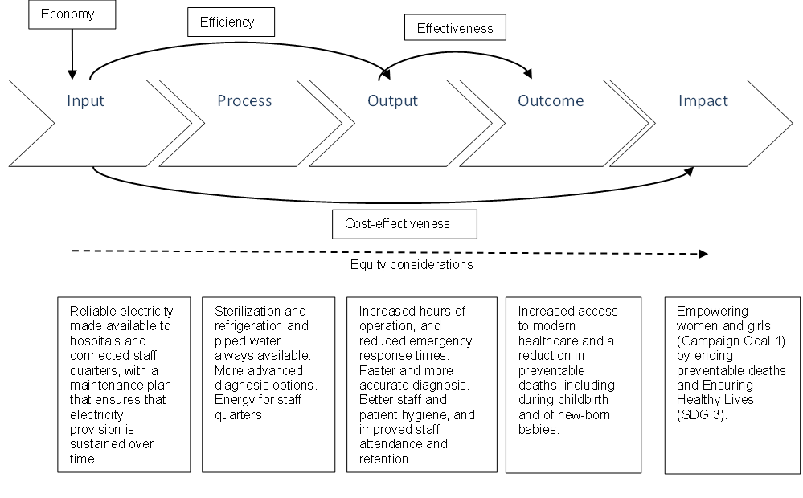
The major impact of additional funding being an increase in the number of facilities supported. There will be additional engagement with wider policy and regulatory issues including a sector wide operations and maintenance regime for solar energy systems, and options for using the private sector to provide greater sustainability either through contracted operations and/ or maintenance, or through models where the private sector owns and operated solar systems and sells power to facilities under Power Purchase Agreements.

though with both figures including Freetown as initial installations included the largest children’s and maternity hospitals in the Freetown and new installations will include the largest general hospital and additional specialist hospitals in the capital)

