Exam Game Plan

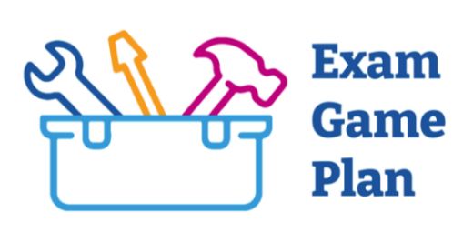

EXAM PREPARATION
How far away is your exam?

We recommend starting to prepare for your exam 6 months before. This allows time for you to organise your resources, review the exam guidance and put together a realistic study plan.

It is a good idea to talk to your supervisor/TPD to help you understand the purpose of the exam as well as covering any gaps in knowledge.

Have you spoken to anyone who has sat the exam recently? Yes / No

What advice/top tips did they give you?

What is one thing they did that contributed to their success?

What could you take away and learn from this?

In order to be successful in exams it is important to determine and understand what the examiners want and how to demonstrate or evidence it.

Have you reviewed the exam guidance/syllabus and downloaded the exam topic lists? Yes / No

What did you take away from this?

What are some of your weaker topics you should focus more on?

Who could help you with these topics?

What are some of your stronger topics that you feel confident with already?

How are you going to maintain your confidence with these topics?

As part of our commitment to supporting you in preparing for your postgraduate exams, we have put together a video series outlining:

- Exam Preparation
- Revision Strategies
- Dealing With Stress, Anxiety and Failure
- Exam Top Tips

Follow the link to find our exam support page on our website where you can find these videos and resources: Exam Game Plan

This worksheet has been designed to help you think and reflect on the content of our video series. Feel free to dip in and out of the videos, whilst completing the relevant sections of this worksheet.

Learning styles will change over time and will probably be different from how you revised for your undergraduate exams. It is important to understand your preferred learning style to maximise your revision.
What is your preferred learning style?
If you are unsure, here is a quiz to find out - Learning Style Quiz

There are several methods for effective revision, and some work better for different people. Use the table below to find your preferred study methods.
Popular Study Methods | Always | Sometimes | Never
Practice tests
Spaced revision & testing
Teaching the material to others
Self-explanation - linking new to old
Interleaved practice – study from topic to topic
Summarising
Highlighting key information as you read
Mnemonics
Text into image
Re-reading notes and textbooks and reading them again

Your Ideal Approach
There are many different factors that affect the productivity of a revision session; the environment being one of the biggest. It is important to find an environment that enables you to concentrate and offers little distraction. Continually being distracted can dramatically affect your personal productivity and motivation.

What does a great revision session look like to you?
- How long would it be?
- What environment would it be in?
- What material/content would it cover?

What small tweaks could you make to get close to this?

Distractions and life commitments can significantly impact our ability to focus on revision. Whether it’s the pull of social media, family responsibilities, or extracurricular activities, these external factors often compete for our attention, making it harder to prioritise study time effectively.

What are your top 3 barriers that get in the way of your revision?
1.
2.
3.

What support do you feel you need to help you overcome these barriers?

Who could provide this support?

Is there anything/anyone that could help you with these commitments?

Revision In the Workplace
Incorporating revision into your day at work reduces the amount of revision you will have to do when you get home. Try and get as much exposure as possible in clinical settings to align your knowledge to day-to-day patient care.

In what ways does your exam relate to your workplace environment?

How can you use everyday experiences to deepen your knowledge?

Which examples could you incorporate more into your day-to-day schedule?

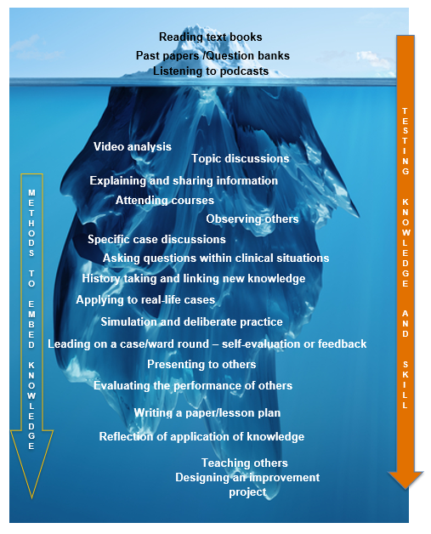

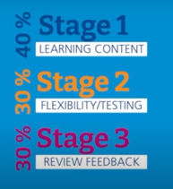

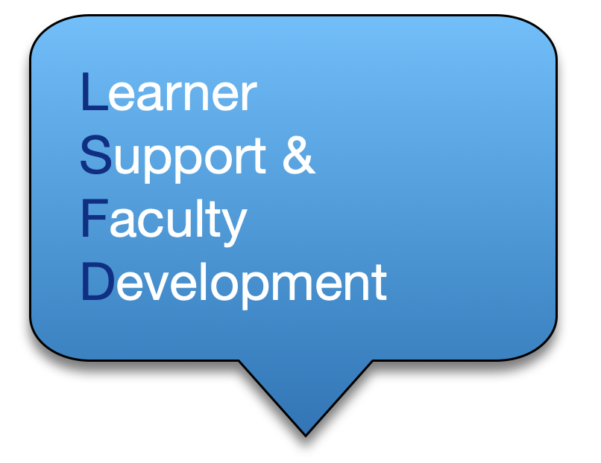
Information you consistently score well on
Information you nearly always get right
Information you find hard to recall
Information you generally remember but still trips you up

REVISION STRATEGIES

Leitner’s 4 Boxes
What would you put in each box?
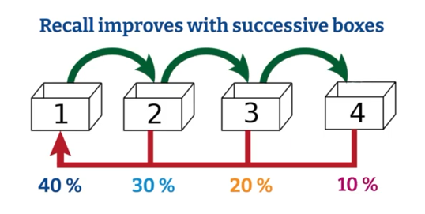

It is natural, that overtime you will need to move information between boxes.

What do you think of this strategy? Will you use this?

Graham Allcott – 3 Stages of Learning
What do you think your percentages are currently?

How can you change them to match Graham Allcott’s suggestions?

Map your revision activities to the three different types of mindsets:
PROACTIVE  e.g. Teaching material to others | ACTIVE  e.g. Past paper questions | INACTIVE  e.g. Reading textbook
Ideally, you would want most of your revision activities on the left side, and as little as possible in the inactive column. But it is important to still have some inactive activities for times where you feel tired/foggy brain.

What could you do to shift your current activities to the left?

STRESS, ANXIETY, FAILURE
The pressures of medical exams can be overwhelming, and it’s important to acknowledge these challenges in order to develop healthy coping mechanisms. Use the two strategies below to help reframe thoughts, regain confidence and improve your mental wellbeing.

Albert Ellis ABC Model
It is very common to have negative thoughts around exams. A way to respond to the automatic negative thoughts is to apply this model and try to dispute your negative thought and provide a different perspective.

A | Activating Event  (I have failed the exam)
B | Belief  (This exam is unfair)
C | Consequences  (This is an impossible exam to pass)
D | Dispute  (What is your evidence)
E | Energising Alternative  (I was only 5% off the pass mark, so I prepared well)

Circle Of Concern/Influence
In order to be proactive, it is important to focus on what you can do and influence and not be affected by things beyond your control. You may find it useful to map out and identify what you can directly influence and what is a concern.

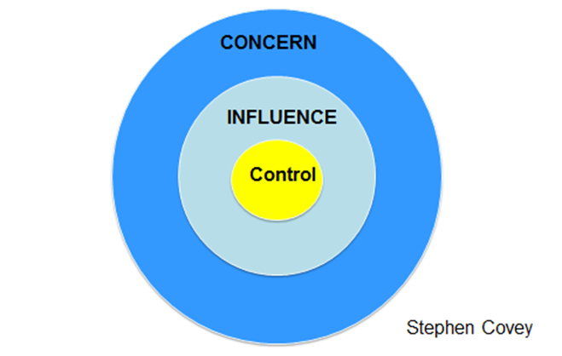

MY STUDY/LIFE PLAN…
Now it’s your turn: use the Exam Workbook, Exam Videos, and this worksheet to try and come up with a realistic study/life plan that suits you.

