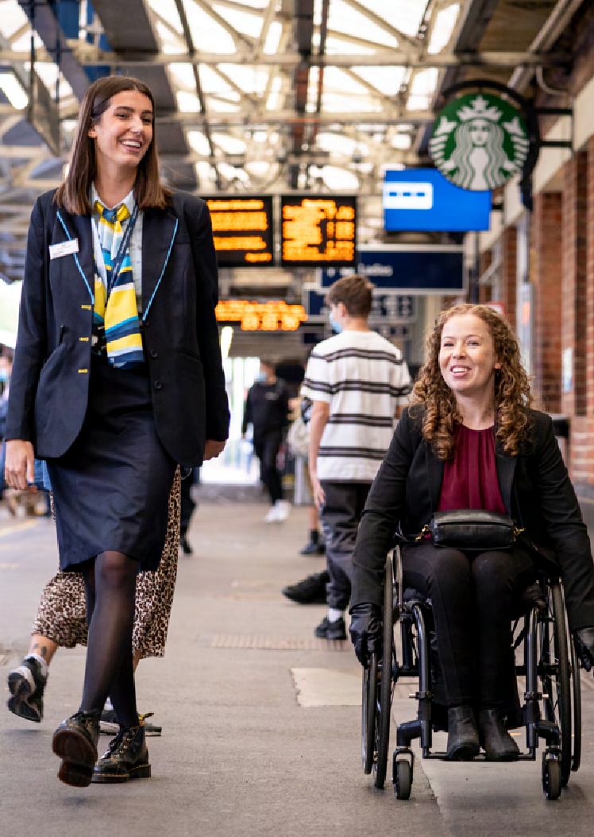

Making Rail Accessible
Helping older and disabled people

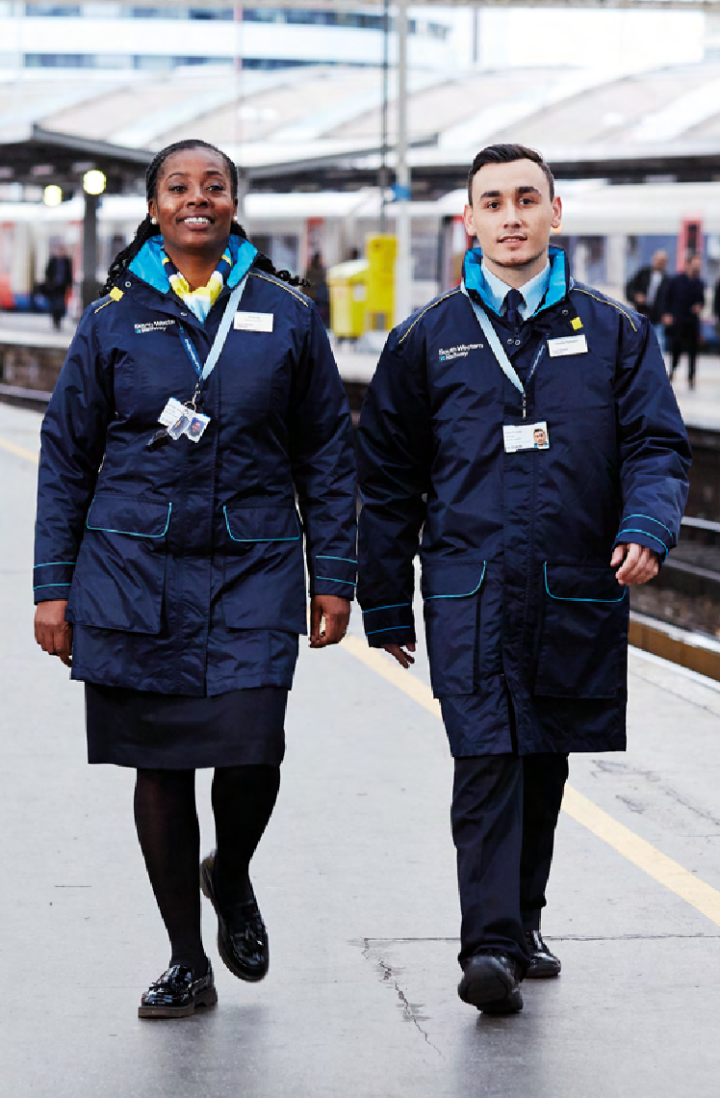
Introduction
It is important to us that all of our customers have an enjoyable, safe and comfortable experience throughout their journey with SWR. This leaflet has been created to explain what assistance is available to customers who want
to travel with South Western Railway (SWR), using our trains and stations.

2

The following pages contain information on:
- How you can book assistance
- What assistance we can provide – and what we cannot
- Where you can get more information if you can’t find it here
Whether or not you travel by train often and you have a disability, have reduced mobility, or feel you may need some extra support during your journey with us, we hope that the information in this leaflet answers any questions you may have. At the end of this leaflet, we have included details on where you can find out more information.
We commit to ensuring that all customers who require assistance can make full use of our rail network as far as possible and we intend to do this by making it as straightforward as we can to use our stations and trains, make our infrastructure accessible and provide the support you need, as and when you need it.
All station information for National Rail stations can be found at www.nationalrail.co.uk/stations_destinations/ default.aspx
This leaflet reflects our Accessible Travel Policy – you can find the full copy of this with our policy and procedures included on our website at www.southwesternrailway. com/travelling-with-us/assisted-travel or by calling us on 0345 6000 650 and we can send you a copy.
You can also request a copy of this leaflet and/or our Accessible Travel Policy in a format that is accessible to you, such as braille or an audio format.

Passenger Assist
Passenger Assist is a national system supported by all train operating companies which allows operators to make necessary arrangements to assist customers with disabilities or restricted mobility.
Our Assisted Travel team will help you book assistance you need at any National Rail station and on any National Rail train advance, and they are available to help you
24 hours a day, 7 days a week, except Christmas Day and Boxing Day.

Assistance: what is available and how to get it

For immediate travel
Planning in advance isn’t always possible so do not worry – you can turn up at any station that is accessible to you and request assistance onto a train from a member of our staff.
At a staffed station please approach any member of staff and they will do their best to make arrangements to assist you onto your preferred train.
All our trains have guards who can assist you onto and off the train. If you are at an unstaffed station, you can use our Assisted Boarding Points service by either calling
0800 528 6599 or using WhatsApp on the same number. This service is free to use and available 24 hours a day (with the exception of Christmas Day and Boxing Day.) More information can be found at: (www.southwesternrailway.com/travelling-with-us/ assisted-travel).
We will do our best to make sure you can be assisted with your train journey as your needs require. If we are not able to assist you fully, or if the station is not accessible to you, we will provide you with alternative accessible transport, such as a taxi, at no extra cost to you.
Please be aware that it may take a period of time to make arrangements if you haven’t booked in advance, especially for any alternative transport.
For station information, please visit the National Rail Enquiries website:
www.nationalrail.co.uk/stations_destinations/

4

When travel is being arranged in advance
You can book assistance with us for journeys involving multiple connections and train operators on the National Rail network up to 2 hours before travel.
Our Assisted Travel team is available 24 hours a day, except Christmas Day and Boxing Day. They are available from 08.00 on 27 December, and are able to arrange assistance in plenty of time before the first train services on 27 December.
When booking assistance to board or get off a train to a part-staffed or unstaffed station, we will ensure that we will provide you with the assistance that you need. If a station is inaccessible to you, we will discuss options with you and may arrange alternative accessible transport, such as a taxi, to the nearest or most convenient accessible station – this will be at no extra cost to you.
Ways to book assistance for your journey
Call: 0800 5282 100
Text Relay: 18001 0800 5282 100
Online: www.southwesternrailway.com/travelling- with-us/assisted-travel
SWR App: You can request immediate* assistance via the SWR App. Although this is only possible for SWR trains and stations, we will do our best to contact other train operators – whether that be their stations or trains.
WhatsApp: You can also contact us up to 10 minutes before your train is due to leave via WhatsApp from dedicated points on all our station platforms.
0800 528 6599.
* We recommend you let us know 20 minutes before your train is due to leave or arrive so that we can make any necessary arrangements. This is treated like any other ‘Turn Up and Go’ request.

The levels of assistance we are able to provide There are a number of different ways we may be able to help you when you are travelling with us – some of which are:
- Help with planning your journey
- Getting through the station, to your platform and boarding the train

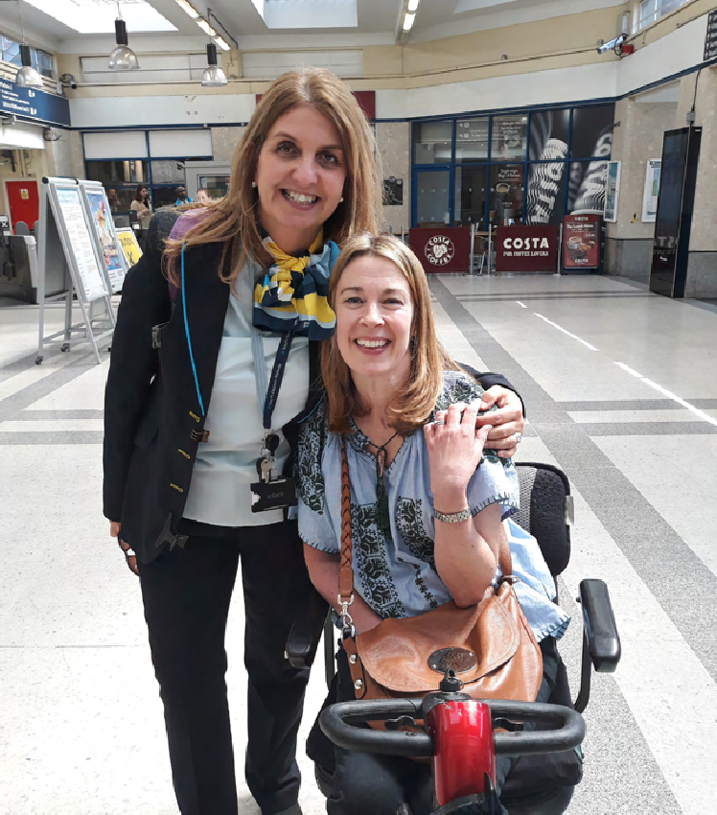

- Assistance with getting on and off the train – for example if you require guiding due to a visual impairment or if you are a wheelchair user and require a ramp
- Help with luggage
- Making a seat reservation or reserving a dedicated wheelchair space (SWR do not have seat reservations but we can make seat reservations for other operators who offer them)
- Assistance to and from connecting services and onward transport within the station area
- Buying tickets
- Checking the accessibility and facilities available on the train and at the station
We have made sure that our staff are trained to help all of our customers and provide the best possible assistance – that includes customers with both visible and non-visible disabilities.

6

SWR staff are trained to recognise the Sunflower Lanyard. You can pick up a free lanyard from our Flagship stations or our customer contact centre. More information on the Sunflower Lanyard scheme is available here: https://www.southwesternrailway.com/travelling-with- us/assisted-travel/sunflower-lanyards
Please be aware that while we will do all that we can
to assist you throughout your journey, we will not be able to accompany you throughout your journey. Although we have a guard on board all SWR trains who you
can ask if you need any assistance, we are unable to provide personal care such as help with eating, taking medication or using the toilet and please ask that if
you need this support when travelling, you should travel with a companion.

Travel Assistance Card
Our Travel Assistance Card is a free card for anyone who may need that extra bit of help and find it difficult to ask. All our staff have been trained to recognise the card and if you show it to any member of our staff, they will help you as best they can. More information can be found at www.southwesternrailway.com/travelling-with-us/ assisted-travel/travel-assistance-card
Our Travel Assistance Card can be requested at any of our stations, through our customer services team, or downloaded from our website.
You can get a Travel Assistance Card by:
- Visiting any SWR staffed station and asking a member of staff at the information point or ticket office (this includes London Waterloo, Clapham Junction, and Guildford stations which are managed by Network Rail)
- Downloading it from our website: www.southwesternrailway.com/travelling-with-us/ assisted-travel/travel-assistance-card
- Completing the contact us form: www.southwesternrailway.com/contact-and-help/ contact-us-form and we will send you one in the post
- Call us on 0800 5282 100 and we will send you one in the post
For more information, visit our Assisted Travel page on our website or speak to a member of our staff.

7

What to expect: our commitment to passengers at every stage of the journey

Before you travel
We will provide you with the information you need to plan ahead for your journey that includes the information you need to understand the accessibility of your journey as well.
Information about planning your journey and tickets can be obtained through the following options:
Phone: Call us on 0800 5282 100
Ticket Office: visit one of our staffed stations. Station staffing information can be found on the National Rail Enquiries website: www.nationalrail.co.uk/stations_destinations/
Online: You can find journey information and purchase tickets on our website at www.swrailway.com
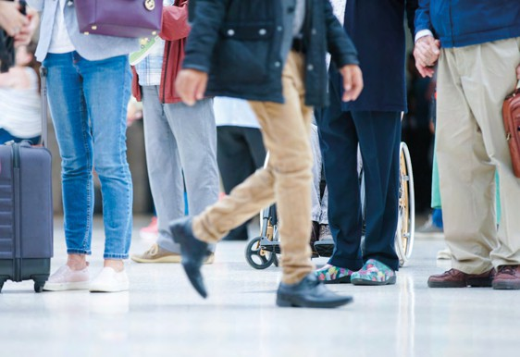
If you need some help in planning your journey or any other advice, then please visit at our website. If you cannot find what you are looking for, our Assisted Travel team are able to help.

8

Buying your ticket
Our team will be happy to help you with purchasing a ticket.
If you are at an unstaffed station or the ticket office is closed, we have Video Ticket Vending Machines and our staff in our Video Contact Centre will be able to help you buy a ticket and to book assistance, 24 hours a day.
You can also book assistance when purchasing tickets on the phone. Our assisted travel team can redirect you when booking assistance for you to book your tickets over the phone.
We have ticket gates at some stations so you will often need a ticket to get onto the station platform.
On our services you should buy a ticket before you board the train unless you are unable to purchase at the station due to the accessibility of facilities.
The ways you can buy a ticket are:
Phone: Call us on 0800 5282 100
Ticket Offfce: many of our stations have ticket offices. Opening hours can be found at www.nationalrail.co.uk/stations_destinations/
Online: You can purchase tickets on our website at
www.swrailway.com
Ticket vending machine: You can find these machines at all SWR stations. You can buy a ticket here using a debit or credit card and cash. You can also collect tickets you’ve bought online.
If you are not able to buy your ticket before you board the train because you cannot access the ticketing facilities at the station, you will still be able to buy a ticket on most of our mainline trains or at your destination. You will also be entitled to fare reductions that you could have received when purchasing a ticket at a station (such as a Disabled Persons Railcard discount).

9

Discounts and railcards
We participate in a number of national schemes offering discounted fares as follows:
If you are visually impaired
Visually impaired customers travelling with a companion who do not have a Disabled Persons Railcard are entitled to the following discounts on Anytime/Day tickets:
First or Standard Class Anytime Single or Return: 34% off
First or Standard Class Anytime Day Single: 34% off
First or Standard Class Anytime Day Return: 50% off
These concessions also apply to the companion but not if you are travelling alone and do not have a railcard
To get these discounts you will need a document confirming your disability that has been issued by a recognised body such as social services, local authority, guide dog ownership certificate, RNIB or Blind Veterans UK.
These discounts are only available from staff at our ticket offices or on board and cannot be purchased online or from Ticket Vending Machines.
If you are a wheelchair user and remain in your wheelchair for a rail journey
If you remain in your wheelchair throughout the journey and do not have a railcard, you are entitled to the following discounts on Anytime/Day tickets:
First or Standard Class Anytime Single or Return: 34% off
First or Standard Class Anytime Day Single: 34% off
First or Standard Class Anytime Day Return: 50% off
The same discount will apply for a companion travelling with you.
Disabled Persons Railcard
If you have a disability you may be eligible for a Disabled Persons Railcard. There are two types of this railcard –
a one-year and a three-year railcard. You are entitled to a discount of up to a third on most rail tickets, as well as no minimum qualifying fare.
As well as that, one adult travelling with you, usually referred to as your companion, can get the same discount as you.

10

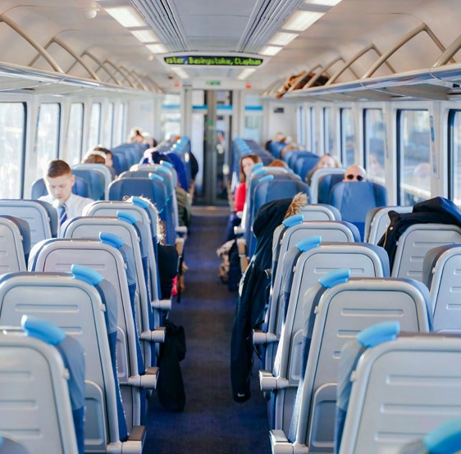
You can find details about this railcard and how to get one at:
Website: www.disabledpersons-railcard.co.uk Email: disability@raildeliverygroup.com
Call: 0345 605 0525
Minicom/Textphone: 0345 601 0132
(for people who are hard of hearing)
Senior Railcard
If you are aged 60 or over you are eligible for a Senior Railcard. There are two types of this railcard – a one-year and a three-year railcard. You are entitled for a discount of up to a third on most rail tickets. You can find details about this railcard and how to get one at:
Website: www.senior-railcard.co.uk
Email: railcardhelp@railcards-online.co.uk Call: 0345 300 0250
At stations: You can use your birth certificate as evidence
Other railcards are available that may be more suitable to you. You can visit www.railcard.co.uk for further information.
11

Linking your railcard to your Oyster card
You can link any railcard to an Oyster Card at any London Underground station or London Overground ticket office.
Staff at some London Terminal stations are also able to do this for you. More information is available on the National Rail Enquiries website.
Once linked, you will be discounted the appropriate fare on each Oyster transaction. Unfortunately, it is not
possible to link this discount with a Contactless bank card or other payment method, such as Apple or Android Pay.
Please be aware that Freedom Passes and the associated discount to London Boundary Zone 6 are only valid after 09:30 Monday to Friday on SWR train services.

Wheelchairs and mobility scooters
We provide wheelchair spaces on all our trains for wheelchair users. You are welcome to use these spaces if your wheelchair fits within the following dimensions and the combined weight of the user and chair is less than 300kg:
Width: 700mm Length: 1200mm
If your wheelchair does not fit within these dimensions, unfortunately you will not be able to travel on our trains.
All our trains, except those used on the Island Line on the Isle of Wight, have 2 dedicated wheelchair spaces in each wheelchair area. These are located next to the Accessible Toilet. On the Island Line, there is 1 wheelchair space in each wheelchair area. There are no wheelchair spaces in First Class.
Customers using mobility scooters require a permit to travel on SWR trains. The combined weight of the scooter and user must be under 300kg.
Mobility scooter dimensions
Width: 700mm (70cm) Length: 1200mm (120cm)
Width: 560mm (56cm) Length: 1120mm (112cm)

12

You may apply for a permit on our website at www. southwesternrailway.com/travelling-with-us/assisted- travel/wheelchairs-scooters-and-ramps or by contacting our Customer Relations team.
You may travel on your scooter by travelling in the wheelchair space on our trains,but this is the only place scooters can go on our trains and must not be stored in vestibules or obstructing aisles as these are emergency exit routes.
If you can transfer to the seat, we would encourage you do to so rather than travelling on your scooter as this may be safer and more comfortable for you.
If your scooter application is rejected, we will explain why. It may be rejected because if doesn’t meet our requirements, but we will try to work with you to accommodate you on our services as best we can.
If you do not hold a scooter permit, colleagues may refuse you to travel with us. However, they will do all they can to help you and may request that you fold your scooter in order to use our train services.
All our stations with step-free access have a scooter size-guide vinyl so that you can discreetly measure your scooter, ensuring we can accommodate your safely on our trains.
Please be aware that other train operators may or may not require a permit to use a scooter on their trains.
Please ensure you check with all operators whose trains you are using, through their website and/or Accessible Travel Policy, what their policy is on mobility scooters before travelling. The above policy is only applicable to trains operated by SWR.

13

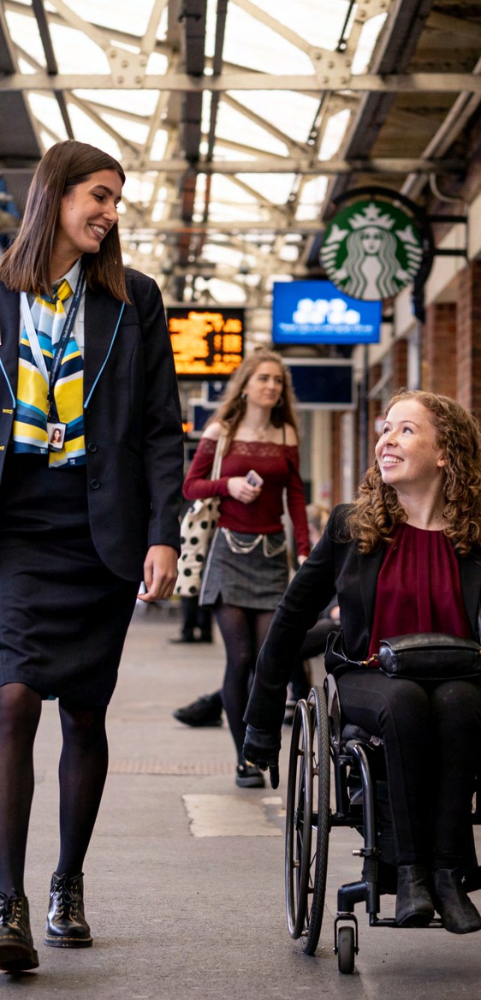

14

Help at the station

Station facilities
We are responsible for 187 stations on the rail network and we will continuously improve the facilities available at those stations. This includes, but is not limited to, lifts, ramps, escalators, accessible counters, induction loops at ticket counters and elsewhere, toilets and accessible toilets, waiting room and shelters, and accessible seating. You can find information about these facilities and what is available at our stations on our website as well as (for our stations and for those of other train operators) at the national rail website: www.nationalrail.co.uk/stations
We work with other train operators and Network Rail to ensure that facilities are maintained and improved at other stations we stop at that we do not manage.

At a staffed station
When you arrive at a station, if you need assistance, please make yourself known to station staff. Staff will be available from the information point, ticket office or
platform at an SWR station. They can be identified either by a blue or orange tabard if on and around the station, or they will be wearing a name badge and SWR blue uniform if in the ticket office.
The meeting point for pre-booked Passenger Assist at all SWR stations varies but is usually the ticket office, Information Point or gateline. You can find the location of the meeting points at stations on our website at www. southwesternrailway.com/travelling-with-us/at-the- station/station-details or from National Rail Enquiries at www.nationalrail.co.uk/stations_destinations/
If you have pre-booked assistance with us, we recommend you arrive at the station at least 20 minutes prior to the departure of your train (some stations may advise more than this – you will be told when booking assistance). If you arrive by car or taxi, we can help you from the station car park drop-off area or a blue badge parking space. We can’t help if you are outside the station area. If you haven’t booked assistance, there may be a wait at the station if our staff have other safety critical duties to carry out.

15

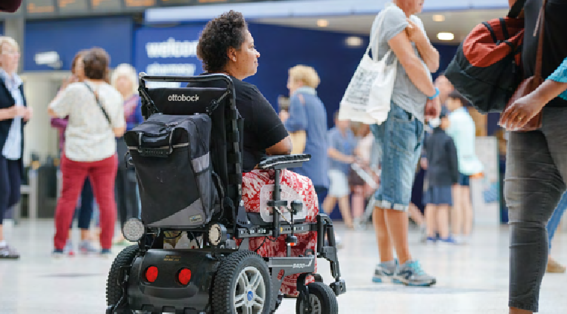
16

We can also carry luggage onto the train – maximum two items up to 23kg each. Please try where possible to book this in advance through our Passenger Assist team. You can also bring a small item with you if you are able to carry it independently.
When the train arrives, we will make sure you are successfully boarded with any luggage that you may have. We will help you to a seat or to a wheelchair space as required. All staffed stations have portable ramps and, where there is not one, we keep ramps on board our trains. We will deploy these for you if you need
step-free boarding. If you think the ramp would make boarding easier for you, let the team know when booking assistance (or let a member of station staff know on the day as early as possible).

At stations without any staff
SWR has many stations which are either part or unstaffed. At stations with only a ticket office, these staff are not able to provide assistance. When using one of these stations where there are no staff available, our guard will provide assistance to you getting on and off the train.
We recommend standing by the Assisted Boarding Point on the station, and if you haven’t managed to pre-book your assistance, please use the Help point or our Assisted Boarding Points service to contact us.
Please note, guards cannot assist you in getting to or from the car park or other assistance on the station due to the limited time that trains stop at stations.

Getting off the train
When you get to your stop, we will make sure you can get off the train. Where appropriate, we will make sure a member of our team is there to help you to the next part of your journey.

Ticket gates
Some stations that SWR manage have ticket gates which are staffed. As well as these stations, major stations we serve that are operated by Network Rail and other train operators (London Waterloo, Clapham Junction, Guildford, Reading, Bristol Temple Meads, Exeter St Davids) do have ticket gates to some or all of the platforms.
When no staff are available to operate the ticket gates at any station, we will lock the gates in the open position so that customers can pass through.
All of our ticket gate lines have at least one wider accessible gate.

Help on the train
Our staff will take everyone’s individual requirements into account and do what they can to provide assistance that bests suits you. Please ask any member of our on-train team if you need assistance and they will do all that they can to help. Our on-train teams will do their best to allow you and any travelling companions to sit together.

Seat reservations
Unfortunately, we do not offer any seat reservations on our trains.
Every carriage on all of our trains have priority seats for those with reduced mobility, who are pregnant or less able to stand. These seats are signposted on our trains. These priority seats have additional legroom to make them easier to use.
We have wheelchair spaces on all of our trains. All wheelchair spaces are in Standard Class and have two companion seats. Our guards and station staff will do what they can to ensure you are sat with your companion(s). These seats are non-reservable and
treated as priority seats and we will ask someone to give up these seats if needed.
We will ensure that priority space of the wheelchair space is enforced at all times. Should you need one of these spaces, our on board or station staff will make sure the space is clear for you to use when you board.

17

Audio and visual information
To help you know where you are along your journey and what is going on throughout, all of our trains have both audio and visual announcements. Our entire fleet of trains have automatic information screens that will display information about the calling pattern of the train, safety information and information in the event of disruption.
The guard is also able to use the Public Address (PA) system to make manual announcements.
If the information is unclear or you think you missed something important, please ask a member of our on board crew.

Train facilities
You can find out information about the different facilities available on our trains on our website, including the availability of priority seating, number of wheelchair spaces, and accessible toilets by train type at www.southwesternrailway.com/travelling-with-us/ assisted-travel

Assistance on arrival
When you get to your destination, staff will help you to get off the train as soon as possible.

18



19

If things do not go as planned

Delays and disruption
Sometimes things outside of our control means that there may be disruption to your journey. We will do everything we can to make it as stress-free as possible and to ensure you are able to continue your journey and that you are not left stranded.
We will make sure to keep you up to date through our website, social media and announcements (both on the train and at the station).
If the disruption means that your original assistance is no longer possible for whatever reason, we will do what we can to get in touch with you before you arrive so that we can help you re-plan your journey and re-arrange that assistance. If necessary, we will arrange alternative accessible transport for you should you no longer be able to travel by rail – this will be at no extra cost to you.
Our staff, both on the station and on the train, will help you as required and have been trained to assist all of our customers. They will communicate disruption either over public address systems or in person.
All our guards and station staff have smart devices so they can help you re-plan your journey and check the accessibility of that journey if the route is different from the one you had originally planned to take.

Emergencies
In the event of an emergency, station and/or train staff will safely carry out any evacuation as needed. Staff will keep you informed and advise of what will be happening throughout the process.
All our trains and stations have evacuation plans that take into account the needs of disabled passengers and our staff and emergency services are aware of these.

Redress and compensation
We will make every effort to ensure your experience of using Passenger Assist is positive.
If something goes wrong and the assistance you’ve pre-booked is not delivered, we will provide you with compensation for your journey.
When your assistance was booked for travel on one of our trains, we will offer you a full refund for the cost of
20

that leg of the journey. We are happy to assist you with your claim as much as we can and will coordinate the response to your claim if your journey involved SWR and other operators.
If you were travelling on another train company’s service, we may need to contact that train company and pass on your details, with your permission, if their train service was not on our network.
To make a claim for redress, please contact our Customer Solutions team through the contact details set out at the end of this document. Please do let us know as soon as possible if something has gone wrong so that we can quickly investigate this and understand what went wrong.
We will always comply with the Consumer Rights Act 2015 and in line with National Rail Conditions of Travel.
If we have not reached a satisfactory conclusion to your claim, you may take this up with the Rail Ombudsman. More information can be found at the end of this leaflet.

Where to get more information and how to get in touch

Large Print and Easy Read are available on our website
Get in touch with our team at 0345 6000 650 and they will arrange for it to be sent to you within seven working days.

Our Accessible Travel Policy:
This document sets out in more detail our commitments and standards of service provision, as well as relevant policies and practices, with regards to disabled people using the rail network. It is available both online at www.southwesternrailway.com/travelling-with-us/ assisted-travel and in Large Print and Easy Read formats available from our team at 0345 6000 650.

21

Stations and trains accessibility information
Trains information is available on our website and to download from www.southwesternrailway.com/ travelling-with-us/assisted-travel
Our stations information is available on our website stations pages at www.southwesternrailway.com/ travelling-with-us/at-the-station/station-details and on the national rail enquiries website at www.nationalrail.co.uk/stations

Assisted Travel and day of travel queries
Phone: Call 0800 5282 100
(Open 24 hours a day, 7 days a week) Text Relay: 18001 0800 5282 100
(Open 24 hours a day, 7 days a week)

How to contact us via social media:
Twitter: @sw_help
Facebook Messenger: South Western Railway

How to provide feedback or make a complaint
Please call our team on 0345 6000 650, or fill out the contact-us form on our website: www.southwestern railway.com/contact-and-help/contact-us-form
You can also contact us by post at

Freepost: South Western Railway
Please use any of the above methods to contact us if
You would like to provide feedback regarding accessibility on the SWR network.
If you are not happy with the way the complaint is dealt with, please contact the Rail Ombudsman on:

Website: railombudsman.org Email: info@railombudsman.org Phone: 0330 094 0363
Post: Freepost – RAIL OMBUDSMAN

22

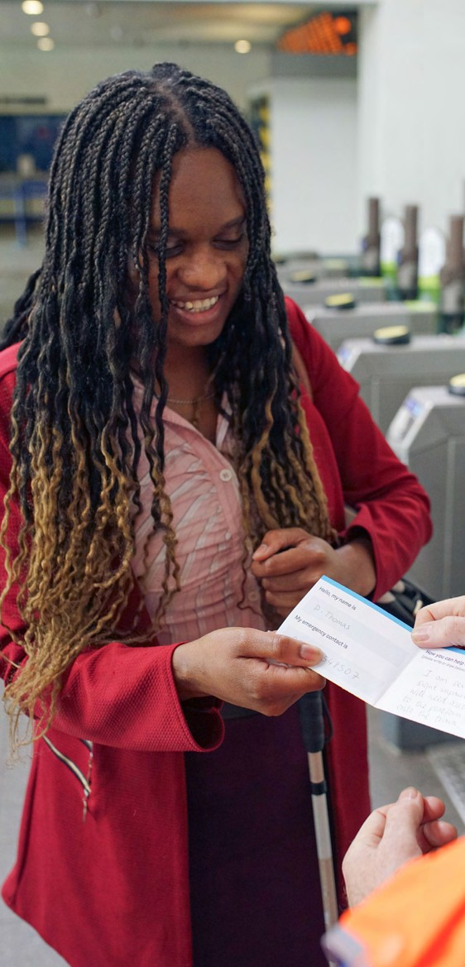

23

Visit us at

southwesternrailway.com

- Buy tickets online
- Find out about special offers and days out
- See live train information

Free Travel alerts
- Plan your journey
- Find train times
- See the latest news

southwesternrailway.com/alerts
Register with us for up-to-date information about train services, delays and alterations.

Twitter

@SW_Help
Follow us on Twitter and be the first to know what’s happening on our network.

Facebook.com/SWRailway
For information about our network and details of our latest offers.

Customer Service Centre

0345 6000 650
Our UK-based team are available
Monday to Friday 08:00 - 20:00, Saturday 09:00 - 18:00
and Sunday 09:00 - 16:00
  - Give us your comments and suggestions

Assisted travel
0800 5282 100

Text Relay
18001 0800 5282 100




This is a Freephone service for older and disabled passengers (open 24 hours a day). We recommend booking assisted travel at least 2 hours before your journey.

National Rail Enquiries

0345 748 4950

Please Recycle

First MTR South Western Trains Limited. Registered in England and Wales, registration number 07900320. Registered office: 8th Floor, The Point, 37 North Wharf Road, London, W2 1AF.

