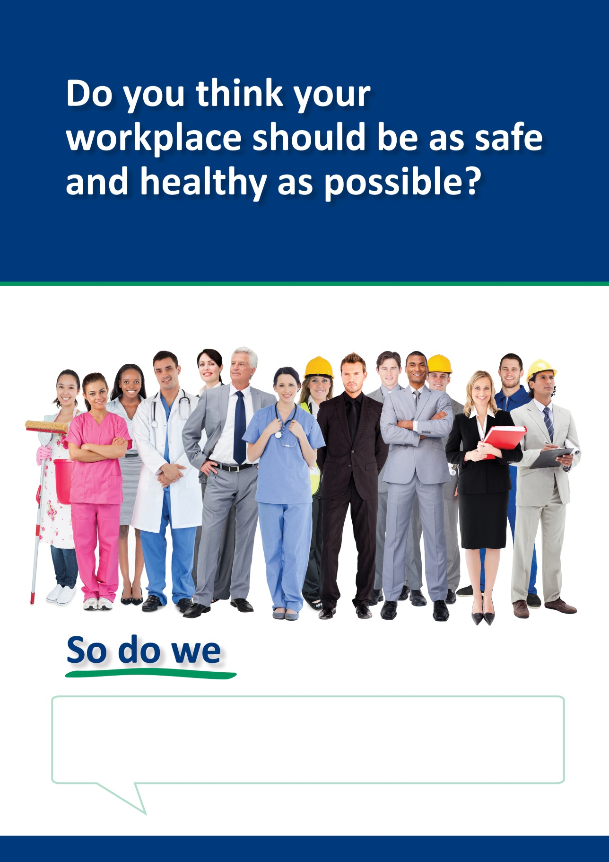
Help to make [company name] safer by completing the Safety Climate Survey
Help make your workplace safer!
You can help make your workplace safer by spending a few minutes to complete the Safety Climate Survey.

[You can add a personal message from your CEO if you wish]

