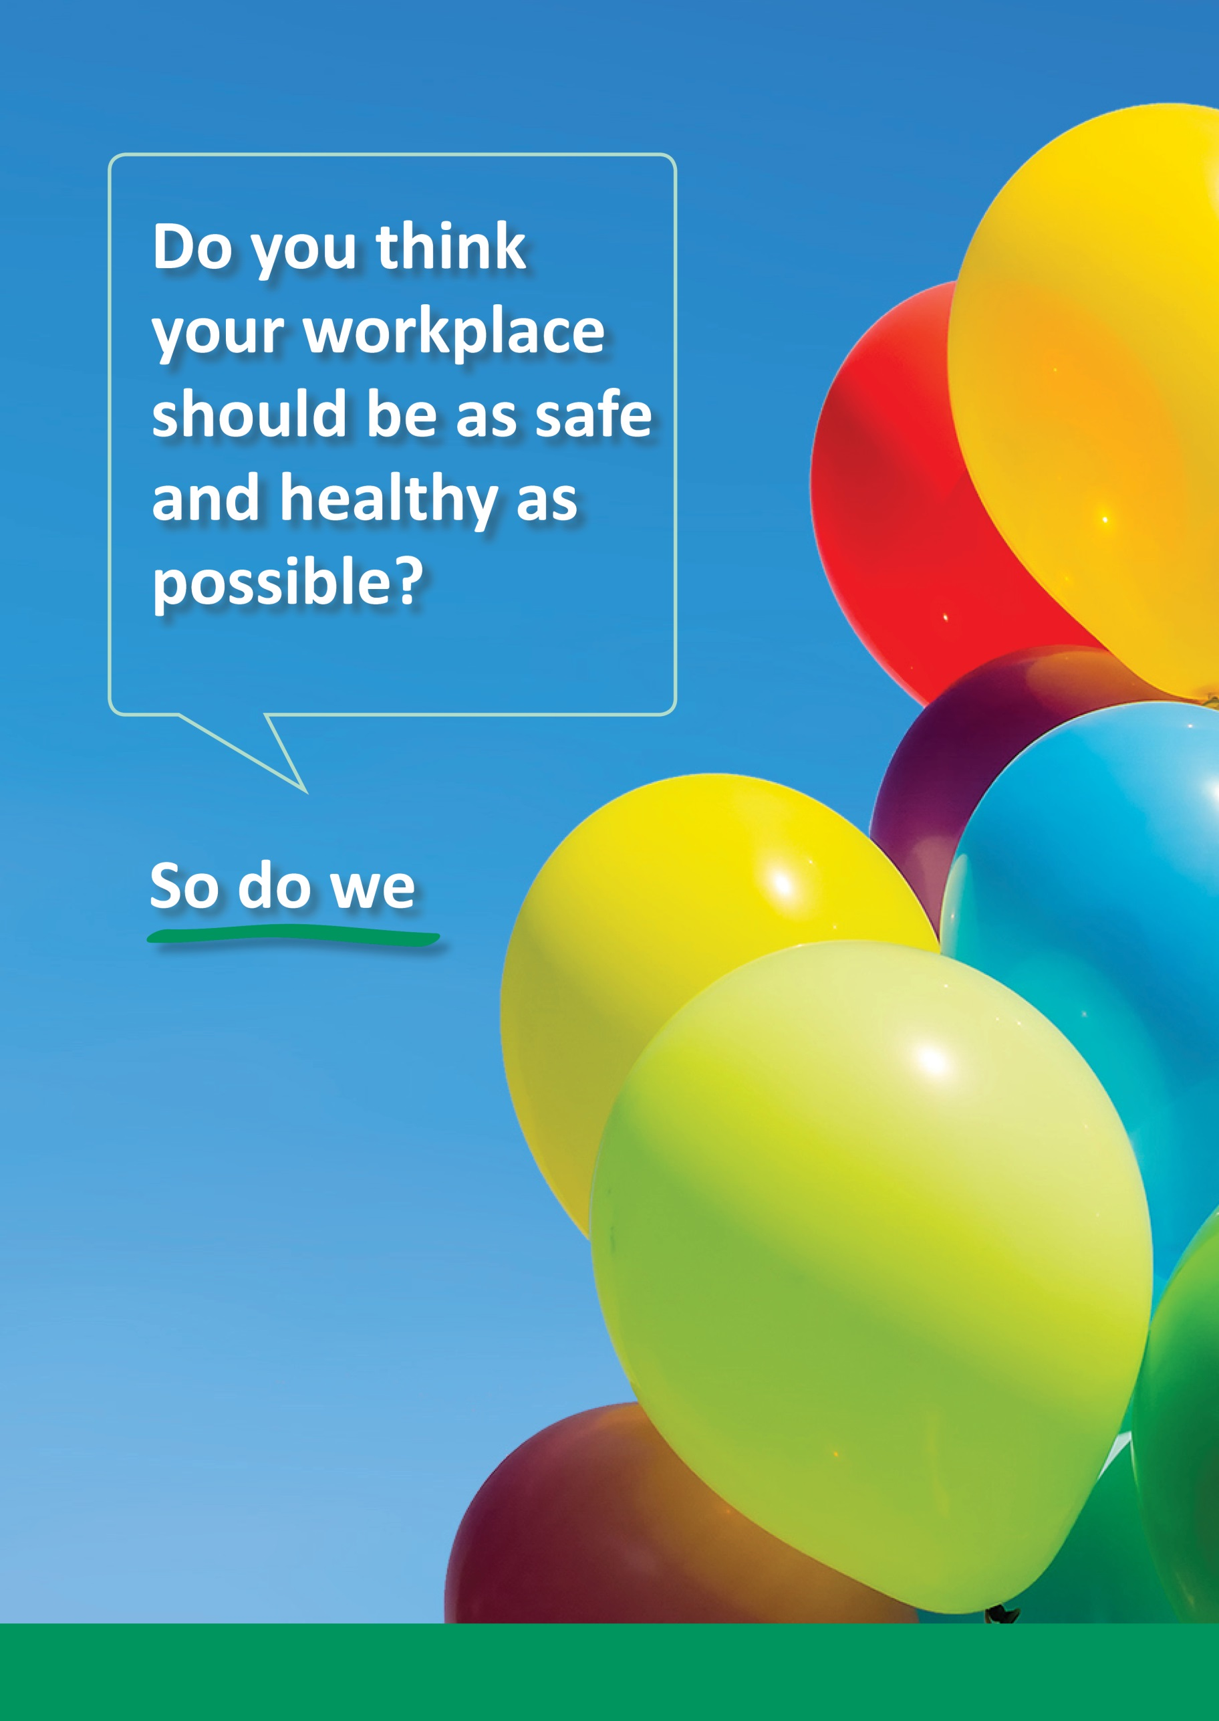
Help to make
[company name]
safer by completing the Safety Climate Survey

