


Health & Safety Management System

V 7.3
February 5th 2026

© Copyright 2025 Network Rail

Introduction and purpose
The purpose of this overarching health and safety management system (HSMS) is to realise our Safety Vision and Everyone Fit for the Future objective to get everyone home safe and healthy every day. It describes how the system is integrated with, and linked to, our operating model and other management systems. It supports our application safety certification and authorisation, detailing how we meet these requirements, as well as the license conditions for operating, maintaining and developing the railway. More widely, it recognises the wider health and safety risks associated with all our business activities, including those where we interface with other organisations. It outlines the safety accountabilities of our routes, regions and functions, providing clear links to their devolved processes. It describes how we comply with the Health and Safety at Work etc. Act 1974, and regulations made under it, including the Railways & Other Guided Transport Systems Regulations 2006, (as amended), and the Railways Interoperability Regulations. 2011, (as amended). To help achieve this we explain how we comply with industry and internal standards and guidance, especially: -

- Assessment criteria for main-line railway safety certificate and safety authorisation applications
- National Technical and Safety Rules
- National Technical Specification Notices
- Network Rail Operating Model and Integrated Management System Processes
- Network Rail Standards
- Schedule 10 of the Rail Safety (Amendments etc) (EU exit) Regulations 2019, relating to Entities in Charge of Maintenance as detailed in the ORR guidance
- ORR Guidance on RM³: the Risk Management Maturity Model
- Rail Industry and Group Standards

We design our systems to conform with BS ISO 45001: OH&S Management Systems and BS ISO 55002: Guidance on Application of ISO 55001: Asset Management. Several of our regions and functions have achieved certification.

Our HSMS covers all our business activities, including system safety, which is how we manage main-line and non-main-line operations and connected activities (primarily train and station accident risks), public safety, health and safety within our wider business, and occupational health and safety. We use a cyclical risk-based approach of planning, doing, evaluating, improving. We want to deliver effective and efficient control of risk in all parts of the business. The HSMS is key to doing this and this document describes how we will do that in a devolved business.

Contents
Introduction and purpose 1
1. Scope, context and objectives 3
2. Health and safety management system overview 4
3. Description of our operation 6
4. Leadership 7
5. Health and safety policy vision 8
6. Board and senior leadership team governance 9
7. Allocating responsibilities 11
8. Management and supervisory accountabilities 13
9. Organisational structure 15
10. Internal communications 16
11. External communications and working with stakeholders 17
12. Organisational culture 18
13. Working together 19
14. Competence management system 20
15. Identifying legal and other requirements and external standard selection 22
16. Internal standards, records, document and knowledge management 24
17. System safety and interfaces 26
18. Risk assessment and management 29
19. Objectives and targets setting 39
20. Workload planning 40
21. Safe and healthy systems of work 41
22. Asset management 43
23. Change management 46
24. Management of procurement and the supply chain 52
25. Emergency planning 53
26. Proactive monitoring and continuous improvement 55
27. Assurance 56
28. Incident investigation 58
29. Management review 59
30. Implementing improvements 59
31. How we meet ROGS, and BS ISO 45001 requirements 61

1. Scope, context and objectives
The scope of our overarching health and safety management system covers all our business activities except High Speed One and Melton Rail Innovation & Development Centre. This is because they have separate safety authorisations and management systems. Specified controls within our system apply only to the operational railway under the Railways & Other Guided Transport Systems Regulations 2006, such as requirements for safety authorisation for infrastructure management, certification for train operations, and obligations as an entity in charge of maintenance, which includes obtaining certification for wagons. The system’s context is informed by internal and external factors that impact our business risks, as well as being informed by understanding the needs and expectations of workers and other stakeholders. Fundamentally, the relevant law, approved codes of practice, guidance and standards are used to shape our risk controls and the safety management system that keeps it effective (and efficient).

Figure 1 Context
The system is linked to regional and functional systems and operating models, such as the Southern Region Business Management System. Click here to see all of these.
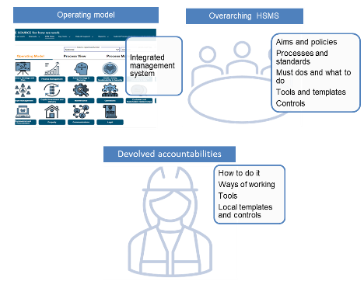
Figure 2 Position of this HSMS in integrated management system
2. Health and safety management system overview
Policy and Leadership
The health and safety management system structure follows the Risk Management Maturity Model,(RM³),which helps drive continuous improvement through our assurance processes, and associated action plans. It reflects recognised good practice in H&S management systems based on both academic theory and our practical application.

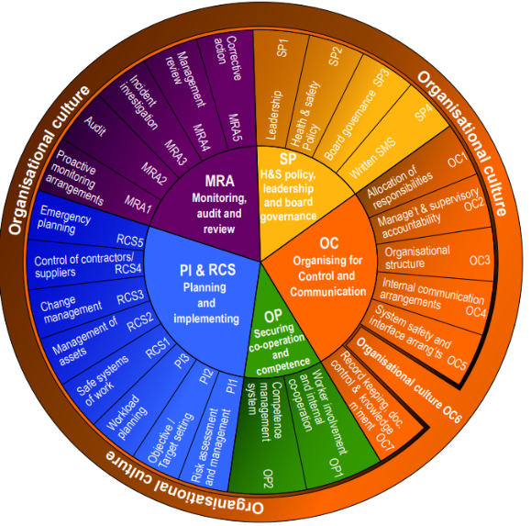
Figure 2 RM³ model elements

ROGS safety certification and authorisation criteria, ISO 9001 Quality Systems, ISO 14001 Environmental Management Systems, ISO 45001 OH&S systems and ISO 55001 Asset Management, Rail Industry and Network Rail Standards are signposted throughout and in the associated document - How we meet ROGS and ISO 45001 criteria .This assists with clarity of the legal and certification requirements and supports integration with other management systems. The structure of the HSMS and this overarching document is described on the next page.

Policy and Leadership

Health and Safety Management System Structure

Figure 3 HSMS structure following RM³ Model

3. Description of our operation
We own, repair and develop the railway infrastructure in England, Scotland and Wales. That’s 20,000 miles of track, with 30,000 bridges, tunnels and viaducts, thousands of signals, level crossings, depots, commercial property and stations. We manage 20 of the country’s largest stations, while all the rest – over 2,500 – are run by the train operating companies, (source: Network Rail: who we are ). We work in places from Abbey Wood to York Leeman Street. Our rail fleet, machines and vehicles and their operators help us maintain and inspect the railway. This includes track monitoring, high output track and electrification work and rail treatment. We have multiple manufacturing and distribution facilities and road fleets which all help to provide services, including our huge Whitemoor National Train Materials Recycling Centre, and Melton and Tuxford Rail Innovation Centres: Melton Innovation Centre is outside the scope of this HSMS as it has its own non-mainline safety authorisation. We work on and over water, do geotechnical and mine engineering work. We have an Air Operations Team using in-house resources and specialist suppliers.
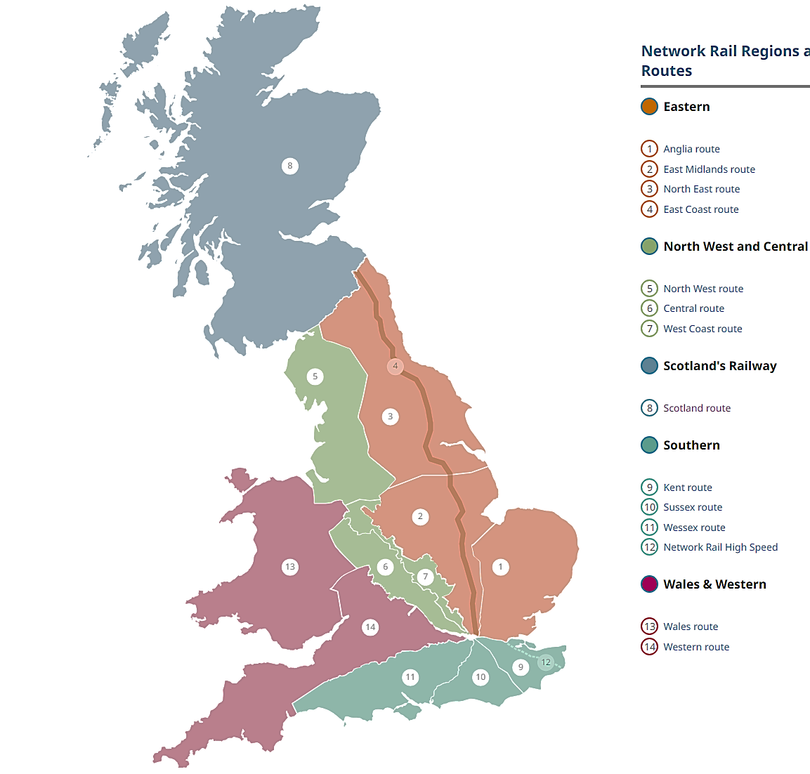
Detailed information on our assets, including access points, telecommunications and boundaries is contained in the Rail Infrastructure Network Model. Network Rail users can access this using GeoRINM_Viewer. Maps of the National Rail Network are freely accessible from National Rail.

Policy and Leadership

4. Leadership
Safety (including health) is a strategic objective, along with train service delivery, efficiency, sustainable growth, and meeting the needs of our customers and communities. Our stated values are that we are empowered to act, always safe, teamwork is key, and care about people. Key to this vision is effective leadership and teamwork. Our leadership teams are committed to embedding a positive safety culture from the Board to the front-line. Responsibilities for health and safety are incorporated into wider operating model and governance accountabilities described in the Network Rail Operating Model Governance Framework. Our Safety Framework contains the principles for equipping all our leaders from the Board to front-line leaders with health and safety skills. It aims to promote a step change in our safety, health and welfare performance and balance national, regional and functional needs. Each region and function has committed to having a plan for skills development. It provides a national framework that allows for regional variations on how to continuously improve. This framework, and the principles agreed below, are a binding and agreed commitment between the regions and functions on the key priorities for health & safety improvement, giving regions accountability and flexibility within the framework on how to do things and develop good practice.
The leadership principles contained within it are:-
- Our leadership teams are equipped to support, coach and lead our people safely.  - Leaders at all levels of our organisation demonstrate our shared values, (safe, care, teamwork, and empowerment). They always lead by personal example, promote a positive culture and attitude, a sense of pride and commitment to safety and service.  - We build leadership capability at all levels through training and experience to achieve continuous safety improvement.  - Our front-line staff take personal leadership responsibility and ownership of safety and care, of themselves and those around them, and have the confidence to call out unsafe behaviour and practices every time.  - We have a leadership skills development programme and approach at regional and functional levels that we are all proud of and live by.  - Our people know what it feels like to be part of a really good team, the bond and feeling that together they will succeed.  - We have well trained, competent, caring frontline managers who can effectively lead their teams by holding them to account. | 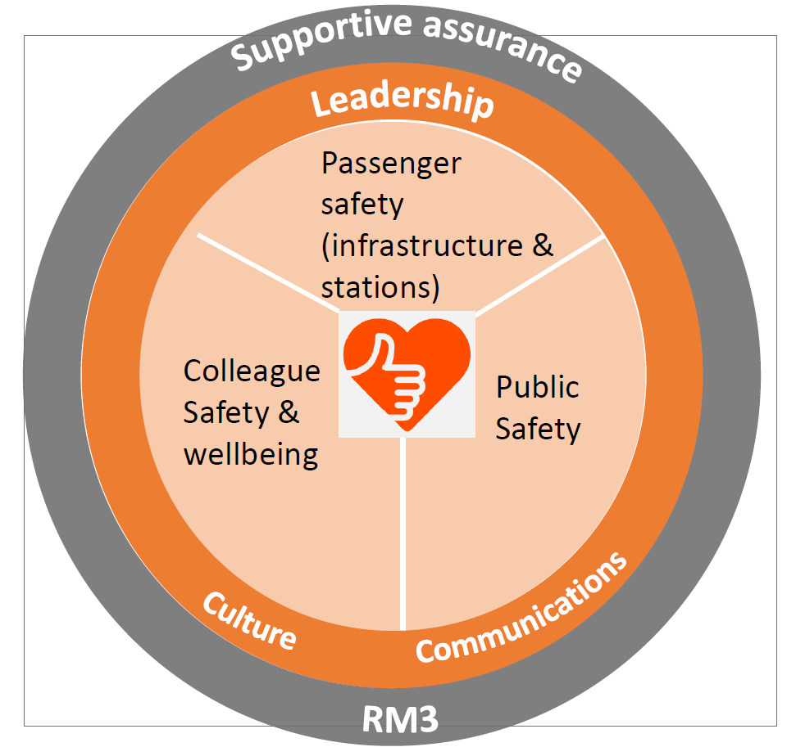  Figure 4 Safety Framework
Leadership and worker participation are linked, which is why there is trade union representation on the Board’s safety, health and environment committee, and in all levels of the business. Workforce involvement in shaping the health and safety management system, leadership capability in business planning, safety conversations and encouraging a safe organisational culture are critical to getting everyone home safe every day, and contribution to delivery of the joint industry strategy , Leading Health & Safety on Britain's Railway (RSSB).

5. Health and safety policy vision
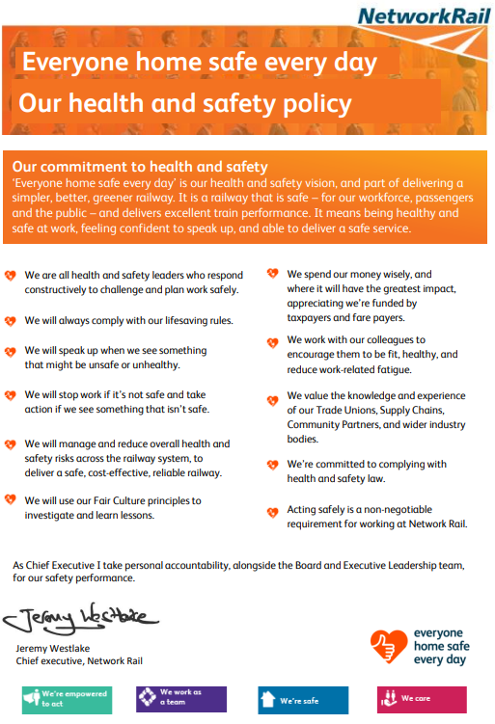

Policy and Leadership

6. Board and senior leadership team governance
Board and executive leadership team responsibilities are described on the Our Leadership web page. Health, safety and wider sustainability are integral to decision making and governance processes, and all of our board members are fully committed to our health and safety policy and vision. We are a public sector, arm’s length organisation. This means our Board is accountable to the Secretary of State for Transport and has to meet strategic policies set by the Secretary of State and Scottish & Welsh Government Ministers. Our health and safety regulators are the Office of Rail and Road, (ORR) for operational railway premises, the Health and Safety Executive, (HSE), for non-railway premises such as Eastleigh long welded rail factory, local authorities for offices, police forces for road traffic as well as the Fire Authorities, for fire safety and the Civil Aviation Authority, (CAA) for air operations. The Board has a non-executive chair, executive directors and non-executive directors, offering a diversity of experience and insight. Non-executive directors provide independence, and broad experience and skills from a range of industries, challenging the executive team to improve with examples of external good practice. They provide assurance that the executive directors are exercising good judgement in delivery of strategy and decision-making. There are six Board committees:
- Safety, health and environmental compliance
- Audit and risk
- Nomination and remuneration
- Treasury
- Environmental sustainability
- Property supervisory
The safety, health and environmental (SHE) committee monitors the robustness of the processes used to fulfil SHE responsibilities and assures itself that SHE policies and strategies are adequate and effective, taking into account relevant law, standards and requirements, and their risk appetite. There are balanced indicators of safety assurance with mechanisms in place to demonstrate that the organisation’s assurance regime is reflecting the reality of the workplace risk. Other meetings feed into the Board, such as Business Assurance Committees, (BACS), Tactical Safety Group and National Strategy Committees.
Operational management is delegated to our chief executive, the chief financial officer (CFO), as well as members of the executive committee. The chief executive and CFO have specific responsibilities for key parts of the business. Many responsibilities are devolved further through managing directors to regional and functional organisations. The Operating Model Governance Framework￼￼￼framework for business strategy, governance, risk management, assurance and improvement, known as the GRAI process. Overall, the regions and functions are expected to meet the standards laid out and managed by this HSMS. We are one legal entity and ultimate accountability sits with the executive officers of the business.
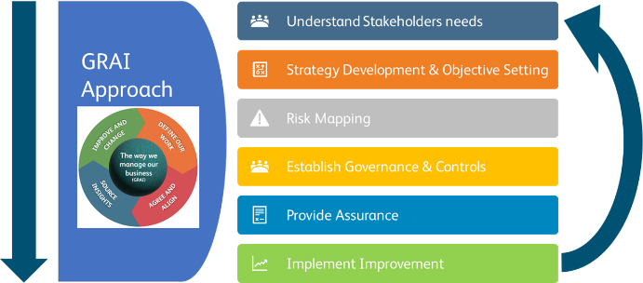
Figure 5 The GRAI Process

Organising for control and communications

7. Allocating responsibilities
Our Network Rail Operating Model, summarised in the Operating Model Governance Framework sets out at a high level how accountabilities and resources are distributed throughout the organisation and the GRAI governance, risk management, assurance and improvement process. This includes how accountabilities are split between regions and national functions, and the specific accountabilities of Core Process Owners. Our regional and functional managing directors are accountable for designing their own local operating models to deliver their accountabilities within the defined framework of the national operating model, as illustrated on the next page. Click here to see the regional and functional models. This also facilitates and empowers alliances and partnerships between train operators and suppliers. Our People Management Core Process covers strategy and workforce planning, organisation, joining our company and building the workforce and provides a common framework for developing our organisation.
Our Route, Regional and Functional Directors, along with our Core Process Owners, deliver their accountabilities by allocating responsibilities to competent people and resources to ensure their responsibilities can be properly discharged. Responsibilities are clearly defined in job descriptions, role profiles, processes, standards and controls. They are clearly explained during induction to the role. Route, Regional and Functional Directors are accountable for having a local operating model which is resourced to deliver their accountabilities, and for appointing competent people to roles. This includes access to competent health and safety advice, a requirement of the Management of Health & Safety at Work Regulations 1999. This is achieved by mapping roles to Institution of Occupational Safety & Health membership categories and certificate or diploma requirements and their recognised equivalents, with any deviations from this considered by the Capability Development Group. There is a similar process for specifying role requirements for technical, operational and organisational leaders. Competent occupational health support is provided externally or in-house. Competence management for our wider workforce and suppliers is described later in the competence management section.
Some roles are designated as key safety posts, as identified on job descriptions. These key safety posts exercise decisive authority over actions, products, decisions and policies that have a direct and material effect on the ability of Network Rail to deliver its legal requirements and health and safety visions. These posts cannot be left vacant, and a competent deputy must be appointed who has been trained and briefed to be able to cover the role if a prolonged absence occurs. The list of key safety posts can be found here.
Some engineering and operations roles in national functions are designated as Heads of Discipline, sometimes also called Professional Heads, or Network Technical Heads. Heads of Discipline are required to have a high level of competence in their subject, usually demonstrated through membership of a relevant professional body. The requirements for their competence, qualifications and professional membership are described in their job descriptions. Our Heads of Disciplines’ responsibilities can be found here
Changes in accountabilities and organisations are managed in accordance with NR/L2/HSS/020 Safety Validation of Organisational Change and the People Management Process. As part of the organisational change process, change proposers must carry out a responsibilities disposition exercise using the RACI tool: Responsible, Accountable, Consulted and Informed.

Organising for control and communications

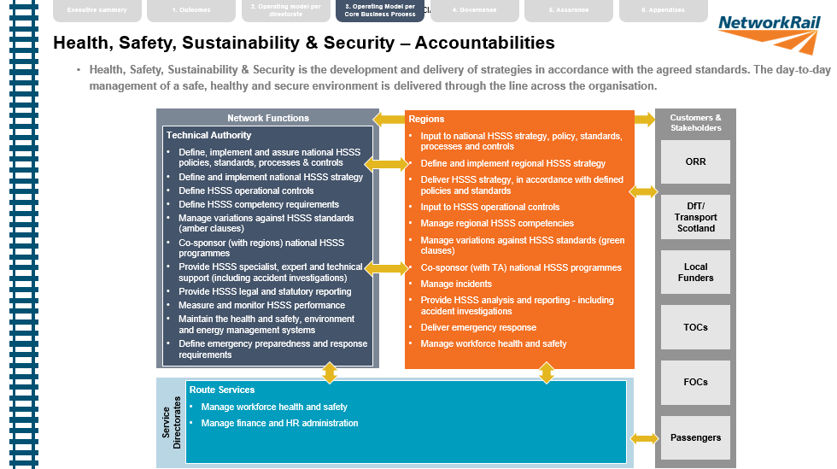
Figure 6 Health, safety and sustainability and security accountabilities in operating model
Organising for control and communications

8. Management and supervisory accountabilities
All our managers and supervisors have responsibilities for their own health and safety and the activities of the teams which they lead. Where they may struggle to meet these responsibilities, they are empowered to raise this with their line manager who can provide additional support. Our line managers are supported by the People Management Process from recruitment onwards. We provide training and development resources such as Line Manager Essentials: Managing Safely . Health and safety accountabilities are clearly defined and set out in job descriptions. Our business planning processes seeks to ensure that they are provided with the necessary resources to fulfil their responsibilities, but where they have concerns over lack of resources they are encouraged to raise this to their manager. Safety leadership is part of our performance review process for Bands 1-4, and Annual Capability Conversations for those with track competencies. At these conversations, our people are encouraged to proactively take control of improvements in health and safety risks they can influence, and constructively challenged about how they can improve.
Our Safety Framework sets out the principles guiding managers and supervisors, as set out on the next page. These include our vision, what and how we will deliver this and first line assurance principles, which are :-
- A checking or inspection process that is understood and helpful for line managers to run their businesses.
- We always check and follow through on what we find…linked to fair culture.
- Managers lead by personal example and promote strong engagement across their teams, motivating and empowering our people to take pride in, and undertake, their work in an efficient and safe manner.
- Teams welcome their managers and leaders to site, willingly engaging to demonstrate how they have delivered their work safely and efficiently.
- Variations from expected outcomes are proactively reviewed by our managers to understand where the business is falling short and corrective action is put in place immediately.

Passenger Safety  (Infrastructure and Stations) | Public Safety | Colleague safety and well being
Our Vision: Everyone Home Safe Every Day applied to all areas of the safety system
Passengers can travel around the rail network without concern for their safety and can get home safe after every journey. | The public understand the risks on the railway and we protect them from harm so they can get home safe. | A workforce that gets home safe every day, has the confidence to call stuff out when it isn’t right and feels fit and well to deliver their job.
The How: We will deliver our vision by focusing on the right things and making it simple
Make sure we are compliant in the key risk controls that prevent train accident risk | Understanding and better controlling the risk at footpath and bridle crossings by improving the completion and quality of narrative risk assessments. | Making sure we have safe places to work, including delivery of improved fire risk management
Make sure we are delivering a safe reliable operation to prevent earthwork failures | Understanding where and how to prevent access for those who wish to take their own lives, and deploying appropriate social media actions to reduce the risk | Look after people, by reducing the risk of exposure to respiratory carcinogens, silica dust, weld fumes and asbestos.
Make sure the railway is kept free of objects that could cause a train derailment such as keeping horses and cows out and tackling trees that could fall on the line . | Understanding where to prevent trespass to the railway and deploy appropriate interventions as well as delivering impactful media awareness campaigns. | Making sure that we manage high hazard activities including track work, on site transport management, electrical safety, plant and machine safety and occupational driving.
The What: We will support our people to develop, create a culture that has safety at its heart and improve how we communicate and engage
Developing and coaching our leaders so they can lead for safety (and giving them the tools to do so), not expecting them to just to do it. | Create a culture where unsafe behaviour is not tolerated (consequences) and where safety leadership is rewarded | Improve how we communicate and engage with the workforce and a focus on safety critical communications
Measuring Success: We will monitor how we perform, support the frontline to improve and share best practice through a learning culture
Measuring progress in a repeatable way (RM³) | Go, look see and supportive assurance (L2, L3) | Leading and Lagging indicators

Organising for control and communications

9. Organisational structure
Our overarching organisational structure and accountabilities taken from the operating model are illustrated below. Beneath this sit regional and functional organisational structures. Click here for the overarching operating and governance models and those for each region and function.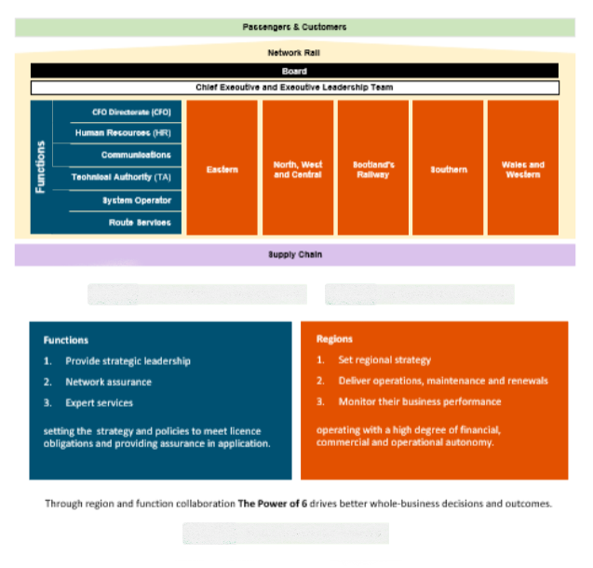

Organising for control and communications

10. Internal communications
The principles of day-to-day internal communications between our front-line managers and teams are contained in our Safety Framework , with guidance provided in A Guide to Leading Safety Conversations. We recognise that engaging communications to our teams need to be relevant, timely and engaging. We seek to use conversation and constructive challenge wherever possible, instead of process and email. We want to make talking about health and safety comfortable, natural and instinctive. Employees and suppliers are able to communicate any concerns and issues or identify improvements to information, instructions, standards and procedures, for example by using our standards challenge process. This is acted upon by managers and feedback is given promptly. We build capability in our frontline leaders so that they possess effective communication skills, helping to promote and foster great working relationships. We train our managers to lead in a compelling way, communicating authentically, demonstrating care for their people and challenging upwards, where necessary, to gain support.

Digital day to day communications channels include:-

- Broadcast email safety bulletins
- Viva Engage
- My Connect
- Safety Central
- Your Voice
- Facing Points Podcast
When we want to flag up concerns, we can use: -
- Close Call Reporting
- Speak Out
- Work Safe Procedure
- CIRAS - Confidential Reporting for Safety.
- Design Close Calls

Our national communications team use channels like My Connect to share information on national improvements, such as the new RailHub planning system. When incidents and accidents happen, we have email based health, safety and environmental alerts, bulletins and shared learning to immediately share key learning and messages. These are shared with our supply chain where appropriate. Our key communication messages align with our Everyone Home Safe Every Day safety vision and our Lifesaving Rules . Our regions and functions are accountable for local safety communications, including deciding how often safety briefings should be held for their staff, and what material should be included. Their communications teams use national cascade communications and add local information to this. Some key roles, particularly frontline operational roles, have role specific development days with content decided nationally to cascade key changes in rules and processes and refresh operational knowledge. We also need to communicate our rules, standards and real time operational changes effectively and consistently and have standards enabling us to do so. NR/L2/CSG/STP001/01 Principles of standard and control management outlines the process for standards briefing on a cascade basis using local people to explain standards’ requirements, accurately and consistently to local audiences. Our standards steering groups and working groups include those who regularly use the relevant standards, to ensure they remain current and relevant.

Organising for control and communications

11. External communications and working with stakeholders
Listening to our stakeholders, clear communications and joint working are key to our business and meeting customers’ and neighbours’ needs safely and sustainably. Our communication ambitions are: -
- One team working together with customers, passengers and stakeholders
- Keeping language, simple clear and warm
- Thinking customer and challenging processes
Communications and stakeholder engagement toolkits include:-
  Timetable change risk groups  Day to day safety and operational communications:e.g.  NR/L2/OPS/035 Dissemination of Urgent Operating Advice  Communication of infrastructure and vehicle changes |   Participation in Rail Safety & Standards Board  Internal and external joint working with unions  Joint industry activities  Train operations safety groups  Liaison with other transport operators |   Freight Business Plan: What Our Customers Want  Rail Delivery Group Freight Board  Freight customer engagement forms
  Health and safety management system and certification and authorisation consultation  Joint safety improvement plans | Stakeholder Relations Code of Practice  Communications Plan Context  Customer & Stakeholder Relationships GRAI & RACI  Stakeholder engagement and communications templates |   Passengers and public  Speak Passenger  Safety in the community, stations and level crossings
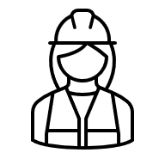  Supply chain forums, e.g.ISLG  Lifesaving Rules  Safety Central  Close Call Reporting |   Planned Disruption Lineside Neighbours  Planning work near the railway |   Positive engagement with regulators  National, regional and route meetings with ORR
Organising for control and communications

12. Organisational culture
Health and safety relies on our people, including our union representatives, working together to maintain a positive culture reflecting our values, particularly during times of organisational change. A safe organisational culture is fair, psychologically safe; allowing people to speak out without negative consequences. It is learning and diverse and recognises people make mistakes, which drives our work to understand the workplace factors that cause errors and address them to prevent significant safety events. It involves positive behaviours and values, communications, respect, a commitment to equality, diversity, and inclusion, supporting improvement of work and fostering trust. It means speaking up when we see something that isn’t right, and being supported when we do. We recognise that safety culture is part of wider organisational culture.
The National Safety Framework defines where we are and our aspirations, while recognising the need for devolved decision making, and the sharing of local best practice with others. We are on a journey to transform our culture from one which is quite traditional, localised and old fashioned, to one where people across the organisation feel cared for, always safe, and empowered to care about the railway, its users, its neighbours, and each other, and put teamwork at the heart of everything we do. This means recognising that sometimes it is not possible to do work in the way that it was imagined to be, and taking action to tackle the underlying causes of this. Line managers have a strong impact on organisational culture in their team and that is why we equip and train our managers in leading people safely, as outlined in the leadership section.
Our Regions each have a plan to improve safety culture, and links to some of our key hubs and plans are provided below. Examples of some of the actions taken include training safety champions, line manager training in safety leadership or safety conversations, information and support on cultural improvement, and local improvement plans. There are other regional and functional hubs available, but here are links to some of them:
- East-Coast-Safety-Culture
- Technical Authority Safety Culture
- Technical Authority - Safety Framework Briefing
- Wales & Western Region Safety Culture
- Better Together Southern
- Viva Engage - Safety Leadership and Culture
- Fair Culture Investigations
- RSSB Changing Safety Culture
Our routes, regions and functions assess their culture at least annually using the RM³ assessment tool and develop local action plans to further improve. Local assessments are then used to provide evidence for the national RM³ assessment, with performance monitored by our Board and Executive Leadership Team, providing us with good data on how our cultural improvement is progressing. The outputs of our RM³ assessments are also shared with our regulator, the Office of Road and Rail, and we take part in industry groups to share ideas for continuous improvement in safety culture.

Participation and competence

13. Working together
Working together is essential to shaping our health and safety management system and continually improving it to bring everyone home safe every day. It also promotes mental and physical health and well-being in and out of the workplace. This goes beyond consultation and meeting our obligations under the Safety Representatives and Safety Committees and Health and Safety Consultation with Employees Regulations. On a day to day basis, safety conversations and listening to each other helps us find ways to make our work healthier, safer and more sustainable. We involve those doing tasks in risk assessments and development of systems of work, particularly through our trade union representatives, so that risk controls are practical and realistic.

We aim to actively engage and work with our colleagues at all levels within the organisation. We have collective bargaining and safety agreements with the unions, including a process for escalation when health and safety problems cannot be resolved at a lower level. At a strategic level, we have trade union representation on the Board’s safety, health and environment committee. We communicate and involve our workforce in health and safety at the National Health, Safety and Wellbeing Council, (NHSWC), with Unite, RMT and TSSA, and regional functional, and local safety forums and committees. There is a procedural agreement for Councils. Every Council member should first attend a briefing, e-learning or other on what it means to be an effective meeting participant, provided by Network Rail or the Trade Unions. The NHSWC has its main meeting once a quarter, with shorter interim meetings once a month, or as and when required. Unions have full representation on the Council. They consult with Network Rail on matters of health, safety and welfare that impact on areas of business where they have trade union recognition. More information is provided for Network Rail readers on the MyConnect site Bargaining Agreements and Councils Structure.

The unions provide training for their representatives and are also represented on strategic policy groups, such as the joint industry RSSB led System Safety Group.

We also work together through Communities of Practice, utilising the power of our organisational size and diversity. The health and safety community is designed to provide an organisation wide oversight of risks, identify areas for improvement, facilitate knowledge and best practice sharing, provide opportunities for skills development, and provide two-way consultation on changes to standards, competence requirements and processes. Anyone in Network Rail and our supply chain can put forward proposals for changing our Network Rail standards and processes, and we encourage constructive challenge. Challenging Network Rail Standards gives guidance on this. We also have an engineering community review group for each discipline and one for system integration, a Buildings & Civils Community Hub, Building and Civils Working Group and Learning from Lessons Library.

Participation and competence

14. Competence management system
Competence in technical and non-technical skills is at the heart of our business. Along with other duty holders and our supply chain partners, our people have health and safety accountabilities and many of us have roles involving work defined as safety critical by ROGS which directly affects the safe operation of the railway. Safety critical work includes driving and dispatching trains, signalling, electrical control, installing components and maintenance, and providing protection for track workers. Our competence management system standards and people management processes follow the five step cycle described in Developing and maintaining staff competence (ORR).

Figure 7 Competence management cycle adapted from ORR (2016)
Our standards incorporate industry best practice from within and out with the rail sector, and external awarding bodies’ requirements. These include: -

- Good practice guide on competence development (RSSB)
- Resources for Observing, Developing and Measuring Non-Technical Skills (RSSB)
- National qualifications internal verification toolkit ( SQA)
- Internal verification: a guide for centres (SQA)
- National occupational standards for learning and development, (Alliance Sector Skills Councils)

The overarching standards are NR/L1/CTM/001 Competence Management, NR/L2/CTM/201 Competence Management and NR/L2/CTM/202 Quality Assurance of Training and Assessment Organisations. These emphasise how important it is for assessors and internal quality assurers to maintain their own competence to make sure that assessments are effective, planned, based on observation and objective evidence of meeting standards, and incorporate learner feedback. We also have NR/L3/CTM/306 Skills Assessment Scheme , a competence assurance process based on risk and the activity being performed by an individual, which covers a small proportion of our workforce. Along with many of our suppliers, we are members of the National Skills Academy for Rail and follow Rail Training Assurance Scheme Rules, (RTAS). RTAS rules are owned and administered by Network Rail’s training department and assured by the National Skills Academy for Rail. We also manage, deliver and participate in the Sentinel Scheme which is used to assure rail workers’ fitness and competencies. There are standards for operational and technical work, for example NR/L2/CIV/1000 Competence Management for Buildings and Civils Infrastructure, track safety and incident response. We have processes in place to make sure accreditations with professional bodies are maintained and their requirements for continuous professional development. Our main-line drivers hold train driving licenses. We also train and assess those using plant and equipment, road vehicle drivers and others whose work is not defined as safety critical but can affect their health and safety and those of others. In summary, our standards cover: -

- Responsibilities and accountabilities for competence management
- Identification of safety critical tasks and risk based training needs analyses, including technical and non-technical skills
- Defining roles carrying out safety tasks, while noting that ROGS defines safety critical tasks rather than roles, and allocating competent people to them
- Recruitment and selection, which often includes aptitude testing
- Competence assessment and monitoring, including post incident and following long absence
- Medical fitness and welfare, avoidance of fatigue, drugs and alcohol
- Record keeping
- Supply chain competence
- Internal and external quality assurance and audit

To find out more about our competence management system, key health and safety accountabilities and safety critical work activities performed in each role group, click on these links: -
 | Policy, Assurance and Administration
 | Live links to current key accountabilities and safety critical work activities performed in each role group, IMS process: define operational competence and capability requirements, including risk based training needs analysis
 | Medical Fitness, Welfare, Fatigue, Drugs and Alcohol
 | Competence Management Occupational Health and Safety
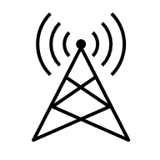 | Signalling and Telecommunications
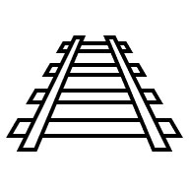 | Buildings and Civils  Track
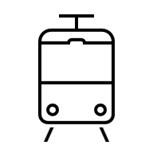 | Electric Power Engineering & Control
 | Competence Management Engineering Work, Site and Track Safety
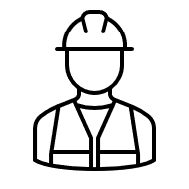 | Suppliers
 | Operations
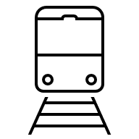 | Plant and rail vehicles - driving, operation and maintenance
 | Road vehicle driving and maintenance
 | Emergencies

Planning and implementation

15. Identifying legal and other requirements and external standard selection
We are committed to complying with all relevant legislation, and identifying the obligations on us is a key step in the development of our standards and controls. In particular, we must comply with the Health and Safety at Work etc. Act 1974, Environmental Protection Act 1990 and regulations made under them including the Railways & Other Guided Transport Systems Regulations 2006 (ROGS) and the Railways (Interoperability) Regulations 2011, the Regulatory Reform (Fire Safety) Order 2005, and the Road Traffic Act 1991. To enable us to do so, we maintain a Health and Safety Legal Register and Regulatory Obligations Register which are reviewed on a regular and frequent basis and cover the requirements we need to meet in England, Scotland and Wales. There are also National Technical and Safety Rules, National Technical Specification Notices and Rail Industry Standards which we need to follow and play a part in reviewing and developing with representation on Rail Safety and Standards Board, (RSSB), standards committees. The Rule Book is the most well-known but there are many more covering: -

- Control command and signalling
- Data systems and telematics
- Energy
- Infrastructure
- Plant
- Rolling stock
- Traffic operations and management
The full set of standards is available in the RSSB Standards Catalogue. For Government guidance on the regulations and standards, visit National Technical Specification Notices.
We also keep records of how we comply with certification requirements for ISO 9001 Quality Systems, ISO 14001 Environmental Management Systems, ISO 45001 OH&S systems and ISO 55001 Asset Management where we have adopted these systems. No single person can be expected to know all the standards that apply to them, and therefore we have the following sources to check our requirements and identify applicable railway standards and the expectations of regulators: -

- Railway Standards Self-Assessment (rssb.co.uk)
- Rail-Vehicle-Structures Standards Self-Assessment (rssb.co.uk)
- Route Compatibility Standard Self-Assessment (rssb.co.uk)
- Vehicle Fire Standards Self-Assessment (rssb.co.uk)
- ORR Health & Safety Strategic Risk Chapters
We monitor compliance with these requirements through our assurance processes and take prompt action to rectify any non-compliances, which are not believed to be acceptable without an agreed variation.

RSSB Guidance on the Application of Railway Standards explains the legislation and standards hierarchy. RSSB Standards provides more information about their purpose and how they work.
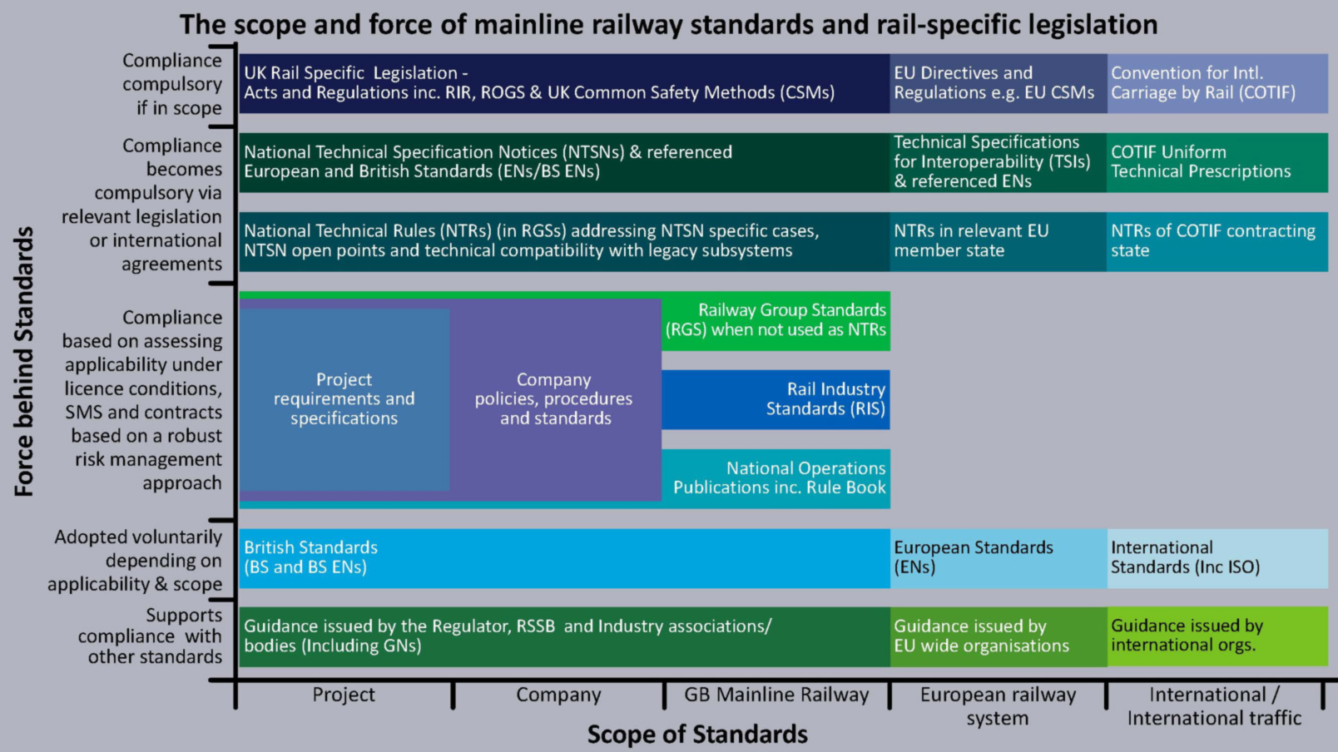
Figure 8 Scope of main-line standards and legislation (RSSB 2022)

16. Internal standards, records, document and knowledge management
Planning and implementation
Our Integrated Management System and Network Rail Standards are the foundations of our health and safety management system, contain what we need to know and are binding on us and our contractors, whether we work centrally or regionally. Our standards and controls exist to manage risk or help us comply with legal requirements which is why they are mandatory unless a variation has been applied for and approved through the official standards process. We build on legislation, external standards and transferable industry good practice when producing, reviewing our standards and controls. Each standard and core process has an owner. Guidance on how to meet the National Requirements detailed within our Integrated Management System can be further expanded upon in regional systems, such as the Southern Region Business Management System.
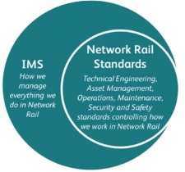
Figure 9 How the IMS and our standards fit together
Standards development is overseen by our standards and controls steering groups, which are discipline specific and include representatives from regions and the relevant functions with the development process being managed by the Standards Team. A list of steering groups and their representatives is published on the standards FAQs. These groups review remits, approve changes, manage, and prioritise the work banks, and oversee the governance for standards in their area. The process for developing and updating standards, as well as applying for and accepting variations against internal standards is outlined in NR/L2/CSG/STP001 Standards and Controls Management. There is guidance available for standards owners, working group members, and steering group members. Anyone in Network Rail and our supply chain can put forward a proposal for change. Challenging Network Rail Standards gives guidance on this.
We have a wide variety of standards contributing to safety and system integration across all our business activities. These include standards for document control, asset information, changes to standards, drafting criteria and managing variations. Our processes for updating and creating standards are risk based and apply the Common Safety Method for Risk Assessment and Evaluation to check whether any changes are significant. Any request goes to the relevant steering group via a standards remit, which contains impact assessments such as finance, sustainability and diversity and impact assessment.
Standards for operations and each engineering discipline interact to control health and safety risks while continually improving customer services and maintaining the wellbeing of Network Rail people and supply chain partners from design, construction, maintenance, and operations to decommissioning then regeneration through circular design.

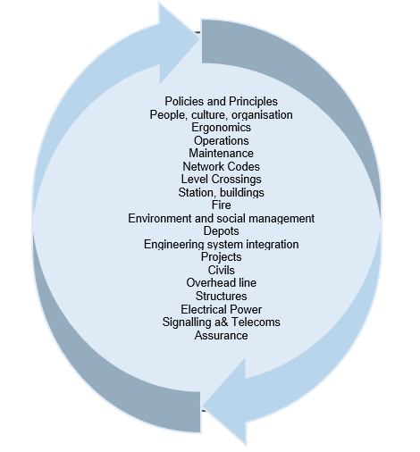

Figure 10 Standards coverage and contribution to health and safety and sustainability.
To help navigate through our many standards and determine which apply, visit Network Rail Standards and Controls Steering Group Portfolios.
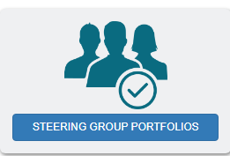 | Asset Data Governance  Asset Information | Buildings and Civil Engineering | Capital Investment | Company Standards and Controls Group | Competence and Training
Electrical Power | Ergonomics | Fire Safety Policy | Information Management | Integrated Risk | Level Crossings
Maintenance | Off Track | Operations | Property | Health, Safety and Environment | Rail Mounted Vehicle and Plant
Security | Signalling | Supply Chain Operations | Systems Engineering | Telecoms | Track Engineering

We try to use the most suitable ways to record and convey information and best formats. We use digital technology and communications systems to record and disseminate information as well as traditional “flat documents”. For example, for urgent safety of the line information. we use Rail Notices and communicate digitally and by phone following NR/L3/OPS/045/3.24 RIS-3350-TOM Urgent Operating Advice and RIS-8250-RST-Safety Related Defects. Briefing materials on infrastructure changes may be provided in audio-visual form. We have a Records Management Hub and processes for document management and drawing configuration control, including electronic and paper based documents, such as track diagrams.

Planning and implementation

17. System safety and interfaces
We define system safety as the safe design, construction, maintenance and operation of the railway. Operating our railway network sustainably requires robust processes for design, construction, maintenance and operation of stations, the main-line railway, depots and sidings to keep passengers, workers and the public safe. To keep our safety certificate for train operations, safety authorisation for infrastructure management and operating licence, we need to satisfy the Office of Rail and Road that we are fit to run by meeting its assessment criteria for main-line railway safety certificate and safety authorisation applications. Under the Railways and Other Guided Transport Systems Regulations 2006, there are also entities in charge of maintenance requirements. This requires effective management of our many, often complex, internal and external technical, operational and organisational interfaces with station, depot and train operators, suppliers, roads, and many others. It requires system integration, close working and interdisciplinary checks between engineering and operating disciplines and other organisations.

Figure 11 Interfaces
Our customers, suppliers and stakeholders are key. We work in partnership with them to meet our mutual health, safety and wider sustainability objectives. In particular, our relationships with other railway group members are crucial in achieving our objective of a safe operational railway. The Stakeholder Relations Code of Practice helps with this. The Network Code is written into our train operating customers’ track access agreements. The Network Rail Assurance Panel Hub gives visibility of the Panel’s work and records on authorisation and decisions on network and vehicle compatibility and route acceptance. The Contract and Procurement Hub is used for supply chain management. Joint working with highway agencies and British Transport Police using ORR Rail Road Interface Guidance is used to manage level crossings and vehicle incursion risks. We have a team dedicated to overseeing and reviewing system safety, a system safety working group and are active participants in the RSSB’s System Safety Risk Group, and its sub-groups, and work with the industry to control shared and common risks, as well as identifying emerging risks. To find out more about our standards and processes for managing system safety and interfaces, click on these links and headings:-
Operations management, planning and real-time  The Rule Book  Traffic operation and management industry standards  Network Rail Standards Portfolio Operations  NR/L3/OPS/045 National Operating Procedures Index | National standards, rules, access contracts, licenses and authorisations    Common safety method regulation  Rail industry standards  Track access contracts  Station and depot access  Operating licenses  Safety certification and authorisation  Entity in Charge of Maintenance  Train driving licenses | Network codes, network, station and depot change, railway operational code  Network Code  Network, vehicle, station and depot change  NR/L2/OCS/009 Network Capability Management Procedure
Control, signalling and telecommunications systems  Control command and signalling industry standards  Data systems and telematics industry standards  NR/L2/TEL/30127 GSM-R Air Interface Functionality, Availability Management and Compliance Validation | Our policies and principles for system safety and interfaces  Network Rail Standards  NR/L2/CSG/STP001 Standards and Controls Management  Network Rail Assurance Panel  NR/L2/ASR/036 Assurance Framework  NR/L2/RSE/100/05 Product acceptance and change to Network Rail operational infrastructure | Infrastructure, vehicles and power  Infrastructure industry standards  Plant industry standards  Rolling stock industry standards  Energy industry standards  NR/L2/RSE/100/03 The application of the Railways (Interoperability) Regulations for Network Rail  NR/L2/RSE/100/04 Introduction of new or modified vehicles
Air, water and rail transport interfaces    NR/L3/OPS/045/4.13 Air Traffic Incidents  NR/L3/OPS/251 Unmanned Aircraft System Operations | Supply chain  Contract and Procurement Hub  NR/L2/OHS/CP0070 Principal Contractor Licensing Assurance  Railway Industry Supplier Qualification Scheme, (RISQS) | Road interfaces    NR/L1/CIV/601 Managing the Highways Interface  Rail Road Interface ORR Guidance
Border interfaces include the London Underground, Elizabeth Line and Overground, metro and light rail systems such as the Tyne and Wear Metro, Trafnidiaeth Cymru/Transport for Wales, South Wales Metro and HS1. Overground Services are operated by others on behalf of Transport for London, but we maintain most of the track and signals. Some Underground services run on our track too, and interfaces include the Northern City Line. The Tyne & Wear Metro partly operates on our infrastructure under bespoke procedures. We connect with Trafnidiaeth Cymru/Transport for Wales, the infrastructure manager for some Welsh routes, which lets contracts for operation of the South Wales Metro and other train services. We interface with HS1 and also operate it on behalf of the infrastructure owner. We also connect with airports from Aberdeen , Prestwick to Heathrow, and Grimsby Dock for rail freight. Rail connections with heritage railways include East Lancashire, North Yorkshire Moors and Strathspey Railways.

18. Risk assessment and management
Planning and implementation

18.1 Enterprise risk and risk profile
Our health and safety risk management aims to identify the things that could deflect us from, or support us with, getting everyone home safe every day. It’s about taking steps to stop threats happening and, if they do happen, to have plans ready to mitigate the consequences, and it’s about taking the best advantage of opportunities. It is based on the reality of the way work is done and includes input from those doing the work. Our framework sets out the key elements of our risk management approach, covering enterprise-wide risk management (which includes health and safety-specific risks, as well as broader risks relating to our objectives) and operational risk management, which covers the targeted approach to managing different health and safety risks.
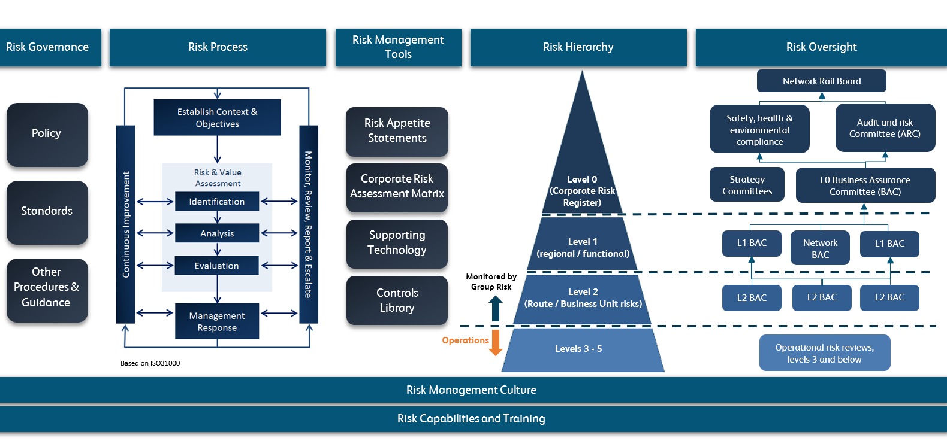
Our risk framework is based on the ISO:31000 international risk standard and is also compliant with the Government’s Orange Book risk guidance. Our policy, framework and tools can be found on the Integrated Management System. Our current enterprise risk registers are available via a management dashboard.
Enterprise risks are assessed by impact (on health, safety and the environment; train service delivery; finance and political/stakeholder impact) and likelihood, using a common Corporate Risk Assessment Matrix. Risk management plans are informed by the Board's risk appetite, which is minimal for Safety, Health and Environmental Compliance risk. Each Enterprise Risk has an owner allocated and is regularly reviewed and assessed. This includes reviewing performance and improvement actions.
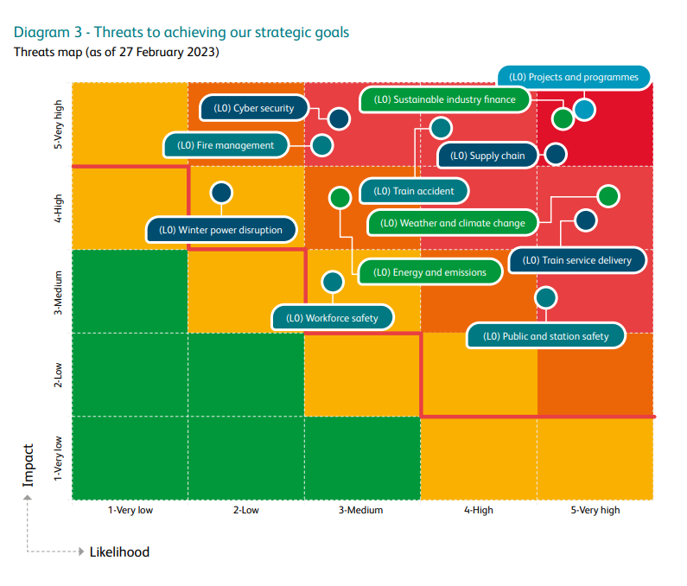
Figure 12 Risk heat map: Our enterprise risks are shown here against plausible worst-case impact (which could be safety, financial, train performance, or stakeholder/political impact) along with the associated likelihood score.

Safety risks are quantified using the RSSB Risk Profile Tool and we use the outputs in a number of risk assessment systems: for example the All Level Crossings Risk Model and the Precursor Indicator Model. This helps align our understanding of risk to the actual levels of harm on the railway. Here's a snapshot of whole railway risks in terms of fatalities and weighted injuries taken from the Annual Health and Safety Report 22/23 (RSSB).
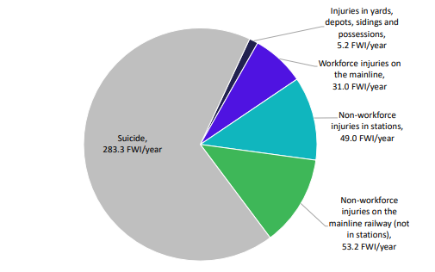
Figure 12 Railway Risk (RSSB 2023)

18.2 What, how and why we risk assess
Risk assessment is a core business activity covered in our operating and business model and is central to how we understand and manage risk. It supports informed decision-making and the identification of appropriate controls to reduce risk so far as is reasonably practicable, driving continuous improvement. We use a variety of qualitative and quantitative techniques and keep our risk assessments under review. At a high level, our regional and functional managing directors are accountable for assessing and managing risks within their respective areas and allocating responsibilities to individuals to carry out assessments, ideally with input from those carrying out the task. The hazards we have to assess and control, both on and off the railway, are varied: here are some: -
Stations, escalators, lifts, platform train interfaces, ticket gates    . | Plant and equipment  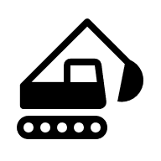 | Buildings and civil engineering, services, architecture,  design, construction  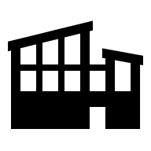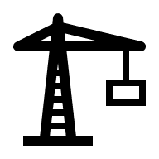
Driving, flying    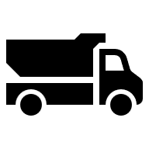 | Railway operations   | Rail vehicles, structures and track engineering, wheel rail interface  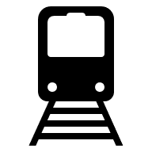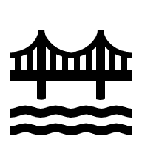
Occupational health and safety, supply chain and direct workforce  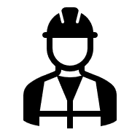 | Signalling and telecommunications | Road rail interfaces and level crossings  
Fire, security  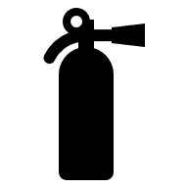 | Electricity   | Weather, climate change  
Click on these links below to find out more about risk assessment standards and policies.
Policies, principles and techniques | Level crossings
Occupational Health & Safety | Buildings, civil and track engineering
Ergonomics and Human Factors | Rail vehicles and train driving
Route crime | Electricity and electro-magnetic compatibility
Fire | Operations
Construction and projects | Possessions and track safety
Change | Road Vehicle Driving
Signalling & Telecommunications | Flying drones
Our risk assessment and control standards detail the arrangements for reassessment when circumstances, legislation or technology change, and their effectiveness is monitored through our assurance process. We use external standards where applicable to inform our internal standards development, and work instructions, particularly for areas such as lifts and escalators, structures, machinery, fire safety and climate change adaptation. A small selection includes: -

- BS EN IEC 31010: 2019 Risk management – risk assessment techniques
- BS EN ISO 14798: 2013: Lifts, escalators and moving walks, risk assessment and reduction methodology
- BS EN 13824 General principles on risk assessment of systems involving structures
- BS EN ISO 12100: 2010 Safety of machinery – general principles for design, risk assessment and risk reduction
- BS ISO 16732: 2012 Fire safety engineering – fire risk assessment
- PAS 79-1:2020 Fire risk assessment of premises other than housing
- BS EN ISO14901: Adaption to climate change – guidelines on vulnerability, impacts and risk assessments

18.3 Railway system risk
Railway system health and safety risk assessment during “steady state” and change is linked to effective management of the supply chain, operations, maintenance, renewals and projects. It covers rail vehicles, stations, depots and work in possessions, operations, level crossings, signals and telecommunications, electrical systems and infrastructure. We use the RSSB Taking Safe Decisions Analysis Tool , RSSB Bowtie Hub and RSSB Rail Risk Toolkit. Assessment tools in the kit cover buffer stops, platform aerodynamics, platform train interface, precursor indicators, red signal aspect approaches (RAATS), the safety risk model and signals passed at danger, (SPAD), risk ranking. Figure 15 below shows an example bow tie model.
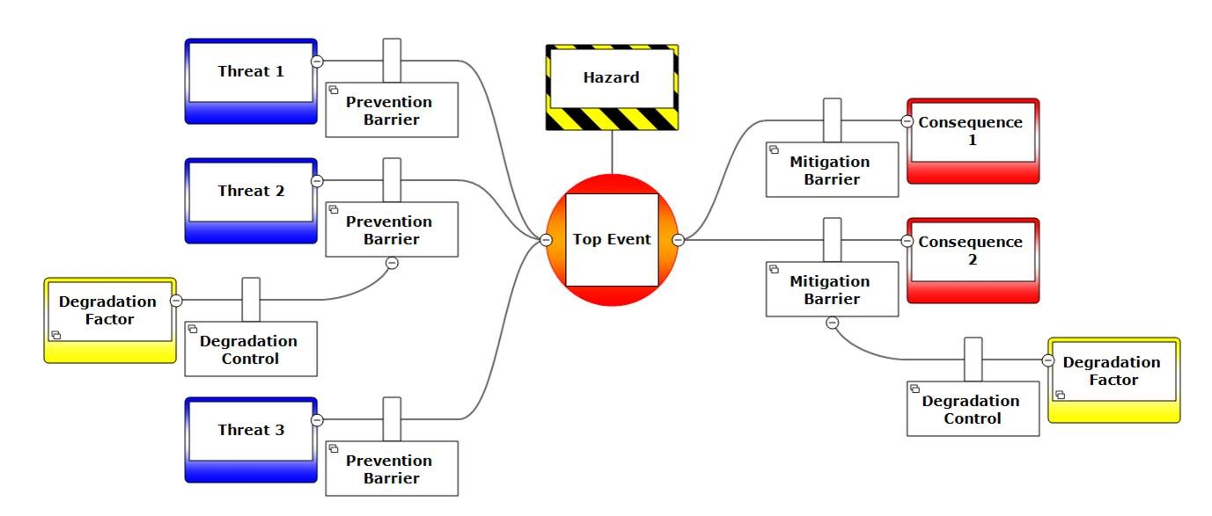
Figure 13 Bow-tie risk assessment (RSSB 2023)
We also use RSSB Research on Common Hazards for the Management of Industry Safety, the All Level Crossing Risk Model (ALCRM) and Signal Over-run Assessment Tool (SORAT) , and a variety of systems and infrastructure assessment techniques: a small selection is: -
- NR/L2/ELP/27717 Bridge parapet electrical risk assessment
- NR/L2/CIV/086/Mod09 Earthworks Adverse/Extreme Weather Risk Assessment
- NR/L2/SIG/14201/Manual Signalling Risk Assessment Handbook
- NR/GN/XNG/30048/01 Level Crossing Bow Tie - Animal, Vehicle, Object or Person on the Line at Risk of Collision
18.4 Risks influenced by others
Our risks are influenced by the activities of other people and organisations as well as ours and those of our suppliers and train operating customers. We have risk controls in place for asset protection, crime prevention and security, bridge strikes and road vehicle incursion, and, of course, level crossings. The requirements for protection and optimisation of assets are described in Planning work near the railway. NR/L2/OPS/291 Railway Crime Risk Management describes how we minimise our vulnerability. We assess our bridges for vulnerability to road vehicle strikes, working with road authorities to implement additional protection measures, and assess sites where the railway may be vulnerable to incursion. Reducing our level crossing risks starts with implementing our upgrade and closure programme, communicating effectively with users and understanding their needs. NR/L1/XNG/100 Level Crossing Asset Policy requires us to “invest in research to improve our understanding of level crossing management, including research into users’ behaviours, trends in safety management, along with technology and engineering opportunities”. We also depend on the competence of risk assessors, which we manage using the NR/L3/XNG/207 Level Crossing Manager Competence Framework. Our communications material and standards include, Level crossing safety - Network Rail, NR/L3/XNG/308 Risk Assessing Level Crossings and NR/L2/XNG/30020 Level Crossing Design Handbook .

18.5 Risk assessing change
Internal and external changes bring risks and opportunities which we need to assess during design, construction, operations and maintenance through to sustainable decommissioning. We use ORR guidance on the Common Safety Method for Risk Evaluation and Assessment Regulation for organisational, operational and technical changes affecting the railway to decide whether there is a significant safety impact, and whether there is a need for independent assessment. CSM-RA e-learning is available for those who would like to know more. Information on how we apply CSM is contained in NR/L2/RSE/100/02 . The guidance covers the roles of the change proposer, the Designated Bodies,(DeBos), Approved Bodies, (ApBos),and National Safety Authority, the ORR.The steps in the process are:-
- Assess whether there is a significant safety impact from the change
- Define the system which is to be changed
- Hazard identification and classification
- Identify risk assessment principles: codes of practice, reference systems, explicit risk estimation
- Risk evaluation comparison with criteria
- Identify, implement and demonstrate compliance with safety requirements
- Independent assessment if necessary
We have many other tools to assess and control change associated with our railway and other business activities These include: -
- NR/L2/P3M/224 Project acceleration in a Controlled Environment (PACE) – Manage risk
- NR/L1/HSS/00126 Prevention through Engineering and Design Policy (PtED)
- NR/L2/OPS/031 Assessing and assuring the impact of operational risks relating to train plan changes
More detail on how we manage change and the roles played by the Network Rail Assurance Panel, safety validation panels and assurance processes is contained in the change management section.

18.6 Occupational Health
Our health vision, Everyone Fit for the Future, recognises the vital importance of managing risks that may cause ill health for our people, and places improving health & wellbeing on an equal footing with improving safety. Improving the air which we breathe, reducing our use of hazardous substances and keeping noise levels down contribute to effective environmental management and wider sustainability. For more information on our sustainability systems, visit Environment and Sustainable Development - Safety Central .Resources on occupational health, mental and physical health and supporting our colleagues’ wellbeing are available on Health and Wellbeing - Safety Central .Here you can find our strategy and video clips like Health-and-wellbeing-in-Network-Rail.

Occupational health falls into linked categories:-

- Management of workplace health hazards: for example, respiratory, substances hazardous to health dermal, noise and musculoskeletal.
- Physical and mental health and wellbeing, which covers the impact of work on health, and health on work, for example, fitness for work and well-being, promoting healthy lifestyles, absence management. Managing the impact of health on work, medical standards, fatigue and drugs and alcohol screening, is covered in the competence management section.

We aim to support our colleagues’ mental and physical health in and outside the workplace by developing more inclusive and accessible standards and work processes, for example training mental health first aiders, and reviewing medical standards to include rather than exclude people. We assess occupational health and well-being using a variety of tools including health assessments, route risk registers, task and work activity risk assessment and work activity specific risk assessments.

Our work activity and workplace specific occupational health risk assessments cover fatigue, manual handling, noise and vibration. They cover exposure to hazardous substances, asbestos, lead, silica dust, naturally occurring and created substances, such as radon, Weil’s disease, and welding fumes. They consider human factors, especially ergonomic assessments during design, and individual requirements, of, for example, pregnant and nursing mothers.

The standards and resources we use for assessing work activity occupational health risk are:-

Noise and vibration    NR/SP/OHS/00114 Risk Assessment - Hand Arm Vibration  NR/SP/OHS/00122 Risk Assessment - Workplace Noise | Manual handling    NR/L2/OHS/00106 Management of Manual Handling Risk  Manual Handling Hub
Control of substances hazardous to health  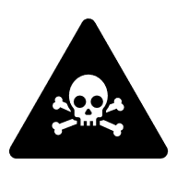  To access the COSHH database, use: Sypol CMS Log in for NR users  NR/L2/OHS/00103 Risk Assessment - COSHH  NR/L3/OHS/MTC/0150 Risk Assessment - COSHH for Infrastructure Maintenance  NR/L3/OHS/NDS/301 Risk Assessment - COSHH for NDS  NR/L3/OHS/00125 Risk Assessment - COSHH for other functions | Ergonomics and human factors    NR/L2/ERG/24020 Engineering assurance arrangements for ergonomics within design and development projects  NR-IP-EN-3124 Standard Technical Requirements Ergonomics and Human Factors  RT/E/S/24017 Control Room Design Specification, Process and Guidance  NR/SP/ERG/00005 Signalling Centre Desks  NR/L2/OHS/00107 Management Procedure - Display Screen Equipment Risk Assessment
Fatigue  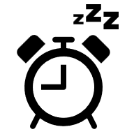  NR/L2/OHS/003 Fatigue risk management | Pregnancy and new mothers    NR/L2/OHS/00117 Risk Assessment – New and Expectant Mothers

18.7 Occupational Safety
We share resources such as Safety Central with our supply chain partners to manage occupational health and safety risk. We use Rail Hub for on-track work planning, risk assessments and method statements, and safe work packs as required by NR/L2/OHS/019 Safety of people at work on or near the line .
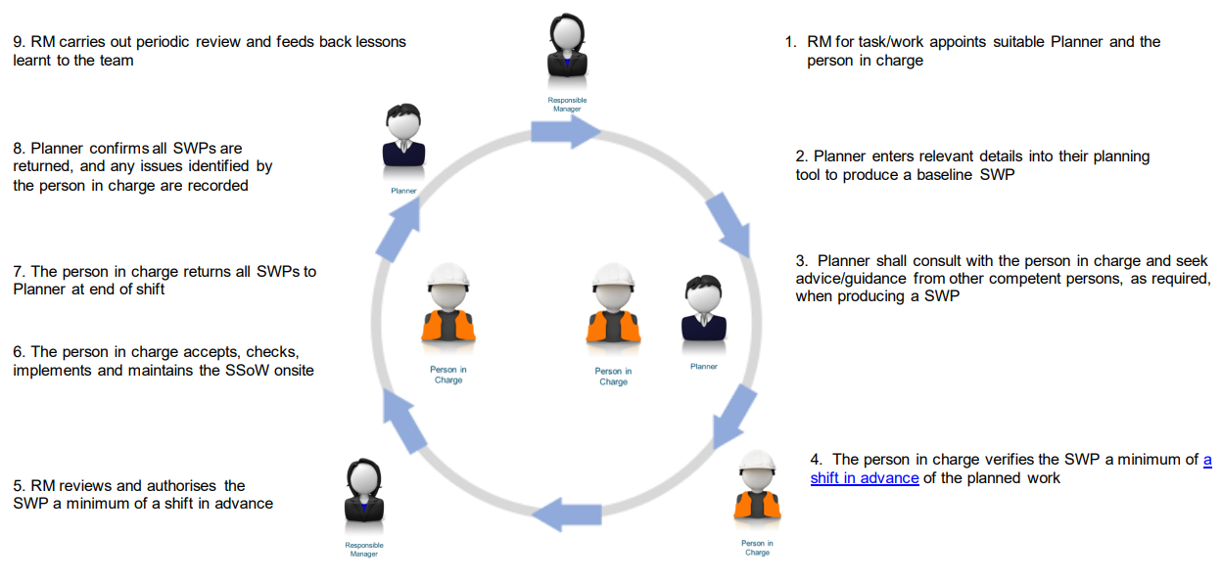
Figure 14 Work planning process
Our suppliers have their own work activity risk assessments and method statements. Our own workplace and work activity risks are assessed and controlled using a system of Risk Control Sheets contained in NR/L3/MTC/RCS0216 Risk Control Manual. The person planning the work is accountable for establishing specific risk assessments and controls using the risk manual and Level 3 standards as a guide. We also have a Risk Assessment Management System database which can be accessed using the-Info-Tracker - Log in for NR users.
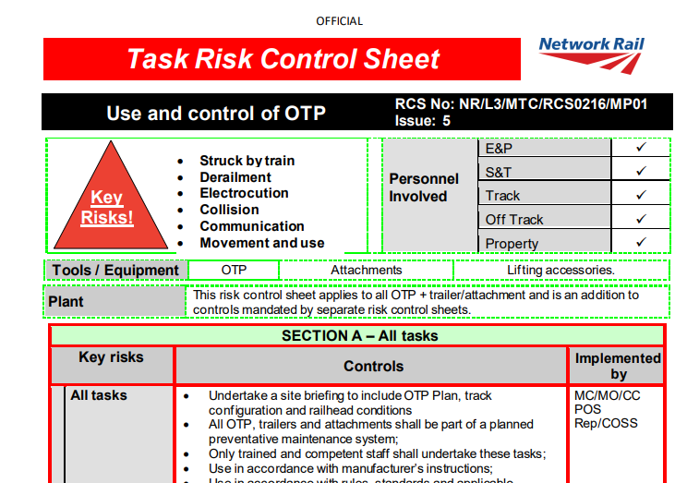

Requirements for work activity assessments are also contained in NR/L2/OHS/00102 Work Activity Risk Assessment, NR/L3/MTC/SE0116 Work Activity Risk Management and NR/PRC/MPI/CP0037 Use of Work Activity Risk Assessment in a Safe System of Work. More information on risk assessments and method statements is contained in the safe systems of work section.

Planning and implementation

19. Objectives and targets setting
The ORR sets Common Safety Indicators and assesses the rail industry’s performance in achieving these. Our objectives contribute to meeting these targets and delivery of the joint industry strategy, Leading Health & Safety on Britain's Railway (RSSB), which we play a key role in shaping. Under ROGS we are required to send the ORR an annual safety report, and to fulfil the requirements of the Common Safety Method for Risk Evaluation and Assessment Regulation we must submit a brief report on our experience of its use and decisions on change significance. Over the long term, our business objectives and funding to meet these are set out in Control Period Strategic Business Plans. We also set national safety, health, and environment targets each year with the agreement of the DfT, and report on the previous year’s performance. These targets are an integral part of our business scorecard, and cover the workforce, passengers, the public, health and well-being, for example mental wellbeing training and hand arm vibration surveillance, the environment and sustainability. Our Tactical Safety Group makes recommendations on qualitative, quantitative, proactive and reactive targets to the Executive Leadership Team’s National Safety Strategy Committee for endorsement. Once agreed, performance in meeting the targets is reviewed each period, along with actions necessary where they haven’t been achieved: here’s an example: -

SHE KPIs published in the National SHEP Report | This Year’s  Target | Year  Forecast ( @ P11) | Next Year’s Target Proposed | Reasoning for target
Workforce Safety
Fatalities & Weighted Index (FWI) | 0.054 | 0.069 | 0.058 | Combination of regional submissions
Lost Time Injury Frequency Rate (LTIFR) | 0.230 | 0.232 | 0.230 | Realistic target based on this year’s forecast
High Potential Workforce Events | 24 | 22 | 20 | 10% reduction on this year’s forecast
Fatalities | 0 | 3 | 0 | Zero fatalities. Everyone home safe everyday
Specified Injuries | 45 | 43 | 40 | Necessary to achieve proposed FWI target and maintain this year’s improved performance.
Lost Time Injuries | 350 | 324 | 310 | Necessary to achieve proposed LTIFR target and maintains this year’s improved performance.
Personal Accountability for Safety | 820 | 820 | 758 | Combination of regional submissions
Train & Station Safety
PIM (not currently in SHEP targets) | 1.60 | 1.60 | 1.56 | Necessary to achieve Control Period exit target of 10% reduction from previous Control Period exit
Train Accident Risk Reduction (TARR) | 95% | 89% | 95% | Maintain this year’s target
High Potential Train Accident Events | 24 | 19 | 21 | 10% reduction on previous target however we are currently forecast to perform better than this year’s target so may require review upon year end.
Station Accidents (RIDDOR Reportable) | 27 | 5 | 10 | Increase in full year forecast due to increasing passenger numbers

Our arrangements for setting objectives and targets within the regions and functions are set out in our operating and governance models, risk, assurance and investment plans, and strategic health, safety and environmental plans. Our safety framework process covers high level improvement actions, with health and safety promises made, and health and safety objectives agreed in individual performance reviews.

Planning and implementation

20. Workload planning
Our processes and standards for workload planning cover strategic and tactical planning. They cover resourcing and project planning, operations and support functions, and range from rostering and fatigue management to major upgrades and organisational changes. For example, Modernising Maintenance has a sizing tool for gauging organisational workload with a supporting integrated management system process. We assess the job design and work demands of operations and maintenance roles in accordance with the ergonomics and human factors assurance process set out in NR/L2/ERG/24020 Engineering Assurance Arrangements for Ergonomics within Design and Development Projects. Standards we use for workload planning include NR/L2/NDS/202 Briefing Material - Principles, Timescales and Functional Responsibilities for Engineering Work, Access and Heavy Resource Planning and NR/L2/OHS/019 Safety of people at work on or near the line , implementation of which is facilitated by Rail Hub. Competence in workload planning is assessed in accordance with standards such as NR/L2/CTM/209 Competence and Training in Safe System of Work Planner and NR/L2/OPS/207 Training and Competence in Engineering Access Planning.

50% of our work activities involve construction, either in-house or using accredited suppliers. We use the RACI tool to make sure that the processes and accountabilities for construction are clearly defined between our capital delivery team and engineers in the routes and regions. We have a Construction Management Strategy and regional engineering and construction management plans: for example, Wales and Western Engineering and Construction Management Plan.

The Construction, Design & Management Regulations require clients, principal designers and principal contractors to resource, plan and manage this work to ensure the health and safety of those on-site and future users and maintainers of the new track, stations, bridges, signalling systems and more. We have a suite of standards covering our approach to ensuring that we and our suppliers meet our duties and have a consistent approach to production of construction phase plans and health and safety files. The planning and competence “what to dos” are included in standards such as NR/L2/OHS/0044 Planning and managing construction work , NR/L2/OHS/0047 Managing Health and Safety in Construction (Application of the Construction (Design and Management) Regulations to Network Rail), NR/L2/RSE/02009 Engineering Management for Projects and NR/L2/OHS/CP0070 Principal Contractor Licensing Assurance .The detailed “how to do its” are contained in our suppliers’ health and safety management systems, temporary works plans and work packages. An example is the South Rail Systems Alliance Engineering and Construction Management Plan .

Planning and implementation

21. Safe and healthy systems of work
We have many standards and processes for safe and healthy systems of work, which includes work defined as safety critical under ROGS, as well as other work which can affect health and safety on and off our own sites. These are specified in The Rule Book, our processes for project management, operations, maintenance and property, and standards for electrical power, signalling, fire, infrastructure maintenance and rail mounted equipment and plant. We believe high risk activities requiring safe systems of work to be:-

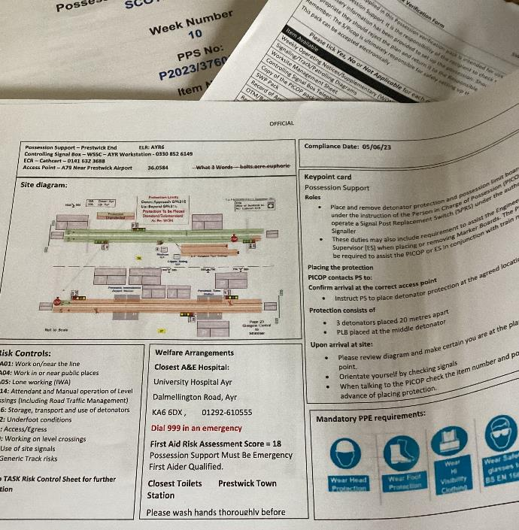 | - Work on or near the track : main-line and non-mainline  - Electrical isolations and switching high and low voltage  - Temporary works: excavations, work at heights, at depths and over water, lifting operations, scaffolds, falsework  - Work in confined spaces  - Work in or affecting mines  - Ionising and non-ionising radiation  - Asbestos  - Dusts and fumes, ballast, silica, welding  - Noise and vibration  - Work on vehicles, plant, equipment and machinery  - Permits to work, including hot work  - Construction work, buried services  - Work in depots  - Road vehicle driving  - Flying
For our highest risk works, such as those outlined above, our standards and processes contain methods to create a safe system of work for the activities required. We have assurance processes to assess that risk controls are operating as designed, for example checking a sample of packs, and processes to manage changes in plans or circumstances to control risks when things change. Not all these activities are directly railway operations. We work in escalator machine rooms and in confined spaces, and even fly drones. Temporary works are a key part of our activities, and we use resources such as the Temporary Works Forum and HSE Guidance on Temporary Works when planning these.

While each risk assessment and method statement for each activity cannot be referenced here, key to getting Everyone home safe every day are:-

- Lifesaving Rules - Safety Central
- NR/L2/OHS/00112 Work Safe Procedure
- NR/L2/OHS/019 Safety of people at work on or near the line and Rail Hub
- NR/PRC/MPI/CP0037 Use of Work Activity Risk Assessment in a Safe System of Work (P&E)
- Rail Industry Guidance Note GOGN3616 Guidance on Operational Railway Safety Awareness
- Safety Central and Regional Hubs
- The Rule Book
- Sentinel
- NR/L3/ELP/29987 25 kV A.C. Electrified Lines ,NR/L3/ELP/3091 DC Electrified Lines and local standards, e.g. Mersey Rail electrics and Selhurst depot for Brighton ECR
- NR/L2/INI/CP1030 Working safely in the vicinity of buried services

Planning and implementation

22. Asset management
The way in which we manage our assets is fundamental to all of our operations. Our customers, workforce and organisations operating in the vicinity of the railway rely on us to manage the infrastructure, our own vehicles and vehicle and infrastructure interfaces for safety and performance. We need to get everyone home safe every day. Railway systems are numerous, complex and all have their own idiosyncrasies. Interfaces can be technical, operational, spatial, and a singular ‘silo’ approach can result in cross-functional hazards and risk of harm to individuals and is not conducive to the management of the railway as a system. Therefore, while the health and safety management system approach to asset management is detailed on a discipline-by-discipline basis, we recognise the need for cross-asset integration and management for safety and performance objectives to be achieved. Our asset management for safety, (AM4S), objectives are to manage risk and improve. There are two core themes:-

Occupational Health and Safety | System Safety
To ensure that the safety, health, and wellbeing of our workforce is not compromised | To ensure risk management through hazard identification, analysis, elimination, and control, throughout the life cycle of our assets.

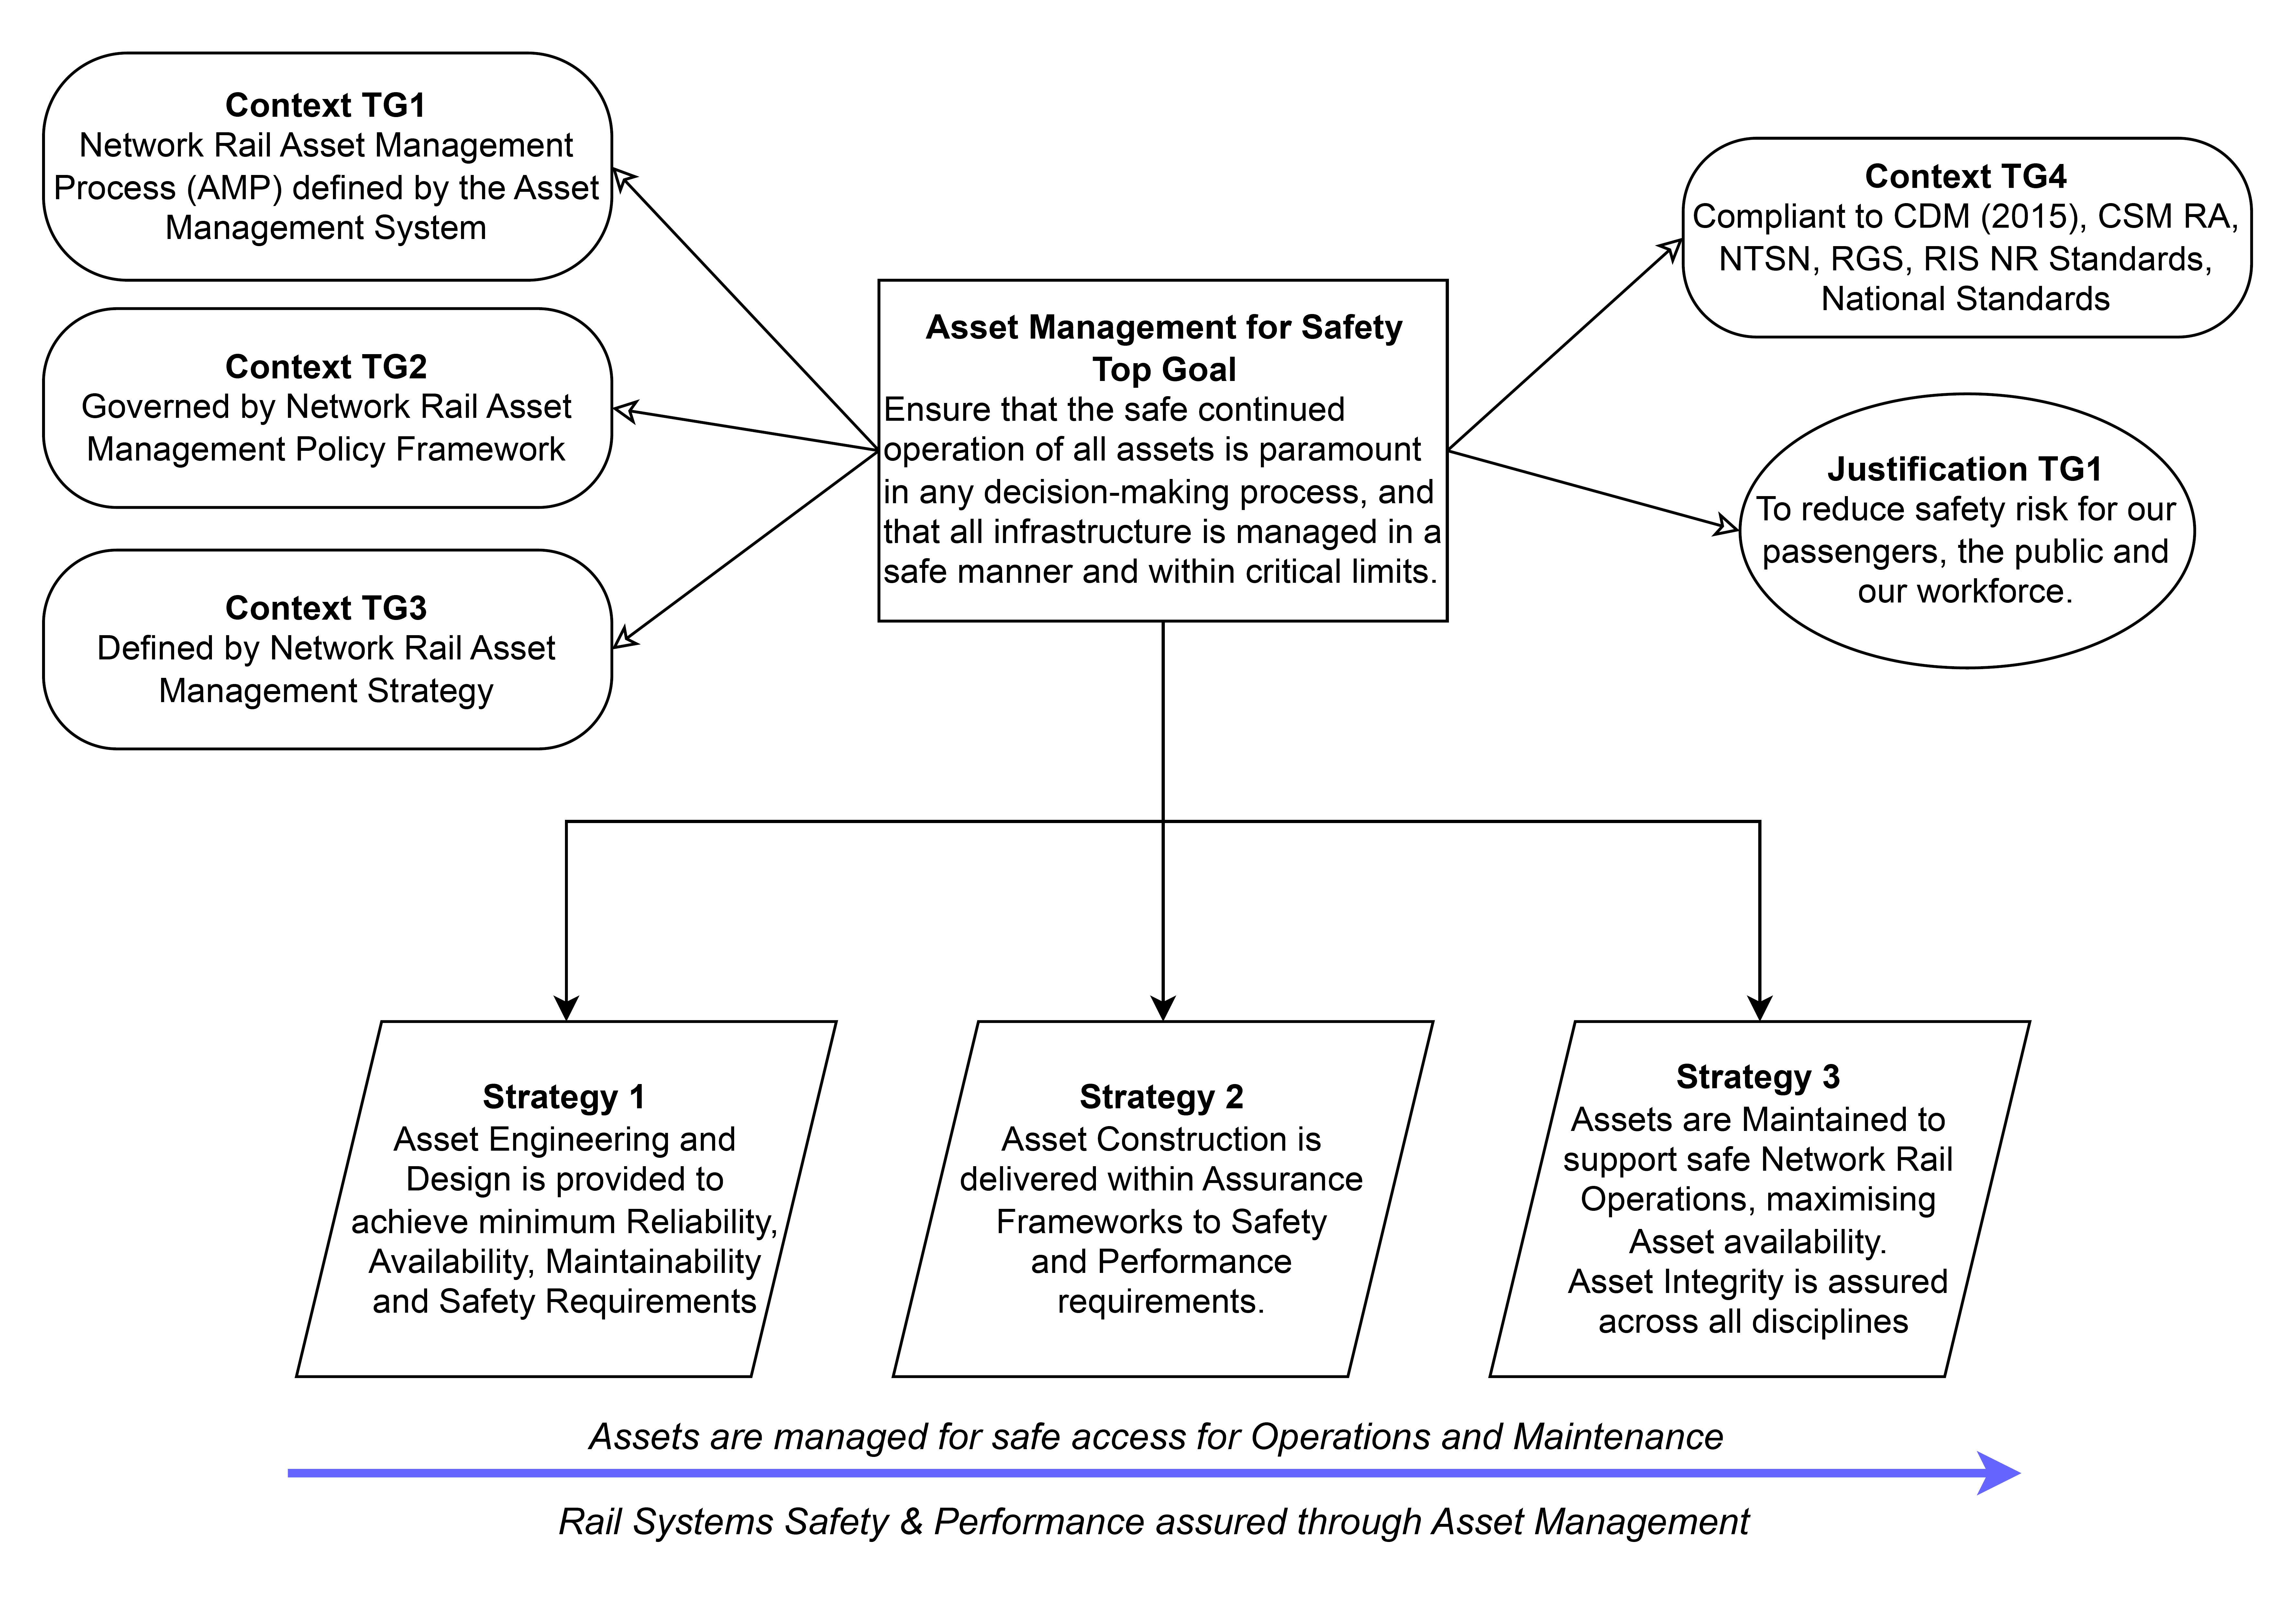
Goal structured notation diagram of our key goals and strategies for asset management.
Our Asset management policy defines the key principles and requirements applied to Network Rail assets to ensure they are managed in a way that contributes to a better railway by delivering the outputs expected safely, sustainably, and efficiently, and supports the roll out of more accreditation to BS EN 55001 Asset Management. The GRAI framework provides a Core Process, Asset Strategy & Plan, under the auspices of the Group Director, Technical Authority. This provides detail on region-specific content, to confirm:
- Ownership of processes within the Asset Strategy & Plan,
- Responsibility and/or accountability for the execution of work in line with these processes
- Input to activities or
- Receipt of outputs from the processes
Responsibility for the policies and strategies for asset management, track, signalling, level crossings and telecoms have been assigned to the respective Network Technical Heads for each discipline.
While the railway is a system and should be treated as such, discipline-specific standards provide the means and methods to ensure AM4S is achieved. Key risks exist at discipline interfaces which should be monitored, managed, and assured. The lifecycle management of assets – design, construct, maintain, decommission – is governed by standards, national, international, rail industry or our own, which include:-

- Asset management policy
- NR/L1/HSS/00126 Prevention through Engineering and Design Policy (PtED)
- NR/L2/INI/CP0075 Entry into Operational Service
- NR/L2/OHS/0047 Managing Health and Safety in Construction (Application of the Construction, Design and Management Regulations to Network Rail)
- NR/L3/SCO/311/01 Entity in Charge of Maintenance
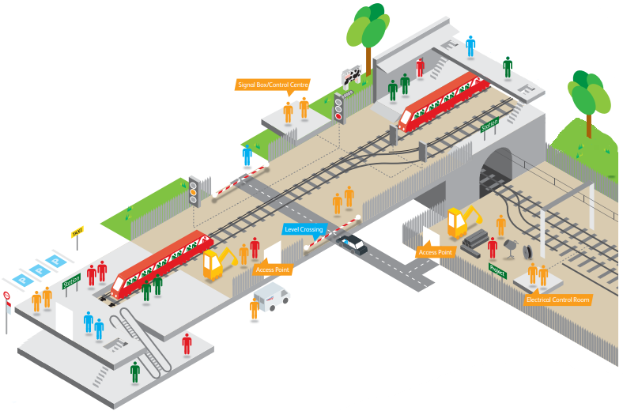
Tunnels

Electrification and Power Supplies
Click on subject to see more
Earthworks

Telecoms
Buildings and Civils

Drainage
Lineside
Track

Projects

Maintenance

On and off track plant and vehicles
Level Crossings
Signalling
It is not realistic to provide references to all technical standards with a potential impact on safety; so we train our engineers to a high level of competency. Our engineers assure themselves of reference sources and their own personal professional competency for the tasks to be carried out. Where doubt exists, or if there is a knowledge gap, they seek advice, and investigate the scope of the standards. These additional pages may help. Links to each engineering discipline can be viewed by clicking on the diagram.

Planning and implementation

23. Change management
23.1 We manage change in a complex environment, so we have mapped our goals to requirements.
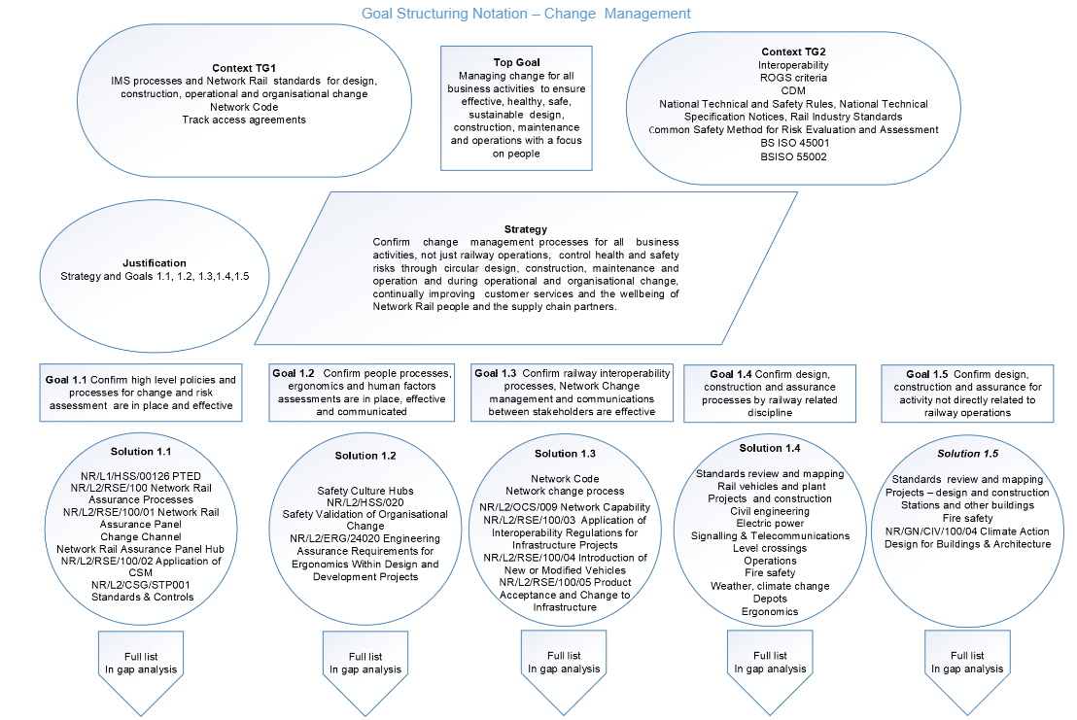

23.2 How we meet our change management goals
We manage change across the business to meet our sustainability goals and regulatory and contractual obligations. We and our contractors must meet our respective duties as client, principal contractor and designer under the Construction, Design & Management Regulations. We need to comply with the Railways & Other Guided Transport Systems Regulations, Railways (Interoperability) Regulations and EU Exit Guidance, including the Common Safety Method on Risk Evaluation and Assessment Regulation. Some major changes require applications for changes to our safety certificate and authorisation, and, or, safety approvals such as Transport & Works Act 1992 Orders. RSSB Management of Change explains the legal framework we work within. Track, station and depot access contracts contain the Network Code and processes for Vehicle, Network , Station and Depot Change .Our changes processes cover:-
- Change management policies and principles
- Cultural and organisational change
- Changes to standards
- Engineering change: projects, stations, commercial property, depots, rail vehicles, civils, electric power, signalling, telecommunications, ergonomics and human factors and system integration
- Operational changes and changes affecting operations: timetable, signalling, safety of the line changes, level crossings, SPAD risk reduction, depots, stations
- Network, station and depot change
- Externally driven change, socio-economic and political, climate change
Our challenge is to realise opportunities and mitigate the risks to deliver effective, healthy, safe, sustainable circular design, organisational, operational and technical change, and adapt to external change. There are tools and internal and external guidance to enable us to do so, notably our ￼and Weather Resilience and Climate Change Adaptation Strategy.and Weather Resilience and Climate Change Adaptation Strategy. Climate Change is recognised as an increasing and substantial threat to our infrastructure and ability to safely run a resilient timetable and we are focusing substantial efforts on evaluating and mitigating these threats.

We also recognise that not all change is planned for in advance, and that changes in external circumstances can mean that it is not possible to carry out work in the planned manner. In situations like these we have a campaign called Take 5 for safety to encourage our colleagues to take the time to think about a safe way forward. We also have a standard on operational decision making to consider how to allow safe movement of trains during an emergency, which can help deal with exceptional circumstances on the operational railway.

Figure 15 Circular design
23.3 Some circular design highlights
Recognising that all change affects people, and most change affects our environment, we use GEGN8613 Application of Human Factors Within Safety Management Systems and RSSB Changing Safety Culture.

We also use RSSB Sustainability resources and BS EN ISO14901: 2O21 Adaption to climate change – guidelines on vulnerability, impacts and risk assessments. Our standards include NR/GN/CIV/100/04 Climate Action Design for Buildings & Architecture and NR/L2/ENV/015 Environment and Social Minimum Requirements – Design and Construction.

In common with other engineering disciplines our buildings and civils colleagues are working hard to ensure designs are safe and healthy before we get to site, and making sure that the overlap between design, construction and project completion is managed so that risks are eliminated or controlled through early consideration at the design stage, in line with ORR strategy, Health and Safety by Design, and our own NR/L1/HSS/00126 Prevention through Engineering and Design Policy. We have a network of health and safety by design groups where we work collaboratively with our designers, construction contractors and engineering consultants nationally and regionally. Their purpose is to embed health and safety into construction and infrastructure operation through improvements at the design stage. Key activities are continued development of guidance tools, lessons learnt and good practice, concentrating on design and execution of permanent and temporary works. This is illustrated by standards such as our Health & Safety by Design Working Groups. For stations, we have NR/GN/CIV/100 Strategic Design Manual. Our requirements for suppliers are set out in Network Rail's Buildings and Architecture Design Guidance. During construction, we use NR/L3/CIV/0063 Piling, Drilling, Crane, MEWP and SMPT operations adjacent to the Railway. For assurance we use NR/GN/CIV/003 Guidance on Engineering and Architectural Assurance of Building and Civil Engineering Works

For work in or affecting mines, we have NR/L2/CIV/191/05 Managing the risk from mining in design and construction, and for bridges NR/L3/CIV/020 Design of Bridges. NR/L2/CIV/005 Drainage Systems Manual covers their life cycle. We sometimes forget the importance of drains. Electric power has NR/L2/ELP/27401 Configuration management and change to protection and control systems. Telecommunications has NR/L2/TEL/30022 Engineering Assurance Arrangements for Communications Engineering Schemes and Services, and signalling has NR/L2/SIG/11201 Signalling Design Handbook. Depots have NR/L2/RVE/0133 Design and Installation of Underfloor Wheel Lathes , NR/L2/RVE/0132 Design and Installation of Cranes and NR/L2/RMVP/27035 Depot Protection Systems .

23.4 Change hubs
We have several change management hubs linking to standards and best practice. Our approach is described in The Way We Improve and Manage Change, and the Network Rail Assurance Panel Hub covers railway changes. National and regional hubs also include the Scotland Portfolio Change Request Site, Anglia Change Team, and Route Services Vision for Change - IT Services.

23.5 Railway engineering and operational change
RSSB, rail industry standards and BS EN ISO requirements for engineering change include:-

- RIS 8270 RST Route Level Assessment of Technical Compatibility between Vehicles and Infrastructure
- RIS 2700 RST Rail Industry Standard for Verification of Conformity of Engineering Change to Rail Vehicles
- BS EN ISO/IEC 17020: 2012 Conformity assessment requirements for the operation of various types of bodies performing inspection
- RSSB Technical Note 104 Engineering Change - Software and Firmware
- RSSB Guidance on the Principles of the Safe Management of Engineering Change
- RSSB Potential Changes to the European Train Control System Onboard Subsystem Requirements
We have our own complementary standards and processes for managing technical and operational changes to our infrastructure, how it is operated, introduction of new or changed products or vehicles or methods of operation, and changes which could affect vehicle and infrastructure compatibility. Their application is overseen by our Network Rail Assurance Panel and assurance processes. We also have System Review Panels. For more information, visit the Network Rail Assurance Panel Hub. There are design, construction and change assurance standards for each engineering discipline: traction and rolling stock, civil engineering, signalling and telecommunications, level crossings and electric power.
The key overarching change standards are:-
- NR/L2/RSE/100 Network Rail Assurance Panel Processes
- NR/L2/ASR/036 Assurance Framework
- NR/L2/RSE/100/01 Network Rail Assurance Panel
- NR/L2/RSE/100/03 The application of the Railways (Interoperability) Regulations for Network Rail
- NR/L2/RSE/100/04 Introduction of new or modified vehicles
- NR/GN/RMVP/27702 Plant product Acceptance Process
- NR/L2/RSE/100/05 Product acceptance and change to Network Rail operational infrastructure
- NR/L2/RSE/100/07 System Review Panels
- NR/L1/HSS/00126 Prevention through Engineering and Design Policy
- NR/L2/MTC/089 Arrangements for the exchange of asset data and the continuing maintenance of assets undergoing change
- NR/L2/INI/CP0075 Entry into Operational Service

Discipline specific standards for engineering change and assurance are:-

- NR/L2/RSE/30041 Electromagnetic Compatibility (EMC) Assurance Process
- NR/L2/SIG/30035 Signalling and Level Crossing Scheme Approval Process
- NR/L2/CIV/003 Engineering and Architectural Assurance of Building and Civil Engineering Works
- NR/L2/TRK/2500 Engineering Assurance Arrangements for the Design and Construction of Track
- NR/L2/ELP/27311 Engineering Assurance Requirements for Design and Implementation of Electrical Power
- NR/L2/TEL/30022 Engineering Assurance Arrangements for Communications Engineering Schemes and Services
- NR/L2/ERG/24020 Engineering assurance requirements for Ergonomics within design and development projects (msappproxy.net)
Engineering changes affect railway operations, for example changes to line speeds, addressed by NR/L2/SIG/30021 Alterations to Authorised Line Speeds. Not all railway change is engineering driven. Rule Book change has a positive impact and the process for contributing to this is described in NR/L2/OPS/034 Management of Rule Book Change .Timetable change has positive and negative impacts, and the processes for evaluating these are specified in NR/L2/OPS/031 Assessing and assuring the impact of operational risks relating to changes to the train plan. British weather constantly throws up challenges for the railway to deal with, and climate change is increasingly exacerbating these challenges and introducing new ones for us to deal with. We and our operating and maintenance colleagues are expert in dealing with the disruption this can cause. There is a standard for this: NR/L2/OPS/021 Weather – Managing the Operational Risks. We are adapting to the challenges of climate change by reviewing and updating this standard and changing our specifications for asset renewals in light of climate forecasts to build in resilience to extreme weather. There is another covering changes to accommodate emergency timetables and dealing with failed trains, NR/L2/OCS/042 Railway Operational Code Implementation, Variation and Review Process. There is a suite of standards for managing and communicating safety of the line information such as emergency speed restrictions.
Changes to our railway have to be communicated and agreed in accordance with the station, depot and network change protocols and the Network Code. NR/L2/OCS/009 Network Capability Management Procedure and NR/L2/OCS/098 Management of Short-term Network Change specify how we will do this. Information for train operators and others on changes is regulated by standards such as NR/L2/OCS/070 Major Infrastructure Changes – The Provision of Staff Briefing Material to Train Operators .
23.6 Using the Common Safety Method
RSSB and ORR resources, rail industry and internal standards covering the use of the Common Safety Method on Risk Evaluation and Assessment Regulation, a mandatory, legal regulation for significant organisational, operational or technical change affecting railway safety, are:-

- Common Safety Method for Risk Evaluation and Assessment Guidance (ORR)
- Design Targets for the Common Safety Method for risk evaluation and assessment
- GEGN8646 Guidance on the Common Safety Method for Risk Evaluation and Assessment
- NR/L2/RSE/100/02 Application of the Common Safety Method for Risk Evaluation and Assessment
- NR/L2/HSS/020 Safety Validation of Organisational Change

When a change is deemed as significant, we appoint an independent assessment body to assess our compliance with the Common Safety Method and our risk management process. One option is using our independent subsidiary, Network Certification Body , one of several assessment bodies which provide independent assessment, assurance and certification services for infrastructure and vehicles on Britain’s railways.
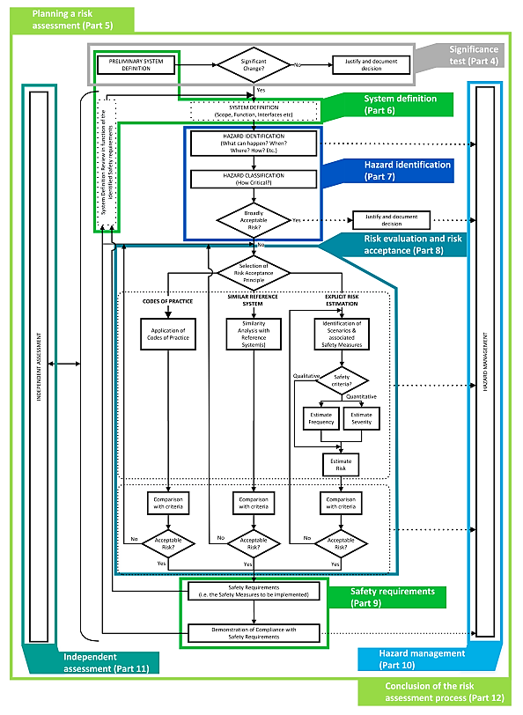
Figure 16 Common safety method process (RSSB 2017)

Planning and implementation

24. Management of procurement and the supply chain
Our procurement is based on sourcing competent suppliers and managing the supplier pipeline, assurance, governance, and a suite of Network Rail contracts. Our supply chain risk assessment assurance is part of this process. Our supply chain partners provide a variety of engineering, operational and support products and services on and off the railway. Some are train and on-track plant operators in their own right. We make strategic alliances, with some, such as Southern Renewals Enterprise and Scotland’s Strategic Alliance. Our suppliers also have legal duties under health and safety legislation and play a crucial role in managing health and safety risks. We work together to continually improve our and their health and safety performance, and the service to our customers, communities and passengers. We work with them to discharge our respective duties under the when these apply. Our Commercial & Procurement Hub contains the detail of procurement and supply chain management.Construction, Design & Management Regulations when these apply. Our Commercial & Procurement Hub contains the detail of procurement and supply chain management. To drive continuous improvement, we have safety cooperation meetings with our supply chain, through forums such as the Infrastructure Safety Leadership Group.
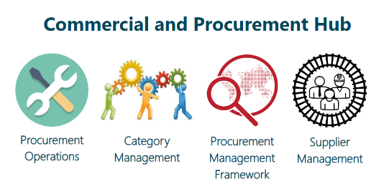
Figure 17 Commercial and Procurement Hub
Its content is supported by the capital investment and delivery, maintenance, project management and commercial and procurement integrated management system processes, and standards for construction, design and management, contracts and procurement, route services and supply chain operations. Our suppliers are required to follow industry standards and our own. As well as technical standards, we use NR/L3/OPS/045/5.04 Management of Station Works and a series of standards for managing CDM. These include :-
- NR/L2/OHS/0047 Managing Health and Safety in Construction (Application of the Construction (Design and Management) Regulations to Network Rail)
- NR/L2/INI/CP0070 Principal Contractor Licensing Scheme Standard - Technical Briefing
- NR/L2/OHS/CP0070 Principal Contractor Licensing Assurance
Pivotal to supply chain management are the Railway Industry Supplier Qualification Scheme, (RISQS) and other supplier accreditation schemes, such as Achilles. Most suppliers are required to sign up to these schemes and maintain ISO 9001, ISO 14001 and ISO 45001 certification. RISQS and other supplier accreditation company audits and management system certification audits check on risk assessments for products, services and workers. Those working on the railway have to maintain their competence and medical fitness to retain their Sentinel passports. Our supply chain partners use Rail Hub for safe track work planning and risk assessment, Safety Central for health, safety and environmental information and other systems.
Planning and implementation

25. Emergency planning
We plan for the worst and expect the best. As well as catastrophic events like derailments, collisions, major fires and terrorism, we prepare for: -

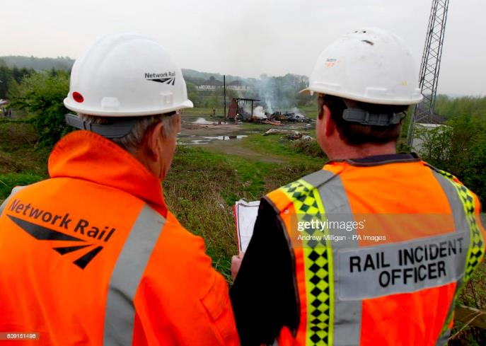 | - Business disruption  - Congestion  - IT and communications systems resilience, contingencies and recovery: passenger information, timetabling, ticket gates  - Cyber-attack: safety or business critical systems  - Traction and domestic power supplies loss  - Dangerous goods incident  - Gas escape  - Explosion  - Structural failure  - Pandemics  - Catastrophic environmental events  - Flooding  - Environmental incidents  - Network infrastructure and S&T failures  - An air, road or maritime accident affecting the railway

ORR assessment criteria for safety certification and authorisation and our own emergency planning processes require us to identify all foreseeable emergencies and disruptions, including degraded operations, document these, keep the list under review and our plans for dealing with them. We must clearly set out roles and responsibilities. When dealing with an event and recovery from it, we must quickly contact and provide information to emergency responders, communicate effectively, including with those who may not speak English as a first language, for example international freight customers, work with other operators and interfacing organisations, including entities in charge of maintenance and vehicle keepers. We must allocate competent people with excellent communication skills and resources to the incident response and the task of getting back to normal.

Our key crisis and business continuity plans are NR/L2/OPS/250 Network Rail National Emergency Plan, Network Rail Security Management System ,and the Business Continuity GRAI Framework Manual .Our System Operator function owns the processes and is responsible for national co-ordination of emergency planning, while our regions have their own plans. These are developed and tested in liaison with industry partners, and for emergency planning, Category One, and Category Two responders under the Civil Contingencies Act. Category One responders are the emergency services, local authorities and NHS. Category Two are transport operators and the utilities. For more information visit: Gov.UK Guidance on preparations and planning for emergencies - responsibilities of responder agencies and others.

Our rail incident response and management plans are aligned with RIS-3118-TOM-Incident Response Planning & Management and Rail Delivery Group guidance, including Joint Industry Provision of Humanitarian Response Following a Major Passenger Rail Incident, its checklist for major incident response, and Train Operator Liaison Officers. We run desktop and simulated exercises to test our emergency and response plans and use the outputs of these to improve our emergency plan at national or route level.

Some of the standards we use to manage and recover from crises, and keep those responding and our people, customers and passengers as safe and well as possible in the circumstances are:-

- NR/L3/OPS/045/4.06 Station Overcrowding and Special Events
- NR/L3/OPS/045/4.10 Emergency Services Personnel on or Near the Line
- NR/L3/OPS/045/4.04 Incident Management - Initial Advice and Guidance
- NR/L3/OPS/251 Unmanned Aircraft System Operations and NR/L3/OPS/045/4.13 Air Traffic Incidents
- NR/L2/OHS/052 Traumatic Incident Management
- NR/L3/OPS/045/2.10 Incident Management Competence Framework
- NR/L3/OPS/045/2.24 Mobile Operations Manager and Incident Officer Training and Competence
- NR/L3/OPS/045/2.10 Incident Management Competence Framework
- NR/L2/CTM/229 Competence and Training for Emergency Evacuation Wardens and Fire Safety
- NR/L3/OPS/045/3.06 Dynamic Risk Assessment Process
- NR/L2/OHS/00110 First Aid at Work

In unprecedented situations we can move quickly to change our standards and controls in response to events. As an example, when COVID 19 hit, we released a new standard, NR/L3/MTC/CP009 COVID-19 Contingency Plan: Safe Working Practices, within a week of the announcement of lockdown. This was regularly updated during the pandemic, as scientific understanding and government
guidance matured.

Monitoring, audit and review

26. Proactive monitoring and continuous improvement
Our commitments to proactive monitoring and continuous improvement are demonstrated by our Improving the Business Policy, use of safety, health and environmental indicators reports and safety data. We measure, monitor and review the effectiveness of risk controls through assurance. Our business assurance committee structure, described in our Operating Model Governance Framework, provides the framework for the assurance and improvement elements of the GRAI process. Our assurance panel processes are also key elements in proactively monitoring, checking and improving our performance through and throughout change. We evaluate the effectiveness of our health and safety leadership, and proactively review our standards. We use feedback from Your Voice and believe that where trust is higher, so are health and safety standards. We learn lessons using the Learning from Lessons Library and sites for each discipline, for example Buildings & Civils DRG - Doc Library and its section on Lessons Learnt
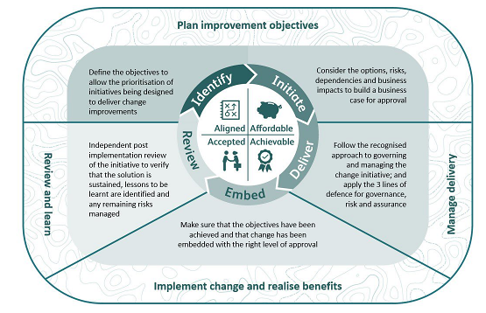
Figure 18 Improving the business policy cycle
GRAI and our Improving the Business Policy reflect the ISO Management Systems’ circle of planning, support and operation, performance evaluation, improvement, then planning over again.

Monitoring, audit and review

27. Assurance
Our processes for assurance, including internal and external audit, are contained in the Network Rail Assurance Manual and our safety and compliance assurance standards. As described in the manual, we have adopted Institute of Internal Audit, industry and government best practice guidance. Our assurance model operates on a three levels of defence principle as illustrated below.

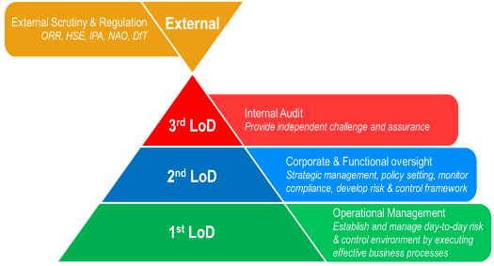
Figure 19 Assurance model

First line

First line of defence is operational management oversight to ensure processes are well controlled to manage risks. It’s delivered through all business areas to provide confidence to managers that processes, and controls are all working correctly at the point of delivery.
First line at Network Rail is represented by the frontline Teams. It’s delivered by those directly involved with or managing the process that know the process, tasks, requirements and challenges face by the business. First line audits are completed in assurance systems, with actions tracked to completion and trends monitored at route and regional level.

Second Line

Second line of defence is corporate and functional oversight through setting policy, supporting the design of effective controls, assurance of processes and controls in operation, and driving improvement.
The second line support management by bringing expertise, process excellence, and monitoring alongside the first line to help ensure that risks are effectively managed.

At Network Rail, the second line is operated at the regional and the corporate level. Second Line assurance activities are typically undertaken by managers not directly involved with the process to assure that documented procedures meet the requirements of legislation, standards, stakeholders, including regulatory and legal obligations in line with our operating license. Process owners are involved in setting assurance requirements, and these are detailed in the Integrated Management System process definitions.
To appropriately deliver assurance activities CPOs, regions and functions are required to provide competent resource to manage and operate assurance activities.

As part of our assurance system, every year we have national RM³ assessments, with participation from our business units, which complement their own RM³ assessments. These assessments adopt a rigorous and honest approach to identifying how performance can attain consistently predictable ratings. We believe that moving our overarching management system to an RM³ format and aligning investigation actions and audit findings to RM³ will drive continuous improvements in health and safety management. We also review our overarching health and safety management system internally on a regular and frequent basis to make sure it is effective, with independent reviews as necessary.

Third Line

Internal Audit form the organisation’s third line. Through a risk-based approach, Internal Audit provide an objective evaluation of how effectively Network Rail assesses and manages its risks, including design and operation of the first and second lines. Internal Audit also provide assurance over the management of cross-organisational risks and support the sharing of good practice within the organisation.

As part of the Annual Audit Plan, Internal Audit reviews topical areas relating to Health and Safety, and also include Health and Safety within the scope of work over operational critical areas under audit. Findings and action plans are published in audit reports and discussed with the Executive Leadership Team and Audit & Risk Committee.

Action plans and timelines addressing the issues noted in audits are agreed with the auditees including steps required for closing out each action. The status is tracked and reported to the Audit & Risk Committee on a quarterly basis. Overdue actions receive detailed attention from the Audit & Risk Committee.

External Assurance

External legislative and regulatory bodies undertake their own assurance to provide confidence that Network Rail are meeting requirements and expectations.

These bodies include
- external auditors, chiefly the National Audit Office (NAO) who have a statutory responsibility for certifying the financial statements and value for money studies undertaken by the NAO, which Parliament use to hold government to account for how it spends public money.
- Office of Rail & Road (ORR) ensures Network Rail is delivering on the requirements and expectations of its charter, and that of a public sector body.

As well as this, we have internal and certification audits to maintain our ISO 9001 Quality Systems, ISO 14001 Environmental Management Systems, ISO 45001 OH&S systems and ISO 55001 Asset Management accreditations, where these have been adopted.

Assurance provides confidence that Network Rail’s policies, processes, controls and plans are effective, enabling stated organisational objectives to be met and that we are ‘doing the right thing in the right way’ to meet our operational licence.
Results from assurance activities, such as inspections, audits and review meetings provide insight that processes are operating as intended and, where necessary, help identify process improvements. The collective outputs of assurance activities give the business, our stakeholders and the Board confidence that we are on track to fulfil our stated objectives.
Assurance provides confidence between the devolved business regions and corporate functions in the achievement of strategic objectives and our legal and regulatory requirements.

Assurance is a key part of the Way we Manage Our Business Framework. Each process in our Integrated Management System identifies the 1st, 2nd and 3rd line of defence assurance activities required for each step in the process. These then inform the production of assurance frameworks and assurance plans. Network BACs will review the outputs from second line of defence assurance activities to inform risk management, identify process improvements and to inform reporting and assurance planning.

Monitoring, audit and review

28. Incident investigation
We work with our industry partners and regulators to capture information on incidents, starting with initial preservation of evidence, and learn lessons from them. Our standards and processes for incident reporting, investigation, identification of underlying causes and learning from recent and historic events are contained in:-
- NR/L3/INV/3001 Reporting and Investigation Manual
- NR/L2/OHS/032 Training, competence and assessment in accident and incident investigation
- NR/L2/OPS/035 Dissemination of Urgent Operating Advice
- NR/L3/TRK/7002 Reporting of Permanent Way Failures and Incidents
- NR/L3/CIV/028 Reporting of Structures and Operational Property Safety Related Events
- NR/L3/CIV/185 Reporting and Investigation of Geotechnical Incidents
- NR/L3/SIG/SG0166 Management of operational signalling equipment involved in wrong side failures and incidents.
- RT/E/S/10047 Management of Safety Related Reports for Signalling and Operational Telecoms

We promptly report incidents to the Rail Accident Investigation Branch ,ORR, HSE, Scottish Environmental Protection Agency, Cyfoeth Naturiol Cymru/Natural Resources Wales, or the Environment Agency as necessary. Our National Operating Centre is responsible for immediate notification and our safety reporting teams for subsequent reporting. We use the Safety Management Intelligence System (SMIS) to record the events which inform the rail industry’s risk model and our own incident reporting and investigation systems, which currently include IRIS. NR/L3/INV/3001/901 Management of Recommendations and Local Actions explains the roles of national and regional recommendations review panels and the mechanisms for agreeing and implementing recommendations effectively. Our assurance processes help us analyse and learn lessons from repeated incidents or events with the potential to cause harm as well as less frequent incidents. Overdue investigation recommendations are tracked in the National Safety, Health and Environment Performance Reports each period.

Our investigations are conducted to allow us to understand the human and technical factors that contribute to the incident. Our Fair Culture Investigations principles provide a mechanism to understand the types of human error in the context of the organisation and the circumstances of the incident. They encourage employees to participate in investigations openly and honestly and allow us to make sure that the consequences of any errors are dealt with in a fair and proportionate manner. All investigators are trained in these principles so that response to an incident is fair and reasonable.

We work closely with investigators, including RAIB, and regulators to support their investigations. We engage with British Transport Police, and other Police Services, the Crown Prosecution Service and Procurator Fiscal.
Our Investigation & Assurance Hub and Lessons Learned site are used to hold useful resources such as completed formal investigations and past safety alerts, bulletins and shared learnings. We send out email alerts, bulletins and shared learning to line managers after an incident of once an investigation has completed in order to quickly cascade safety information. These are often included in local safety communications and briefs.

We have a Close Call Reporting system and use Safety Central for health, safety and environmental alerts, bulletins and shared learning. We also send out email alerts, bulletins and shared learning to line managers for cascade briefing, and these are often included in local safety communications. When things just don’t seem right, we have the Work Safe Procedure, Speak Out and CIRAS - Confidential Reporting for Safety.

Monitoring, audit and review

29. Management review
The effectiveness of our Health & Safety Management system is monitored at business unit, region/function and national level. All areas of the business complete and RM³ assessment every year, including reviewing the evidence for each part of the assessment. These are then rolled up into a national assessment. Actions from these assessments are tracked locally to drive continuous improvement, and the Chief Health & Safety Officer’s team considers whether any findings from the national RM³ assessment should lead to a review of the relevant section of the HSMS.
Additionally, our business assurance committee structure and safety and compliance assurance standards bring together data on safety performance and assurance findings, as well as tracking improvement actions. There are reviews of business units by the executive leadership team and national strategy committees, one of which covers health and safety.
Finally, our board regularly reviews company Health & Safety strategy and policy, for example at board strategy days, or through the SHE Committee. The board also reviews the Health and Safety Management System document and Safety Policy and Vision on an annual basis. This provides independent scrutiny of company strategy and policy and drives continuous improvement.

30. Implementing improvements
Our Improving the Business Policy and Network Rail Assurance Manual describe how we implement improvements. Taking corrective action is covered by the business assurance committee structure and safety and compliance standards for incident investigation and assurance. All audit and assurance activity actions are recorded and tracked in digital systems, not in paper or electronic files, as are most investigation actions, and all investigation recommendations. Our assurance processes cover implementation of internal audit, safety assurance and incident investigation recommendations, responding to enforcement action and the findings of the ORR’s inspection plans. They cover corrective actions taken as a result of independent audit recommendations, certification audits and enforcement action taken by the regulators: ORR, HSE, SEPA, Cyfoeth Naturiol Cymru or the Environment Agency.

31. How we meet ROGS, and BS ISO 45001 requirements
The requirements of the ORR’s Assessment criteria for main-line railway safety certificate and safety authorisation applications, ORR Guidance for Entities in Charge of Maintenance in Great Britain and BS ISO 45001: 2018 are met as described in the linked table, click here:- How we meet ROGS and ISO 45001 criteria.docx

