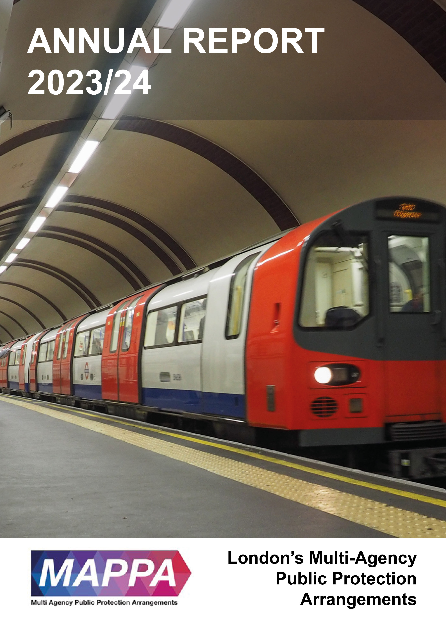
Area name here

Introduction

This annual report reflects the work undertaken by MAPAA (Multi Agency Public Protection Arrangements) during the period 1st April 2023 to 31st March 2024

Public Protection remains our highest priority. We recognise that the crimes for which violent and sex offenders are responsible impact enormously on the lives of victims, their families and communities. This report provides statistical information about the number of offenders managed under the arrangements and how the three Responsible Authorities of Probation, Prison and Police and the Duty to Co-operate Agencies have worked together to keep communities safe.

Whilst it is never possible to eliminate risk, what can be expected is that all reasonable steps have been taken to reduce the risk of serious harm to the public from known offenders. Early identification of dangerous offenders, joint assessment and risk management plans underpinned by intelligence sharing, enables the risk of serious harm occurring to be reduced and known victims to be protected.

The SMB has welcomed the opportunity to complete the MAPPA SMB Self-Assessment Tool enabling partners to reflect on what is working well and on strategic areas that can be improved. The Board is committed to continuous improvement and the development of practice and local processes, ensuring all opportunities to review the work of MAPPA are taken. The SMB will continue to work together to ensure key priorities for London are developed.

On behalf of the SMB, I would like to take this opportunity to thank staff across London involved in the provision of MAPPA arrangements for their continued hard work managing complex and challenging individuals to ensure our communities remain safe.

I am thankful to all colleagues from Responsible Authorities for their involvement, along with the contribution of those from our Duty to Cooperate Agencies. I also extend my thanks to our Lay Advisor, our MAPPA Coordinator and Deputy MAPPA Coordinator, without whom the work of the SMB would not be effective.

Pamela Spring
Chair of London MAPPA SMB and Head of Public Protection, The Probation Service – London Region

What is MAPPA?

MAPPA background
MAPPA (Multi-Agency Public Protection Arrangements) are a set of arrangements to manage the risk posed by individuals who have committed the most serious sexual, violent and terrorist offences (MAPPA-eligible individuals) under the provisions of sections 325 to 327B of the Criminal Justice Act 2003.
They bring together the Police, Probation and Prison Services in each of the 42 Areas in England and Wales into what is known as the MAPPA Responsible Authority.
A number of other agencies are under a Duty to Co-operate (DTC) with the Responsible Authority. These include Social Services, Health Services, Youth Offending Teams, Department for Work and Pensions and Local Housing and Education Authorities.
Local Strategic Management Boards (SMB) comprising senior representatives from each of the Responsible Authority and DTC agencies are responsible for delivering MAPPA within their respective areas. The Responsible Authority is also required to appoint two Lay Advisers to sit on each MAPPA SMB.
Lay Advisers are members of the public appointed by the Minister with no links to the business of managing MAPPA-eligible individuals act as independent, yet informed, observers; able to pose questions which the professionals closely involved in the work might not think of asking. They also bring to the SMB their understanding and perspective of the local community (where they must reside and have strong links).

How MAPPA works
MAPPA-eligible individuals are identified and information about them is shared between agencies to inform the risk assessments and risk management plans of those managing or supervising them.
That is as far as MAPPA extend in the majority of cases, but some cases require more senior oversight and structured multi-agency management. In such cases there will be regular MAPPA meetings attended by relevant agency practitioners.
There are 4 categories of MAPPA-eligible individual:
- Category 1 –subject to sex offender notification requirements;
- Category 2 – mainly those convicted of violent offences and sentenced to 12 months or more imprisonment or a hospital order;
- Category 3 – individuals who do not qualify under Categories 1, 2 or 4 but whose offences pose a risk of serious harm.
- Category 4 – terrorism convicted and terrorism risk individuals
Data on Category 4 individuals is not included in this report due to data protection issues related to low numbers. This data will be aggregated and published nationally.
There are three levels of management to ensure that resources are focused where they are most needed; generally those presenting the higher risks of serious harm.
- Level 1 is where the individual is managed by the lead agency with information exchange and multi-agency support as required but without formal MAPPA meetings;
- Level 2 is where formal MAPPA meetings are required to manage the individual.
- Level 3 is where risk management plans require the attendance and commitment of resources at a senior level at MAPPA meetings.
MAPPA are supported by ViSOR. This is a national IT system to assist in the management of individuals who pose a serious risk of harm to the public. The use of ViSOR increases the ability to share intelligence across organisations and enables the safe transfer of key information when high risk individuals move between areas, enhancing public protection measures. ViSOR allows staff from the Police, Probation and Prison Services to work on the same IT system, improving the quality and timeliness of risk assessments and interventions to prevent offending.
All MAPPA reports from England and Wales are published online at: www.gov.uk

MAPPA Statistics

MAPPA-eligible individuals on 31 March 2024
 | Category 1:  Subject to sex offender notification requirements | Category 2:  Violent  offenders | Category 3:  Other dangerous  offenders | Total
Level 1 | 7082 | 3855 | - | 10937
Level 2 | 25 | 67 | 47 | 139
Level 3 | 3 | 20 | 9 | 32
Total | 7110 | 3942 | 56 | 11108

MAPPA-eligible offenders in Levels 2 and 3 by category (yearly total)
 | Category 1:  Subject to sex offender notification requirements | Category 2:  Violent  offenders | Category 3:  Other dangerous  offenders | Total
Level 2 | 180 | 274 | 245 | 699
Level 3 | 15 | 40 | 32 | 87
Total | 195 | 314 | 277 | 786

Category 1 cautioned or convicted for breach of notification requirements | 122

Category 1 who have had their life time notification revoked on application | 43

Restrictive orders for Category 1 offenders
Sexual Harm Prevention Order (SHPO) | 487
SHPO with foreign travel restriction | 1
Notification Order | 20

Number of individuals who became subject to sex offender notification requirements following a breach(es) of a Sexual Risk Order (SRO) | 5

Level 2 and 3 individuals returned to custody
Returned to custody for breach of licence | Category 1:  Subject to notification requirements | Category 2:  Violent  offenders | Category 3:  Other dangerous  offenders | Total
Level 2 | 19 | 25 | 41 | 85
Level 3 | 5 | 3 | 9 | 17
Total | 24 | 28 | 50 | 102

Breach of SHPO
Level 2 | 0
Level 3 | 0
Total | 0

Total number of individuals subject to sex offender notification requirements per 100,000 population | 91

This figure has been calculated using the mid-2023 estimated resident population, published by the Office for National Statistics (ONS) on 15 July 2024, excluding those aged less than ten years of age.

Consistent with previous publications up to 2021/22, this figure is based on the midyear of the publication period. For 2022/23 publication, the population figure was based mid-2021 instead of mid-2022 due to a change in publication schedule by the ONS. As such, the current figure may not be directly comparable with last year’s figure.

Explanation commentary on statistical tables

MAPPA background
The totals of MAPPA-eligible individuals, broken down by category, reflect the picture on 31 March 2024 (i.e. they are a snapshot). The rest of the data covers the period 1 April 2023 to 31 March 2024.
(a) MAPPA-eligible individuals – there are individuals defined in law as eligible for MAPPA management because they have committed specified sexual, violent or terrorist offences or they currently pose a risk of serious harm. The majority are managed at Level 1 without formal MAPPA meetings. These figures only include those MAPPA eligible individuals living in the community. They do not include those in prison or detained under the Mental Health Act.
(b) Subject to Sex Offender Notification Requirements – those who are required to notify the police of their name, address and other personal details and to notify of any subsequent changes (this is known as the “notification requirement.”) These individuals are assessed and managed by the police. They may also be managed by probation or health services if they are subject to licence or a hospital order. Failure to comply with the notification requirement is a criminal offence that carries a maximum penalty of 5 years’ imprisonment.
(c) Violent Offenders – individuals convicted of violent offences who were sentenced to imprisonment or detention for 12 months or more, or detained under a hospital order and a small number of individuals convicted of sexual offences who are not subject to notification requirements. These individuals are assessed and managed by the Probation Service, Youth Offending Team or Mental Health Services.
(d) Other Dangerous Offenders – individuals who do not qualify under the other MAPPA-eligible categories, but have committed an offence that indicates that they pose a risk of serious harm which requires management via MAPPA meetings. These individuals are assessed and managed by whichever agency has the primary responsibility for them.
(e) Terrorism and Terrorism Risk Offenders – individuals subject to terrorism offender notification requirements; individuals convicted of terrorism or terrorism related offences who were sentenced to imprisonment or detention for 12 months or more, or detained under a hospital order; and those who have committed an offence and may be at risk of involvement in terrorism-related activity. These individuals are assessed and managed by Counter-Terrorism Police and the National Security Division of the Probation Service.
(f) Breach of Licence – individuals released into the community following a period of imprisonment will be subject to a licence with conditions (under probation supervision). If the individual does not comply with these conditions, the Probation Service will take breach action and the individual may be recalled to prison.
(g) Sexual Harm Prevention Order (SHPO) (including any additional foreign travel restriction). Sexual Harm Prevention Orders (SHPOs) and interim SHPOs replaced Sexual Offence Prevention Orders are intended to protect the public from individuals convicted of a sexual or violent offence who pose a risk of sexual harm to the public by placing restrictions and/or positive obligations on their behaviour. They require the individual to notify their details to the police (as set out in Part 2 of the 2003 Act) for the duration of the order.
The court must be satisfied on the balance of probability that an order is necessary to protect the public (or any particular members of the public) in the UK, or children or vulnerable adults (or any particular children or vulnerable adults) abroad, from sexual harm from the individual. In the case of an order made on a free standing application by a Chief Officer, the National Crime Agency (NCA), British Transport Police (BTP) or the Ministry of Defence Police (MODP), the chief officer/NCA/BTP/MODP must be able to show that the individual has acted in a way since their conviction that makes the order necessary.
The minimum duration for a full order is five years. The lower age limit is 10, which is the age of criminal responsibility, but where the defendant is under the age of 18 an application for an order should only be considered exceptionally.
(h) Notification Order – this requires individuals convicted of qualifying sexual offences overseas to register with the police, in order to protect the public in the UK from the risks that they pose. The police in England and Wales may issue a notification order directly to an offender who is already in the UK or who is intending to come to the UK who has to notify within three days of receipt. Individuals have a right of appeal against notification.

(i) Sexual Risk Order (including any additional foreign travel restriction) –The Sexual Risk Order (SRO) replaced the Risk of Sexual Harm Order (RoSHO) and may be made in relation to a person without a conviction for a sexual or violent offence (or any other offence), but who poses a risk of sexual harm.
The SRO may be made at the magistrates’ court on application by the police, NCA, BTP or MODP where an individual has committed an act of a sexual nature and the court is satisfied that the person poses a risk of harm to the public in the UK or children or vulnerable adults overseas.
An SRO may prohibit the person from doing anything described in it, including travel overseas, or place positive obligations upon them. Any prohibition and/or obligation must be necessary to protect the public in the UK from sexual harm or, in relation to foreign travel, protecting children or vulnerable adults from sexual harm.
An individual subject to an SRO is required to notify the police of their name and home address within three days of the order being made and also to notify any changes to this information within three days.
An SRO can last for a minimum of two years and has no maximum duration, with the exception of any foreign travel restrictions which, if applicable, last for a maximum of five years (but may be renewed).
The criminal standard of proof continues to apply. The person concerned is able to appeal against the making of the order and the police or the person concerned are able to apply for the order to be varied, renewed or discharged.
A breach of an SRO is a criminal offence punishable by a maximum of five years’ imprisonment. Where an individual breaches their SRO, they will become subject to full notification requirements.
Individuals made subject of an SRO are recorded on VISOR as a Potentially Dangerous Person (PDP).

(j) Lifetime notification requirements revoked on application – Qualifying individuals may submit an application to the police to review their indefinite notification requirements. The police review the application and decide whether to revoke the notification requirements. This decision is made at the rank of Superintendent. Those who continue to pose a significant risk will remain subject to notification requirements for life, if necessary.
Individuals will only become eligible to seek a review once they have been subject to indefinite notification requirements for a period of at least 15 years for adults and 8 years for juveniles.

Violence Against Women and Girls

The Met Launched a new action plan in December 2023 outlining how the MPS would commit to transforming how we protect the public from Harm and how we combat Violence Against Women and Girls (VAWG). Ten commitments were highlighted under three pillar headings including, Building Trust and Confidence, Relentless Pursuit of Perpetrators and Safer spaces. Management of offenders crosses many of these 10 commitments and six month update was published in July 2024. The full report can be found here. The following highlights some of the areas where offenders and or victims are impacted.

Building Confidence and Trust

To continually improve our response to VAWG, we are creating new ways to hear the views of those affected by VAWG and the policing response to it. We are creating an independent advisory group to provide test and challenge to our VAWG plan and policies. We are establishing a new multi-agency violence against women and girls investigations scrutiny panel to bring in expert and community voices. The panel, which is made up of representatives from the Mayor’s Office for Policing and Crime (MOPAC), independent VAWG partners, charities, and VAWG champions who provide challenge and assurance in relation to outcome decisions. This will help us to listen to public concerns and improve confidence in how we investigate crimes perpetrated against women and girls. We aim to launch the first panel in October 2024. We will use these new approaches to better engage with our VAWG partners and communities across London (in particular, minoritised women) to make sure we understand their concerns, learn lessons, and seek ways of collaborating on tangible solutions.

Each local leader has new responsibilities to work with VAWG partners, community members and victim groups. We have launched a new neighbourhood model to make sure we are listening and working on local issues more effectively.

In the last six months, we have increased the scale of data we share about crimes, including VAWG, with our partners and the public. These can be accessed by the public through our website and through the https://data.london.gov.uk/
We now share over 100 anonymised data fields with our local authority partners so that we can all meet our responsibilities under the Serious Violence Duty. We continue to support Mayor’s Office for Policing and Crime (MOPAC) and the Greater London Authority in their automation of shared data into a ‘Safe Stats’ system. This platform is part of a broader effort to share more data on VAWG with partners and the public in an ethical manner and use it to reduce disparity in outcomes.

Relentless Pursuit of Perpetrators

We will do much more to identify and tackle the most dangerous and prolific perpetrators of VAWG.

We have committed to identifying/ targeting the most harmful VAWG Predators via the V100 approach, where multiple police units work to disrupt and convict some of the most harmful VAWG offenders. Positive action (Conviction, charge, Arrest or remand) has been taken against 54% (108) of the subjects once they were tasked. 76 subjects have been arrested for a total of 163 offences (59 subjects were arrested for VAWG offences. 21 subjects have been arrested for rape, 3 for grievous bodily harm (GBH) and 5 for non-fatal strangulation). 51 subjects have been charged with a total of 80 offences (32 of these subjects were charged with VAWG offences, including 10 for rape, 3 for GBH and 1 for attempted murder) 45 subjects have been convicted since becoming a V100 nominal (18 were convicted of VAWG offences).

Operation Bassano is a matrix which allows the prioritisation of nominals that are considered most at risk of committing sexual harm (wider than the target group in V100). The aim of this list is to aid police decision making about who should be the focus of enforcement or preventative interventions and civil disruptions, prioritising specialist resources to tackle VAWG offenders. Since the launch of the action plan, Specialist Crime (including Operation Bassano) has secured 68 arrests of VAWG nominal, 59 charges and 16 convictions.

We have been implementing the learning from the Home office Funded Op Soteria, to ensure a context led, suspect focused and victim centred approach to rape and investigation aims to transform police response to Rape and Serious Sexual Assault.

Alongside managing offenders, we are taking action to improve the support and care for victim-survivors of domestic abuse and other VAWG offences through the criminal justice process to ensure a consistent and compassionate service everywhere in London. For example we have improved our training and support to all specialist officers who support victims of rape and serious sexual offence. 250 officers were trained in 2023/24. We have increased the number of rape positive outcomes by a further 441. This means that in the last 12 months, we have made 780 charges compared with the previous year’s total of 665. Our current positive outcomes rate over the last 12 months is 8.9% compared with 7.4% 12 months ago.

We will make better use of police powers to protect women and girls from perpetrators, such as civil orders and protection orders. We will work closely with partners to explore and maximise the use of wider powers such as public space protection orders and community orders to reduce offending and offer better public protection to women and girls.

We have made good progress in establishing new governance and oversight of the policing units responsible for obtaining and managing protective civil orders for VAWG. Regular CPD (continuous professional development) and learning is being delivered to officers. We have launched a pilot in South Area Basic Command Unit focused on new Domestic Abuse Protection Orders. The number of stalking offences have increased by 9% of forced marriage protection orders by 9%

We continue to work in partnership with probation and the prison service on the national Unwanted Prisoner Contact service (formerly Victims Helpline) prevents victims, including survivors of domestic abuse or any member of the public, from receiving unwanted contact from prisoners. It protects victims and witnesses from unwanted contact. This is especially important if the victim is vulnerable or subject to controlling or coercive behaviour, exploitation, harassment, or intimidation. Preventing contact is critical in stopping further harm or trauma, maintaining confidence, and supporting prosecutions. From September 2023 to June 2024 prisons across England and Wales have handled 1558 Non-contact Portal requests.

Safer Spaces

We aim to identify high risk and high harm locations, for Violence against Women and Girls (VAWG) and target resources to those places to improve Safety or Women and Girls in London’s public spaces. We use intel and risk terrain modelling to identify areas where Women and Girls feel unsafe, or where VAWG offending takes place, so the local policing can respond.

Over the last 6 months work has continued to improve spaces in the Night Time Economy. Key to tacking these complex issues has been by creating and maintaining strong partnerships. Working in partnership with the Safer Business Network, Welfare and Vulnerability, Engagement (WAVE) training sessions have taken place and licensing teams work with venues to identify and improve their response to VAWG crimes, including Spiking. For example, the MPS took part in a co-ordinated National Spiking week in March, with over 400 Venues visited and staff where advised what to do if a spiking is suspected, to help identify the perpetrator and support the victim.

In partnership with the National Business Crime Centre, we are rolling out the Safer Spaces initiative across retailers and in our planning for major events and festivals. We encourage festival organisers to create something similar to Safer Spaces in their ticketed events where people can find personal space and support if they need it. We are working harder to understand where women and girls don’t feel safe, refreshing our offer to walk with women and girls where they live a work with a greater focus to problem solving and tracking results. Women and girls can report places that they feel unsafe in via our StreetSafe app.

Project Vigilant is an operation consisting of officer deployments into VAWG hotspots, predominately in the night time economy areas using a mixed team of plain clothed and uniform officers. Vigilant tactics include behavioural detection methodology as part of early disruption; intervening and challenging predatory behaviour.

We continue to utilise all skilled Met officers to tackle VAWG, including via our Protective Security Operations team who use Counter Terrorism hostile reconnaissance tactics to disrupt VAWG predators. Some of their recent work includes intelligence led deployments into public spaces. This is to target, monitor and disrupt registered sex offenders to prevent further sexual offending.

We are working closely with local authority partners to explore and maximise the use of wider powers such as public space protection orders (PSPOs) and community orders to reduce offending and offer better public space protection to women and girls. In partnership with MOPAC, we hosted an event for all local authority heads of community safety, BCU commanders and borough superintendents to share good practice in relation to the implementation and enforcement of PSPOs.

DS Samantha Batchelor
Frontline Policing Headquarters, Metropolitan Police

Circles of Support and Accountability

A Circle of Support and Accountability (or ‘Circle’) is a simple concept by which a group of trained and professionally supervised volunteers form a ‘Circle’ around an individual who has been convicted of a sexual offence (known as the ‘Core Member’) living in or due to be released into the community. A Circle provides a structured support network to the Core Member whilst holding them accountable for their behaviour. The Circle works in close partnership with the statutory agencies and is managed by a trained professional known as the Circle Coordinator. Circle support typically lasts between 12 and 18 months.

Circles South East have been delivering Circles in London for the past 8 years. We are currently contracted by the Ministry of Justice to deliver Circles to People on Probation in London. The cohort of People on Probation we typically work with under this contract are those who pose a high or very high Risk of Serious Harm, are socially isolated and are likely to reoffend sexually.

Circles South East also delivers Circles ReBoot, which incorporates the principles of traditional Circles whilst targeting a different group of Service Users, using a slightly adjusted delivery method. A ReBoot Circle is more structured and shorter than a traditional Circle and volunteers make use of a specifically designed resource pack to support the Core Member to develop in key areas. Circles ReBoot works with those who pose a medium Risk of Serious Harm and who’s offending relates to Child Sexual Exploitation Material (CSEM, or Indecent Images of Children). We are currently able to take referrals for Circles ReBoot from both the Police and Probation in London.

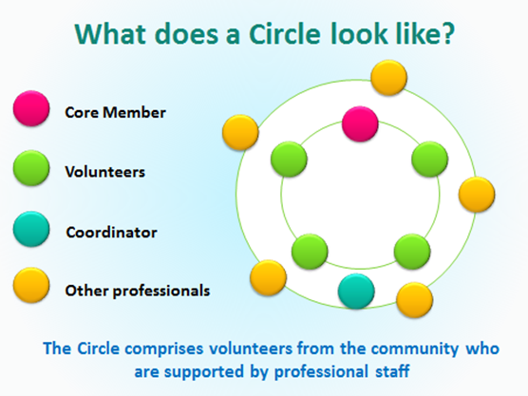

Aims:

The key aims of the Circles model are to:

- Strengthen risk management delivered by statutory partners (e.g. Police and Probation) and therefore contribute positively to the protection of the public
- Contribute to a reduction in dynamic risk for Core Members engaging in a Circle
- Increase the likelihood of desistance from sexual offending for Core Members engaging in a Circle
- Reduce Core Members’ experiences of social isolation and the associated risks of sexual reoffending
- Support Core Members to work towards more stable, pro-social lives through outcomes such as finding suitable volunteering or employment opportunities, building appropriate social networks and engaging in community activities
- Improve the emotional wellbeing of Core Members

Beneficiaries:

The overarching beneficiary of a Circle is the wider community – through the intended aims of the Circle, we are contributing to the ultimate goal of ‘No More Victims’. By supporting individuals who have caused sexual harm to integrate safely into the community, we intend to help them achieve fulfilling lives and thereby desist from further sexual offending.

In addition to this, the local community benefits from our service too. Through our work to raise awareness of the Circles model and sexual harm more widely, community members are given the chance to learn about this important area and provided with opportunities to get involved through volunteering.

The Circle Core Member is also a key beneficiary. Core Members engage with us voluntarily, aware that their lifestyle has led them to previously inappropriate and abusive behaviour. By engaging with our volunteers, Core Members learn to live life in a more content, purposeful and secure manner, meaning they may no longer choose to commit acts of abuse to meet their needs. Our Core Members report increased feelings of wellbeing as a result of their engagement with a Circle and typically end a Circle feeling more optimistic about the future, having made some positive steps towards achieving their goals.

Circles and MAPPA:

Circles South East has a long and positive history of working with MAPPA. Our Coordinators are invited to attend MAPPA meetings for Core Members engaging in Circles. Circle Coordinators provide valuable information which is obtained from volunteers engaging in informal discussions with the Core Members which can form important parts of the ‘jigsaw puzzle’ where there are risk concerns.

Circles often also provide evidence of positive developments and increase in protective factors which are useful for MAPPA to be aware of. Circle Coordinators can encourage volunteers to work with Core Members in particular ways to assist in risk management based on feedback from MAPPA. Circle Coordinators or Managers can also be invited to MAPPA meetings for cases being referred to Circles where there are significant or pressing risk concerns, prior to the Circle starting. The Circle can then be set-up with the concerns flagged by MAPPA in mind. Volunteers can then be appropriately briefed at the start of the Circle regarding pressing risk concerns.

Circles South East recently engaged in a London MAPPA Chairs forum focusing on Interventions for individuals convicted of sexual offences. A member of Circles staff was joined at this event by two members of our Service User Engagement Group (SUEG), one of whom was an ex-Core Member, and another a current volunteer, to provide an overview of our services for MAPPA Chairs. The SUEG members were able to provide some personal reflections on the positive impact the work that Circles has had on them and their communities which was very well received by attendees.

Service User Feedback:

“I am very thankful for the whole Circles experience. It has been very well structured and carried out with expertise and consideration. The facilitators are very experienced, always willing to listen and explore things that troubled me and help me reach level-headed understanding of my mistakes and behaviour”

Core Member: “I am much happier and content (now), not as impulsive as I used to be and have learned to think things through - I am totally committed to never offending again”.

Ashleigh Palombo
Senior Manager
Circles South East

London MAPPA SMB Training and Research Sub-Group

The multi-agency London MAPPA SMB Training & Research Sub-Group (TRSG) oversees and implements the London MAPPA Training & Research Training Plan on behalf of the London MAPPA Strategic management Board (SMB). A primary objective of the plan is to ensure regular co-ordinated MAPPA Training activities in London raising the quality and consistency of London MAPPA practice for London MAPPA Chairs. All training delivered is evaluated for its effectiveness and feedback has been consistently positive in ensuring improved skills and knowledge of London MAPPA chairs.

Training of London MAPPA Chairs takes place via an initial MAPPA 2-day training course followed by a range of continuing professional development (CPD) events. Where possible direct expert by experience input is provided to CPD MAPPA events, recognising the importance and value this brings.

In 2023-2024 three 2-day MAPPA Chair Training events were delivered for new MAPPA Chairs totalling approximately 59 staff. Whilst targeted at MAPPA Chairs, all events are open to London MAPPA Administrators to broaden their understanding and promote collaborative MAPPA working relationships.

Following consultation with London MAPPA Chairs and national/regional MAPPA priorities two quality improvement training areas were prioritised to drive London MAPPA Chair quality improvement:

- Improving the quality of presentations at MAPPA by staff from different responsible authority agencies
- Improving MAPPA Chairs understanding of mental health considerations and provisions

In May 2023 51 staff attended a half day MAPPA Chairs event on improving practice and developing a consistent approach to MAPPA case presentation in London. Objectives were:

- Consulting with Chairs around the content and approach to London MAPPA case presentation
- Discussing how MAPPA case presentation should be operationalised
- Reflecting on how diversity is incorporated into MAPPA case presentation and discussion

Following the event an ‘aide memoir’ was produced on best practice to support practitioners with case presentations at MAPPA meetings to promote consistent MAPPA practice regarding MAPPA case presentation.

In December 2023, 55 staff attended a 1-day MAPPA Chairs Mental Health Event. Objectives were to:

- Understand the learning from serious case review involving mental health and MAPPA
- Understand the role of the MoJ Mental Health Casework Section (MHCS)
- Understand the role and expectations of Mental Health Services within MAPPA
- Have a greater understanding of assessing and managing MAPPA cases where there is a mental health concern
- Have an understanding of interventions available for individuals on the Personality Disorder Pathway
- Reflect on the importance of Lived Experience in MAPPA Chair practice.

After this event a ‘Tips for Chairs re mental health and MAPPA’ draft was produced and is currently being finalised following consultation to support ongoing learning and professional knowledge.

In addition, to MAPPA Chairs training events, training/ briefings have also been delivered to staff in the Probation Service London Region and London Mental Health Trusts to support the development of MAPPA practice more widely.

London MAPPA SMB Training and Research Sub-Group

.



