
Area name here

Avon and Somerset

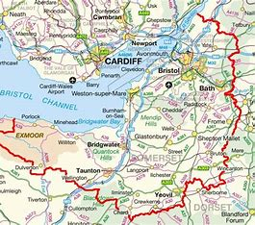

Annual Report

2023-2024

Introduction

It is a pleasure to be introducing the 2023-24 MAPPA annual report. This year has seen a change in those involved at a Senior level in the oversight of MAPPA with both probation and police Strategic Management Board chairs moving on and being replaced. We are lucky to have inherited a very motivated and knowledgeable team of people working in the MAPPA unit and in the wider MAPPA work, chairing and contributing to meetings. This has been a very busy year for referrals into level 2 & 3 MAPPA & for meetings. As always, we have been supported in the MAPPA work by the invaluable contributions from our coordinators, administrators & chairs as well as our partner agencies who participate at all levels of MAPPA in terms of strategic oversight and improvement in MAPPA SMB & sub-groups and in attending individual meetings to ensure we have the best risk management plans.

As is detailed below there has been an emphasis on learning and development in the work of the MAPPA team. As well as this we continue to monitor the publication of national reports involving learning in relation to MAPPA, offender management and agencies working together at the MAPPA Strategic Management Board to ensure that we incorporate learning, review against our own practices and implement positive change. Our briefings to MAPPA Chairs and to the Strategic Management Board aim to propel this learning as far as possible.

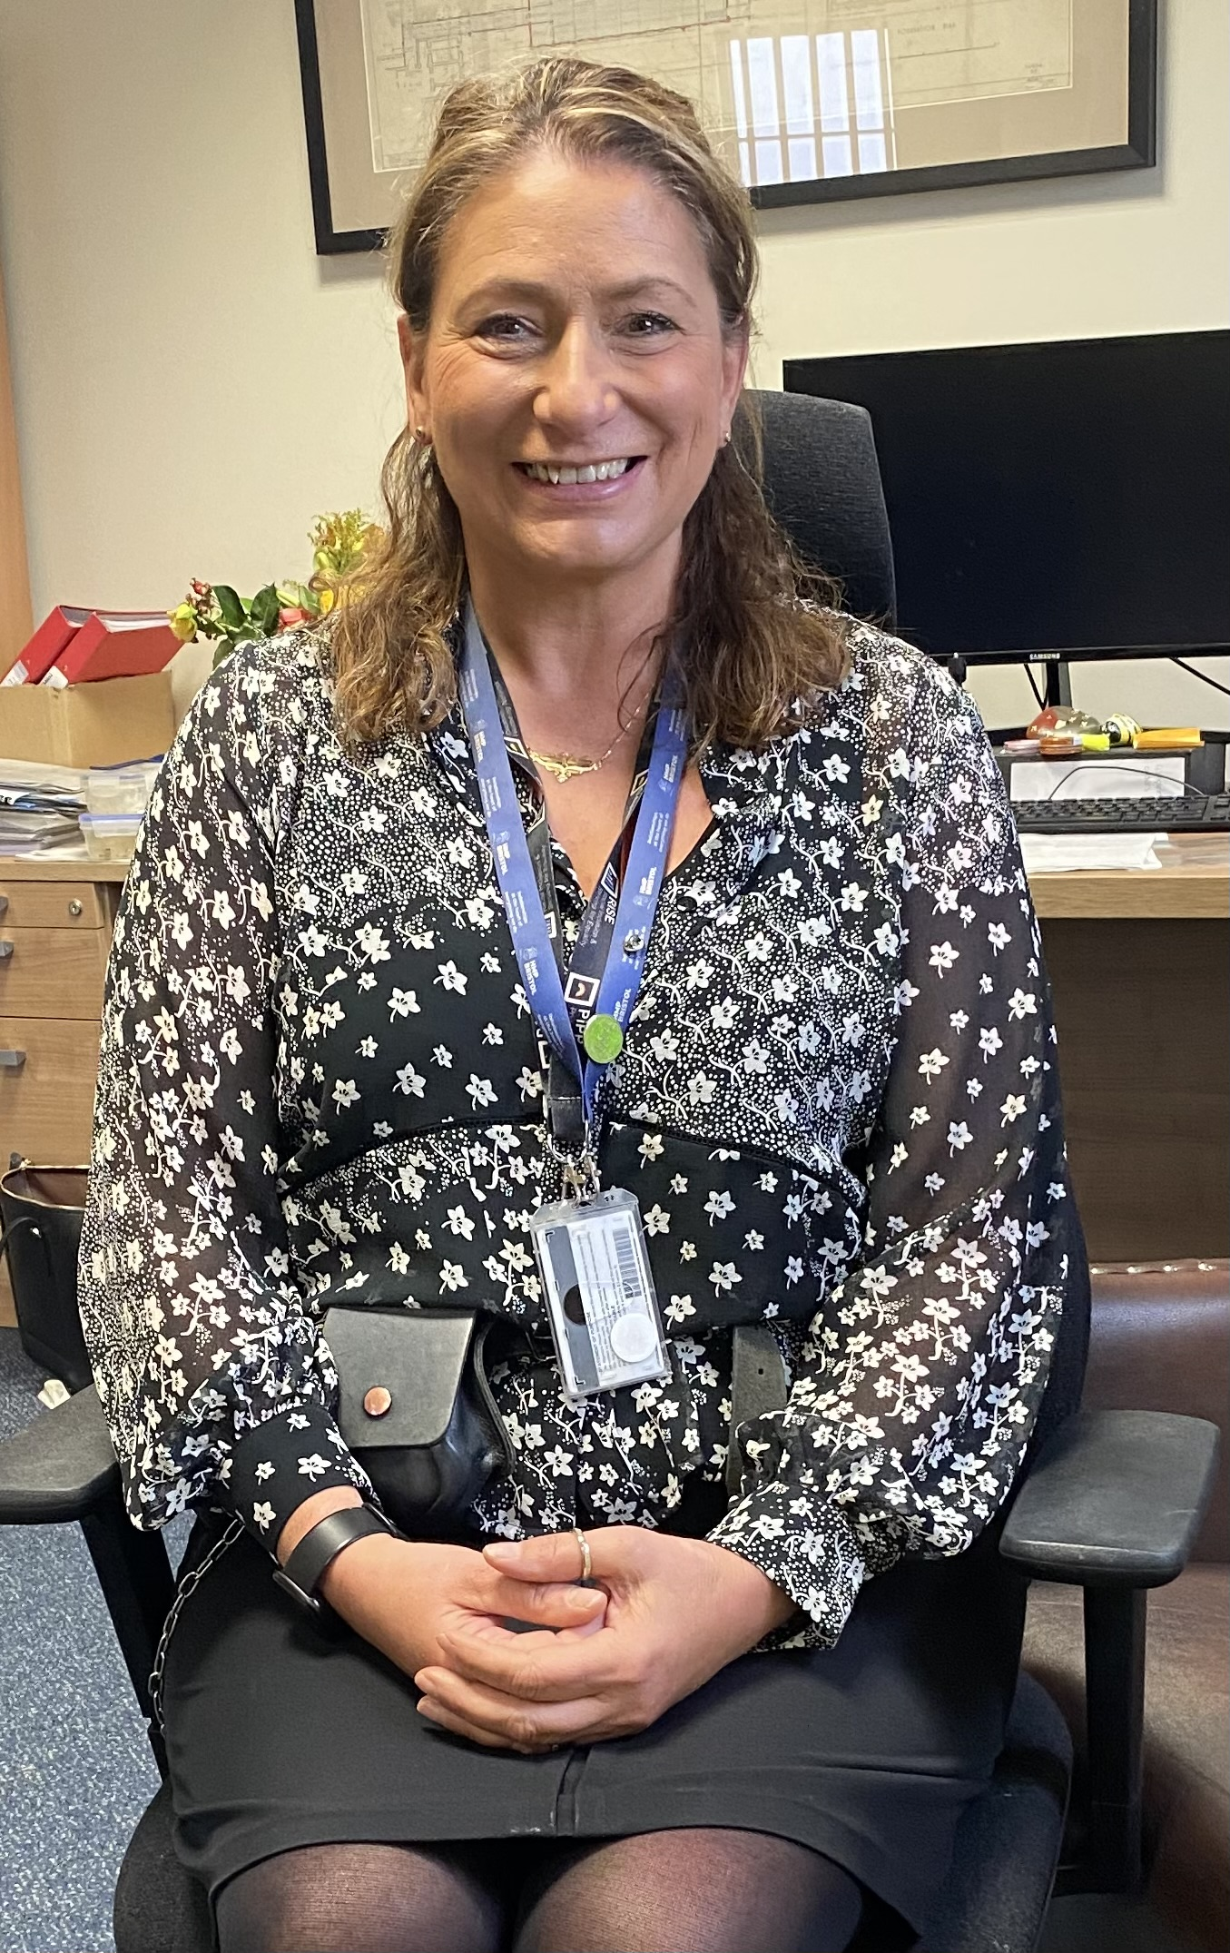


Katy Trundley Jon Cummins Vanessa Prendergast
Assistant Chief Officer Assistant Chief Constable Interim Governor
Probation Service Avon and Somerset Constabulary HMP Bristol

What is MAPPA?

MAPPA background
MAPPA (Multi-Agency Public Protection Arrangements) are a set of arrangements to manage the risk posed by individuals who have committed the most serious sexual, violent and terrorist offences (MAPPA-eligible individuals) under the provisions of sections 325 to 327B of the Criminal Justice Act 2003.
They bring together the Police, Probation and Prison Services in each of the 42 Areas in England and Wales into what is known as the MAPPA Responsible Authority.
A number of other agencies are under a Duty to Co-operate (DTC) with the Responsible Authority. These include Social Services, Health Services, Youth Offending Teams, Department for Work and Pensions and Local Housing and Education Authorities.
Local Strategic Management Boards (SMB) comprising senior representatives from each of the Responsible Authority and DTC agencies are responsible for delivering MAPPA within their respective areas. The Responsible Authority is also required to appoint two Lay Advisers to sit on each MAPPA SMB.
Lay Advisers are members of the public appointed by the Minister with no links to the business of managing MAPPA-eligible individuals act as independent, yet informed, observers; able to pose questions which the professionals closely involved in the work might not think of asking. They also bring to the SMB their understanding and perspective of the local community (where they must reside and have strong links).

How MAPPA works
MAPPA-eligible individuals are identified and information about them is shared between agencies to inform the risk assessments and risk management plans of those managing or supervising them.
That is as far as MAPPA extend in the majority of cases, but some cases require more senior oversight and structured multi-agency management. In such cases there will be regular MAPPA meetings attended by relevant agency practitioners.
There are 4 categories of MAPPA-eligible individual:
- Category 1 –subject to sex offender notification requirements;
- Category 2 – mainly those convicted of violent offences and sentenced to 12 months or more imprisonment or a hospital order;
- Category 3 – individuals who do not qualify under Categories 1, 2 or 4 but whose offences pose a risk of serious harm.
- Category 4 – terrorism convicted and terrorism risk individuals
Data on Category 4 individuals is not included in this report due to data protection issues related to low numbers. This data will be aggregated and published nationally.
There are three levels of management to ensure that resources are focused where they are most needed; generally those presenting the higher risks of serious harm.
- Level 1 is where the individual is managed by the lead agency with information exchange and multi-agency support as required but without formal MAPPA meetings;
- Level 2 is where formal MAPPA meetings are required to manage the individual.
- Level 3 is where risk management plans require the attendance and commitment of resources at a senior level at MAPPA meetings.
MAPPA are supported by ViSOR. This is a national IT system to assist in the management of individuals who pose a serious risk of harm to the public. The use of ViSOR increases the ability to share intelligence across organisations and enables the safe transfer of key information when high risk individuals move between areas, enhancing public protection measures. ViSOR allows staff from the Police, Probation and Prison Services to work on the same IT system, improving the quality and timeliness of risk assessments and interventions to prevent offending.
All MAPPA reports from England and Wales are published online at: www.gov.uk

MAPPA Statistics

MAPPA-eligible individuals on 31 March 2024
 | Category 1:  Subject to sex offender notification requirements | Category 2:  Violent  offenders | Category 3:  Other dangerous  offenders | Total
Level 1 | 1821 | 492 | - | 2313
Level 2 | 4 | 13 | 8 | 25
Level 3 | 1 | 0 | 0 | 1
Total | 1826 | 505 | 8 | 2339

MAPPA-eligible offenders in Levels 2 and 3 by category (yearly total)
 | Category 1:  Subject to sex offender notification requirements | Category 2:  Violent  offenders | Category 3:  Other dangerous  offenders | Total
Level 2 | 26 | 53 | 55 | 134
Level 3 | 2 | 2 | 1 | 5
Total | 28 | 55 | 56 | 139

Category 1 cautioned or convicted for breach of notification requirements | 79

Category 1 who have had their life time notification revoked on application | 5

Restrictive orders for Category 1 offenders
Sexual Harm Prevention Order (SHPO) | 146
SHPO with foreign travel restriction | 0
Notification Order | 5

Number of individuals who became subject to sex offender notification requirements following a breach(es) of a Sexual Risk Order (SRO) | 1

Level 2 and 3 individuals returned to custody
Returned to custody for breach of licence | Category 1:  Subject to notification requirements | Category 2:  Violent  offenders | Category 3:  Other dangerous  offenders | Total
Level 2 | 8 | 10 | 8 | 26
Level 3 | 0 | 1 | 1 | 2
Total | 8 | 11 | 9 | 28

Breach of SHPO
Level 2 | 1
Level 3 | 1
Total | 2

Total number of individuals subject to sex offender notification requirements per 100,000 population | 115

This figure has been calculated using the mid-2022 estimated resident population, published by the Office for National Statistics (ONS) on 21 December 2022, excluding those aged less than ten years of age.

Consistent with previous publications, this figure should be based on mid-2023 estimated resident population; however, the ONS has changed its publication schedule such that the mid-2023 estimates will be published later this year. As such, the current figure may differ from the corresponding figure based on the mid-2023 estimates.

Explanation commentary on statistical tables

MAPPA background
The totals of MAPPA-eligible individuals, broken down by category, reflect the picture on 31 March 2024 (i.e. they are a snapshot). The rest of the data covers the period 1 April 2023 to 31 March 2024.
(a) MAPPA-eligible individuals – there are individuals defined in law as eligible for MAPPA management because they have committed specified sexual, violent or terrorist offences or they currently pose a risk of serious harm. The majority are managed at Level 1 without formal MAPPA meetings. These figures only include those MAPPA eligible individuals living in the community. They do not include those in prison or detained under the Mental Health Act.
(b) Subject to Sex Offender Notification Requirements – those who are required to notify the police of their name, address and other personal details and to notify of any subsequent changes (this is known as the “notification requirement.”) These individuals are assessed and managed by the police. They may also be managed by probation or health services if they are subject to licence or a hospital order. Failure to comply with the notification requirement is a criminal offence that carries a maximum penalty of 5 years’ imprisonment.
(c) Violent Offenders – individuals convicted of violent offences who were sentenced to imprisonment or detention for 12 months or more, or detained under a hospital order and a small number of individuals convicted of sexual offences who are not subject to notification requirements. These individuals are assessed and managed by the Probation Service, Youth Offending Team or Mental Health Services.
(d) Other Dangerous Offenders – individuals who do not qualify under the other MAPPA-eligible categories, but have committed an offence that indicates that they pose a risk of serious harm which requires management via MAPPA meetings. These individuals are assessed and managed by whichever agency has the primary responsibility for them.
(e) Terrorism and Terrorism Risk Offenders – individuals subject to terrorism offender notification requirements; individuals convicted of terrorism or terrorism related offences who were sentenced to imprisonment or detention for 12 months or more, or detained under a hospital order; and those who have committed an offence and may be at risk of involvement in terrorism-related activity. These individuals are assessed and managed by Counter-Terrorism Police and the National Security Division of the Probation Service.
(f) Breach of Licence – individuals released into the community following a period of imprisonment will be subject to a licence with conditions (under probation supervision). If the individual does not comply with these conditions, the Probation Service will take breach action and the individual may be recalled to prison.
(g) Sexual Harm Prevention Order (SHPO) (including any additional foreign travel restriction). Sexual Harm Prevention Orders (SHPOs) and interim SHPOs replaced Sexual Offence Prevention Orders are intended to protect the public from individuals convicted of a sexual or violent offence who pose a risk of sexual harm to the public by placing restrictions and/or positive obligations on their behaviour. They require the individual to notify their details to the police (as set out in Part 2 of the 2003 Act) for the duration of the order.
The court must be satisfied on the balance of probability that an order is necessary to protect the public (or any particular members of the public) in the UK, or children or vulnerable adults (or any particular children or vulnerable adults) abroad, from sexual harm from the individual. In the case of an order made on a free standing application by a Chief Officer, the National Crime Agency (NCA), British Transport Police (BTP) or the Ministry of Defence Police (MODP), the chief officer/NCA/BTP/MODP must be able to show that the individual has acted in a way since their conviction that makes the order necessary.
The minimum duration for a full order is five years. The lower age limit is 10, which is the age of criminal responsibility, but where the defendant is under the age of 18 an application for an order should only be considered exceptionally.
(h) Notification Order – this requires individuals convicted of qualifying sexual offences overseas to register with the police, in order to protect the public in the UK from the risks that they pose. The police in England and Wales may issue a notification order directly to an offender who is already in the UK or who is intending to come to the UK who has to notify within three days of receipt. Individuals have a right of appeal against notification.

(i) Sexual Risk Order (including any additional foreign travel restriction) –The Sexual Risk Order (SRO) replaced the Risk of Sexual Harm Order (RoSHO) and may be made in relation to a person without a conviction for a sexual or violent offence (or any other offence), but who poses a risk of sexual harm.
The SRO may be made at the magistrates’ court on application by the police, NCA, BTP or MODP where an individual has committed an act of a sexual nature and the court is satisfied that the person poses a risk of harm to the public in the UK or children or vulnerable adults overseas.
An SRO may prohibit the person from doing anything described in it, including travel overseas, or place positive obligations upon them. Any prohibition and/or obligation must be necessary to protect the public in the UK from sexual harm or, in relation to foreign travel, protecting children or vulnerable adults from sexual harm.
An individual subject to an SRO is required to notify the police of their name and home address within three days of the order being made and also to notify any changes to this information within three days.
An SRO can last for a minimum of two years and has no maximum duration, with the exception of any foreign travel restrictions which, if applicable, last for a maximum of five years (but may be renewed).
The criminal standard of proof continues to apply. The person concerned is able to appeal against the making of the order and the police or the person concerned are able to apply for the order to be varied, renewed or discharged.
A breach of an SRO is a criminal offence punishable by a maximum of five years’ imprisonment. Where an individual breaches their SRO, they will become subject to full notification requirements.
Individuals made subject of an SRO are recorded on VISOR as a Potentially Dangerous Person (PDP).

(j) Lifetime notification requirements revoked on application – Qualifying individuals may submit an application to the police to review their indefinite notification requirements. The police review the application and decide whether to revoke the notification requirements. This decision is made at the rank of Superintendent. Those who continue to pose a significant risk will remain subject to notification requirements for life, if necessary.
Individuals will only become eligible to seek a review once they have been subject to indefinite notification requirements for a period of at least 15 years for adults and 8 years for juveniles.

Local page

Over the last 12 months the MAPPA Team have prioritised rolling out training and breifings to a range of agencies. This has included running on two occcasions Avon and Somerset MAPPA Bite Size Training which is now in its second year and saw a high turnout for SMB agencies.
Of note is the MAPPA Hydra which is an immersive learning experience facilitated by Avon and Somerset Police and is a multi media training event which has representation from a number of agencies. The foucs is on risk assessmetna dn risk management. This was a succesful event and will continue be run twice a year.
A significant focus has been on raising awareness to agencies of the changes to Category 3 DA and Stalking guidance via breifings and strategic work actioned by the SMB. This will continue to be monitored for the next year. Furthermore briefings have been held with investigation teams from the Police whose focus is violent and sexual offending.
A priority has been developing relationships within the two Mental Health Trusts that sit within our geographic borders. This has included briefings and hospital visits, as well as securing representation from both MH trusts on our screening panel.

With the assistance of our MAPPA Chairs & other partners two audits have been undertaken. The first focused on victims representation and voice of the child. The second upon risk assessments. Our future aim is to continue to complete two audits a year which can to develop practice and knowledge. Alongside the audits we taken the opporuntity to provide training to chairs to improve the quality of the meetings.

Finally we have responded to local significant incidents of knife crime and ensure MAPPA awareness has been raised with our Youth Justice Service Teams and Probation Delivery Units across Avon and Somerset. Furthermore we have established relationships with specialist Police Teams to attend MAPPA meetings for this cohort to devleop a trauma informed approach aswell as recognising both risk and vulnerability amongst this cohort.
Avon and Somerset Police have continued to prioritise the effective management of registered sexual and violent offenders within our communities. This year, we have implemented several key initiatives aimed at enhancing public safety and reducing reoffending rates including greater use of intelligence and monitoring tools to ensure offenders are complying with conditions of their orders.
We have strengthened our collaboration with partner agencies to improve information sharing and risk management, focusing particularly on high-risk individuals under the MAPPA framework. Our dedicated teams have been instrumental in launching new preventative measures, including targeted operations against domestic abuse perpetrators and those at risk of exploitation. Additionally, we have invested in further resources and training for our Integrated Offender Management teams to meet growing demand, enabling them to better address the complexities of managing offenders with diverse needs and risk profiles. Moving forward, we will continue to leverage these efforts to ensure a safer environment for our communities, maintaining our commitment to protecting the most vulnerable and reducing harm across the force area.

This reporting year saw the first significant changes to policy regarding early releases from custody which have been implemented by the Prison & Probation Service. During this time referrals to MAPPA have and will remain a key part of established Probation practice. Probation Delivery Units continue to have close working relationships with the MAPPA Team and have representation at all training events as well as dedicated MAPPA input at development days.

Our aims for the next report year are to continue to work towards the aim of our local business plan whilst striving to focus on the quality of the MAPPA meetings held within Avon and Somerset and maintaining our relationships with the five Local Authorities that comprise Avon and Somerset & the Health Trusts.
2025 will also mark the 25th Anniversary of MAPPA and Avon and Somerset Strategic Management Board will be developing an event to celebrate this occasion.

All MAPPA reports from England and Wales are published online at:
www.gov.uk







