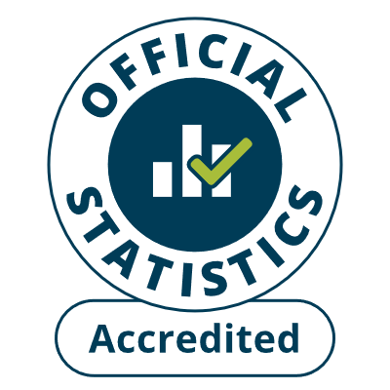
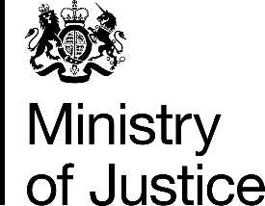

Published on 31 October 2024
Multi-Agency Public Protection Arrangements (MAPPA) Annual Report 2023/24

Main Points
MAPPA population continues to grow and was at 93,436 on 31 March 2024 |  | The overall MAPPA population on 31 March 2024 was up 3% on the previous year and up 44% since 2014.
On 31 March 2024:  70,052 Category 1;  22,534 Category 2;  563 Category 3; and  287 Category 4. |  | There have been increases in all categories of offender since the previous year: of 2% for Category 1 offenders, 3% for Category 2 offenders, 4% for Category 3 offenders and 17%for Category 4.
On 31 March 2024:  91,873 managed at Level 1; 1,356 managed at Level 2; 207 managed at Level 3. |  | The populations managed at Level 1, Level 2 and Level 3 all increased, by 3%, 1% and 2% respectively from the previous year.
216 SFO charges and 132 SFO convictions during 2023/24. |  | The number of serious further offence (SFO) charges increased by 33% from the year before, and the number of SFO convictions increased by 15%.
1,104 Level 2 and Level 3 licence recall returns to custody in 2023/24. |  | Licence recall returns were up by 6% in 2023/24, the sixth successive annual increase.
6,093 SHPOs imposed in 2023/24 |  | More Sexual Harm Prevention Orders (SHPOs) were imposed, an increase of 8% on the previous year.

This bulletin covers MAPPA statistics for England and Wales in 2023/24. A set of summary tables covering each section of this bulletin and a table of all the data provided by individual local MAPPA areas are published at https://www.gov.uk/government/collections/multi-agency-public-protection-arrangements-mappa-annual-reports.

Statistician’s comment
“Published numbers today show the MAPPA population on 31 March continues to increase yearly, with latest figures showing increases in all categories of offender and in all levels of management from the previous year. Historically, these increases have been driven mainly by increases in the number of persons convicted of sexual offences and subject to notification requirements.
We have seen large increases in convictions for sexual offences in the last couple of years, and these, in addition to efforts to increase prosecutions of rape cases under the Rape Review Action Plan, are likely to feed through into an increasing number of Category 1 offenders under MAPPA in the future. The Category 2 population saw an increase over the previous year. The increases in the number of Category 3 offenders over the last few years may reflect changes to the statutory MAPPA guidance to encourage practitioners to consider all domestic abuse cases for MAPPA Category 3 management.
The Level 1 population continues to increase yearly, and latest figures also show increases in the number of offenders managed at both Level 2 and Level 3.
The number of Serious Further Offence (SFO) charges against probation-managed eligible MAPPA offenders increased in the latest year, following a decrease to a decade low in the previous year.

Change to table presentation
We have combined previous Table 1, Table 2a and Table 2b into one table, Table 1, to allow users to obtain the same information in the three tables in one table. “

For feedback related to the content of this publication, please contact us at: mappa@justice.gov.uk

1. MAPPA Population on 31 March

MAPPA population continues to grow. It increased by 3% to 93,436 on 31 March 2024.

There were increases in all four MAPPA categories.

The MAPPA population on 31 March 2024 increased by 2,396 (3%) on the previous year, accounted for by an increase of 1,695 in Category 1, 637 in Category 2, 23 in Category 3, and 41 in Category 4. The March 2024 figure is an increase of 44% in the MAPPA population since 2014.

Figure 1: MAPPA population by Category on 31 March 2014 – 2024 (Source: Table 1)

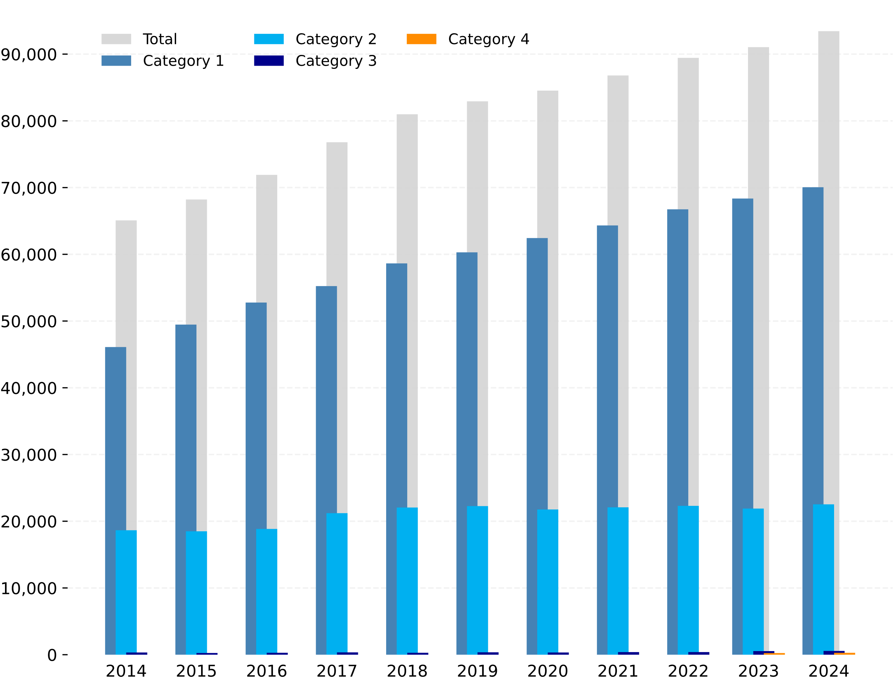

Categories

- The number of Category 1 offenders continues to increase annually, standing at 70,052 on 31 March 2024. This is an increase of 2% on the previous year and 52% higher than in 2014. About 70-75% of MAPPA offenders are Category 1, consistent over the
last decade.

The number of people being convicted of sexual offences and the requirement for many of those convicted to register for long periods of time, very largely explain the rise in Category 1. The average annual increase in the Category 1 population over the last five years is slightly lower than it was before 2017/18, partly due to fewer people being convicted of sexual offences since a peak in 2017 and more people coming off notification requirements. Notification requirements began in 1997, with the threshold for adults lowering in 2004 as a result of the Sexual Offenders Act 2003.

The number of offenders subject to notification requirements (i.e. Category 1) per 100,000 members of the population aged 10 and over has trended upwards, and it was 129 on 31 March 2024.

Figure 2: Category 1 Offenders subject to notification requirements per 100,000 members of the population aged 10 or over (Source: Table 3)

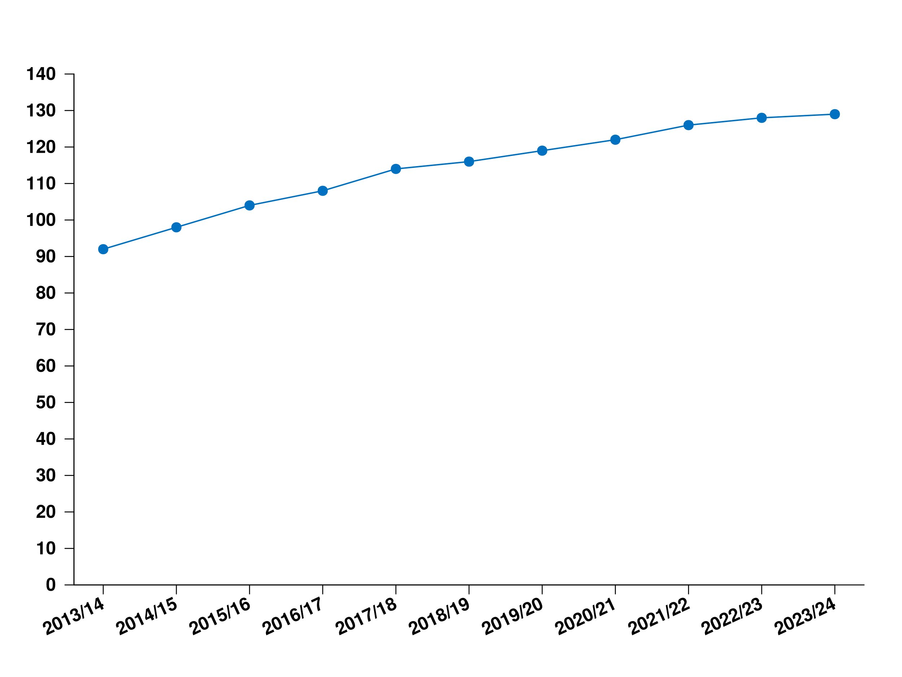

- The number of Category 2 offenders increased by 3% from the previous year, standing at 22,534 on 31 March 2024, following a 2% decrease in the previous year. Annual figures have been relatively stable since 2017/18 but increased before that, with the latest figure representing a 21% increase from 2014. About a quarter of MAPPA offenders are Category 2, consistent in the last decade.

- After decreasing to a decade low of 255 in 2015, the Category 3 population on 31 March has since trended upward. The latest figure of 563 is an increase of 4% on the previous year and the highest since 2010. The total number of offenders managed under Category 3 over the course of a year reached a low of 931 in 2017/18, before the MAPPA Guidance was updated in 2018 to emphasise bringing domestic abuse perpetrators into MAPPA under Category 3. A total of 1,724 offenders were managed under Category 3 between April 2023 and March 2024, an increase of 85% from 2017/2018.

- Category 4 was introduced by the Police Crime Sentencing and Courts Act 2022 and is reported for the second time. On 31 March 2024 there were 287 Category 4 offenders, an increase of 17% from the previous year.

Management Levels

- The overwhelming majority (currently 98%, the same as the previous year and at least 97% since 2014) of MAPPA offenders continue to be managed at Level 1. On 31 March 2024, 91,873 offenders were being managed at Level 1, 3% higher than in the previous year and 46% higher than in 2014.

About 76% of those managed at Level 1 are Category 1 offenders, with the remainder almost all Category 2 offenders. Category 3 offenders cannot be managed at Level 1 as they only qualify for MAPPA if they require multi-agency management to be overseen by a formal meeting at Level 2 or 3.

- The Level 2 population has seen successive increases in the last two years, following a downward trend for much of the last decade and relative stability in the 3 years prior. The Level 2 population on 31 March 2024 was 1,356, an increase of 1% from the previous year and a decrease of 28% from 2014.

Category 3 formed the largest category (38%) of those managed at Level 2 for the second year running, coinciding with the recent increase in Category 3 offenders. Category 1 accounts for 28% of those managed at Level 2 and Category 2 constitutes about 31%, with Category 4 making up 3%.

- The Level 3 population on 31 March 2024 was 207, an increase of 2% from the previous year and 31% from 2014. Level 3 has relatively equal proportions of Category 1 offenders (24%), Category 2 offenders (29%), Category 3 offenders (26%) and Category 4 offenders (22%).

Diversity

The distribution of sex, ethnicity and age on 31 March 2024 is as follows:

- About 94% of offenders managed at MAPPA Level 2 or 3 are male.

- About 7% of offenders managed at MAPPA Level 2 or 3 are Asian, 9% are black, 6% are mixed, 74% are white, 1% are of other ethnic group, and 3% are unknown.

- About 33% of offenders managed at MAPPA Level 2 or 3 are 30 years of age or younger, 50% are 31-50 and 18% are over 50. However, there is a higher proportion of those aged up to 30 years in Category 3 (43%) and Category 4 (44%) than in Category 2 (28%) and Category 1 (22%).

2. Serious Further Offences and Serious Case Reviews (Offenders under MAPPA)

Charges and convictions triggering a review under the Probation Service Serious Further Offence (SFO) Procedures both increased in the latest year

SFO charges rose by 33% to 216, the highest level since 2018, and SFO convictions rose by 15% to 132 in the latest period.

SFO charges

The number of MAPPA offenders supervised by the Probation Service on licence or on a community order who were charged with an SFO increased in the latest year, following a decrease in the previous year. The number of offenders charged with an SFO increased for all categories. The latest figure of 216 is the highest since 2017/18 when 242 offenders were charged with an SFO.

Of the 216 offenders charged, 93 were Category 1, 104 were Category 2, 18 were Category 3 and 1 was Category 4. An offence only counts as an SFO if it is committed by someone under probation supervision. Most Category 1 offenders are not under probation supervision (they are under police supervision). This partly explains why more Category 2 offenders fall within the scope of the Probation SFO Review Procedures despite there being three times as many Category 1 offenders within MAPPA.

Not surprisingly, the majority (85%) of those charged with an SFO were managed at Level 1 as Level 1 constitutes about 98% of the MAPPA population.

SFO Convictions

The number of SFO charges and number of SFO convictions in the same year do not necessarily relate to the same group of offenders, as charges for the convictions reported may have been laid in the previous years and charges laid in the current year may conclude in subsequent years.

The number of MAPPA SFO convictions went up by 15% to 132 in the latest year following a 9% decrease in the previous year. Outstanding charges increased by three from 113 to 116. About 38% of SFO charges that concluded in the latest year did not result in an SFO conviction, up from 29% in the previous year.

Figure 3: SFO charges, convictions, outstanding cases and other outcomes
(Source: Table 8, Table 9b and, in previous publications, Table 9a and 9b)

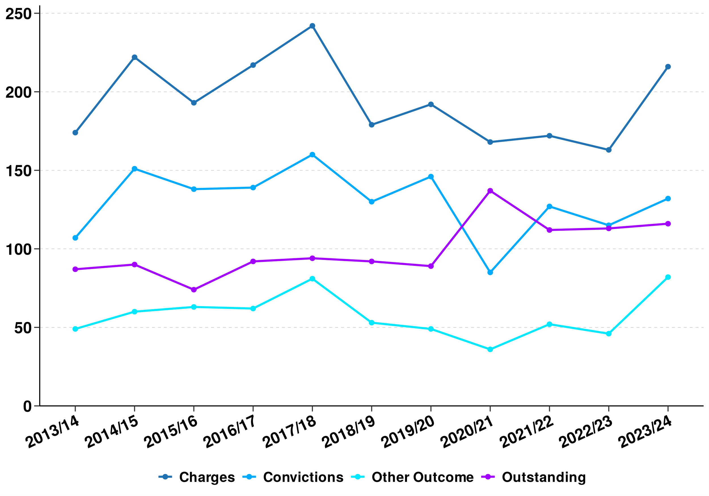

Serious Case Reviews

Serious Case Reviews are mandatory where an offender managed by any agency at either MAPPA Level 2 or 3 is charged with committing or attempting to commit an offence of murder, manslaughter or rape. They are also done on a discretionary basis in some other circumstances.

The number of serious case reviews decreased from 10 to 7 in the latest year, having increased from 6 in the previous year.

3. Committals to custody following licence recall and SOPO/SHPO breaches (Levels 2 and 3)

Returns to custody following licence recall increased for offenders managed at Level 2 and Level 3 and more were sent to prison for breach of Sexual Offences Prevention Orders (SOPOs) /Sexual Harm Prevention Orders (SHPOs) in the latest year.

Licence recall returns went up by 6% to 1,104, and the number of offenders sent to custody for breach of a SOPO/SHPO went up by 24% to 31 in the latest period, following a decrease of 32% in the previous year.

Licence Recalls (Level 2 and Level 3)
Licence recalls for those managed at Level 2 and Level 3 have continued to increase in recent years, reflecting increases in general recalls and increases in the number of offenders managed annually at Levels 2 and 3 (Table 4).
Figure 4: Offenders managed at Level 2 and Level 3 returned to custody in connection with breach of licence and escalating risk (Source: Table 7a)

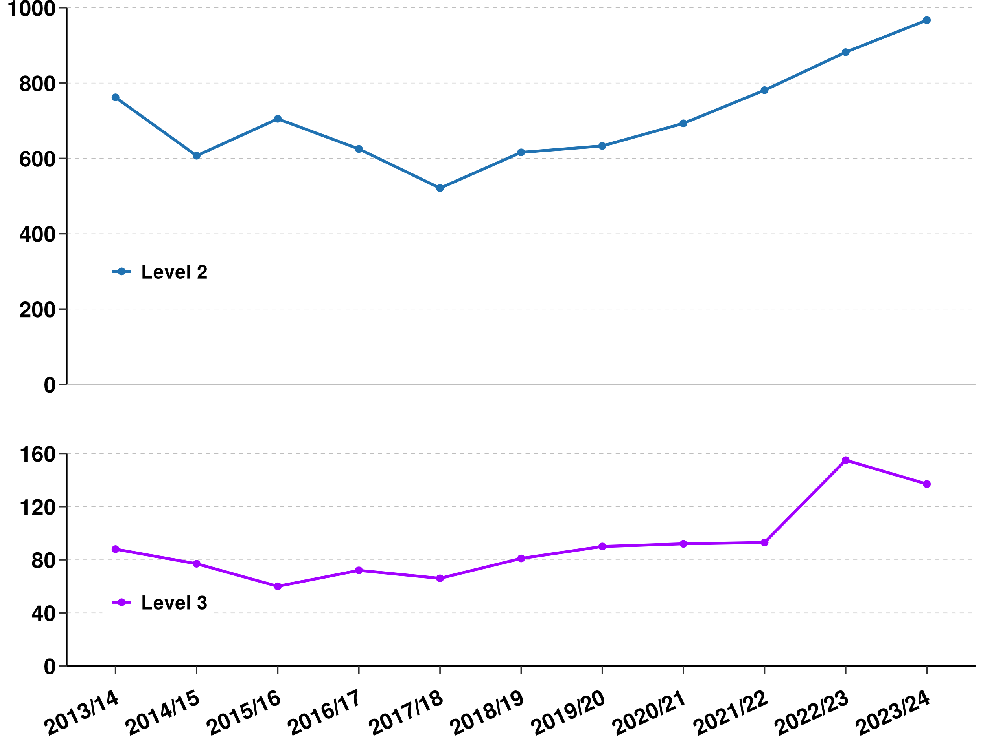

Licence recalls increased for Level 2 but decreased for Level 3 offenders in the latest year. Level 2 returns were up by 10% and Level 3 returns went down by 12%.
Overall, about 1 in 4 offenders managed at each of Level 2 and Level 3 were returned to custody for breach of license conditions in the latest year, similar to the previous year. Information is not collected on those managed at Level 1 who were returned to custody for breach of licence conditions.
Category 1 offenders managed at Level 2 and Level 3 sentenced to custody for breaching SOPO/SHPO

Breaching a SOPO/SHPO is a criminal offence punishable by up to 5 years’ imprisonment. The number of Category 1 offenders managed at Level 2 or Level 3 sent to custody for breach of a SOPO/SHPO increased to 31. This is about 2% of Category 1 offenders managed at Level 2 and Level 3, the same as the previous year. Information is not collected on those managed at Level 1 who were sent to custody for breach of SOPO/SHPO.

4. Restrictive Orders and Notification Requirements

The number of Sexual Harm Prevention Orders (SHPOs) imposed increased and the number of Notification Orders (NOs) imposed decreased in the latest year.

SHPOs imposed increased by 8% to 6,093 and NOs imposed fell by 9% to 125.

SHPOs Imposed
The number of SHPOs imposed annually increased to 6,093 (8% increase) in the latest year, following a 2% decrease in the previous year.
Figure 5: SOPOs/SHPOs, NOs and Foreign Travel Orders (FTOs)/Foreign Travel Restrictions (FTR) withing SHPOs or SROs imposed by the courts (Source: Table 6)

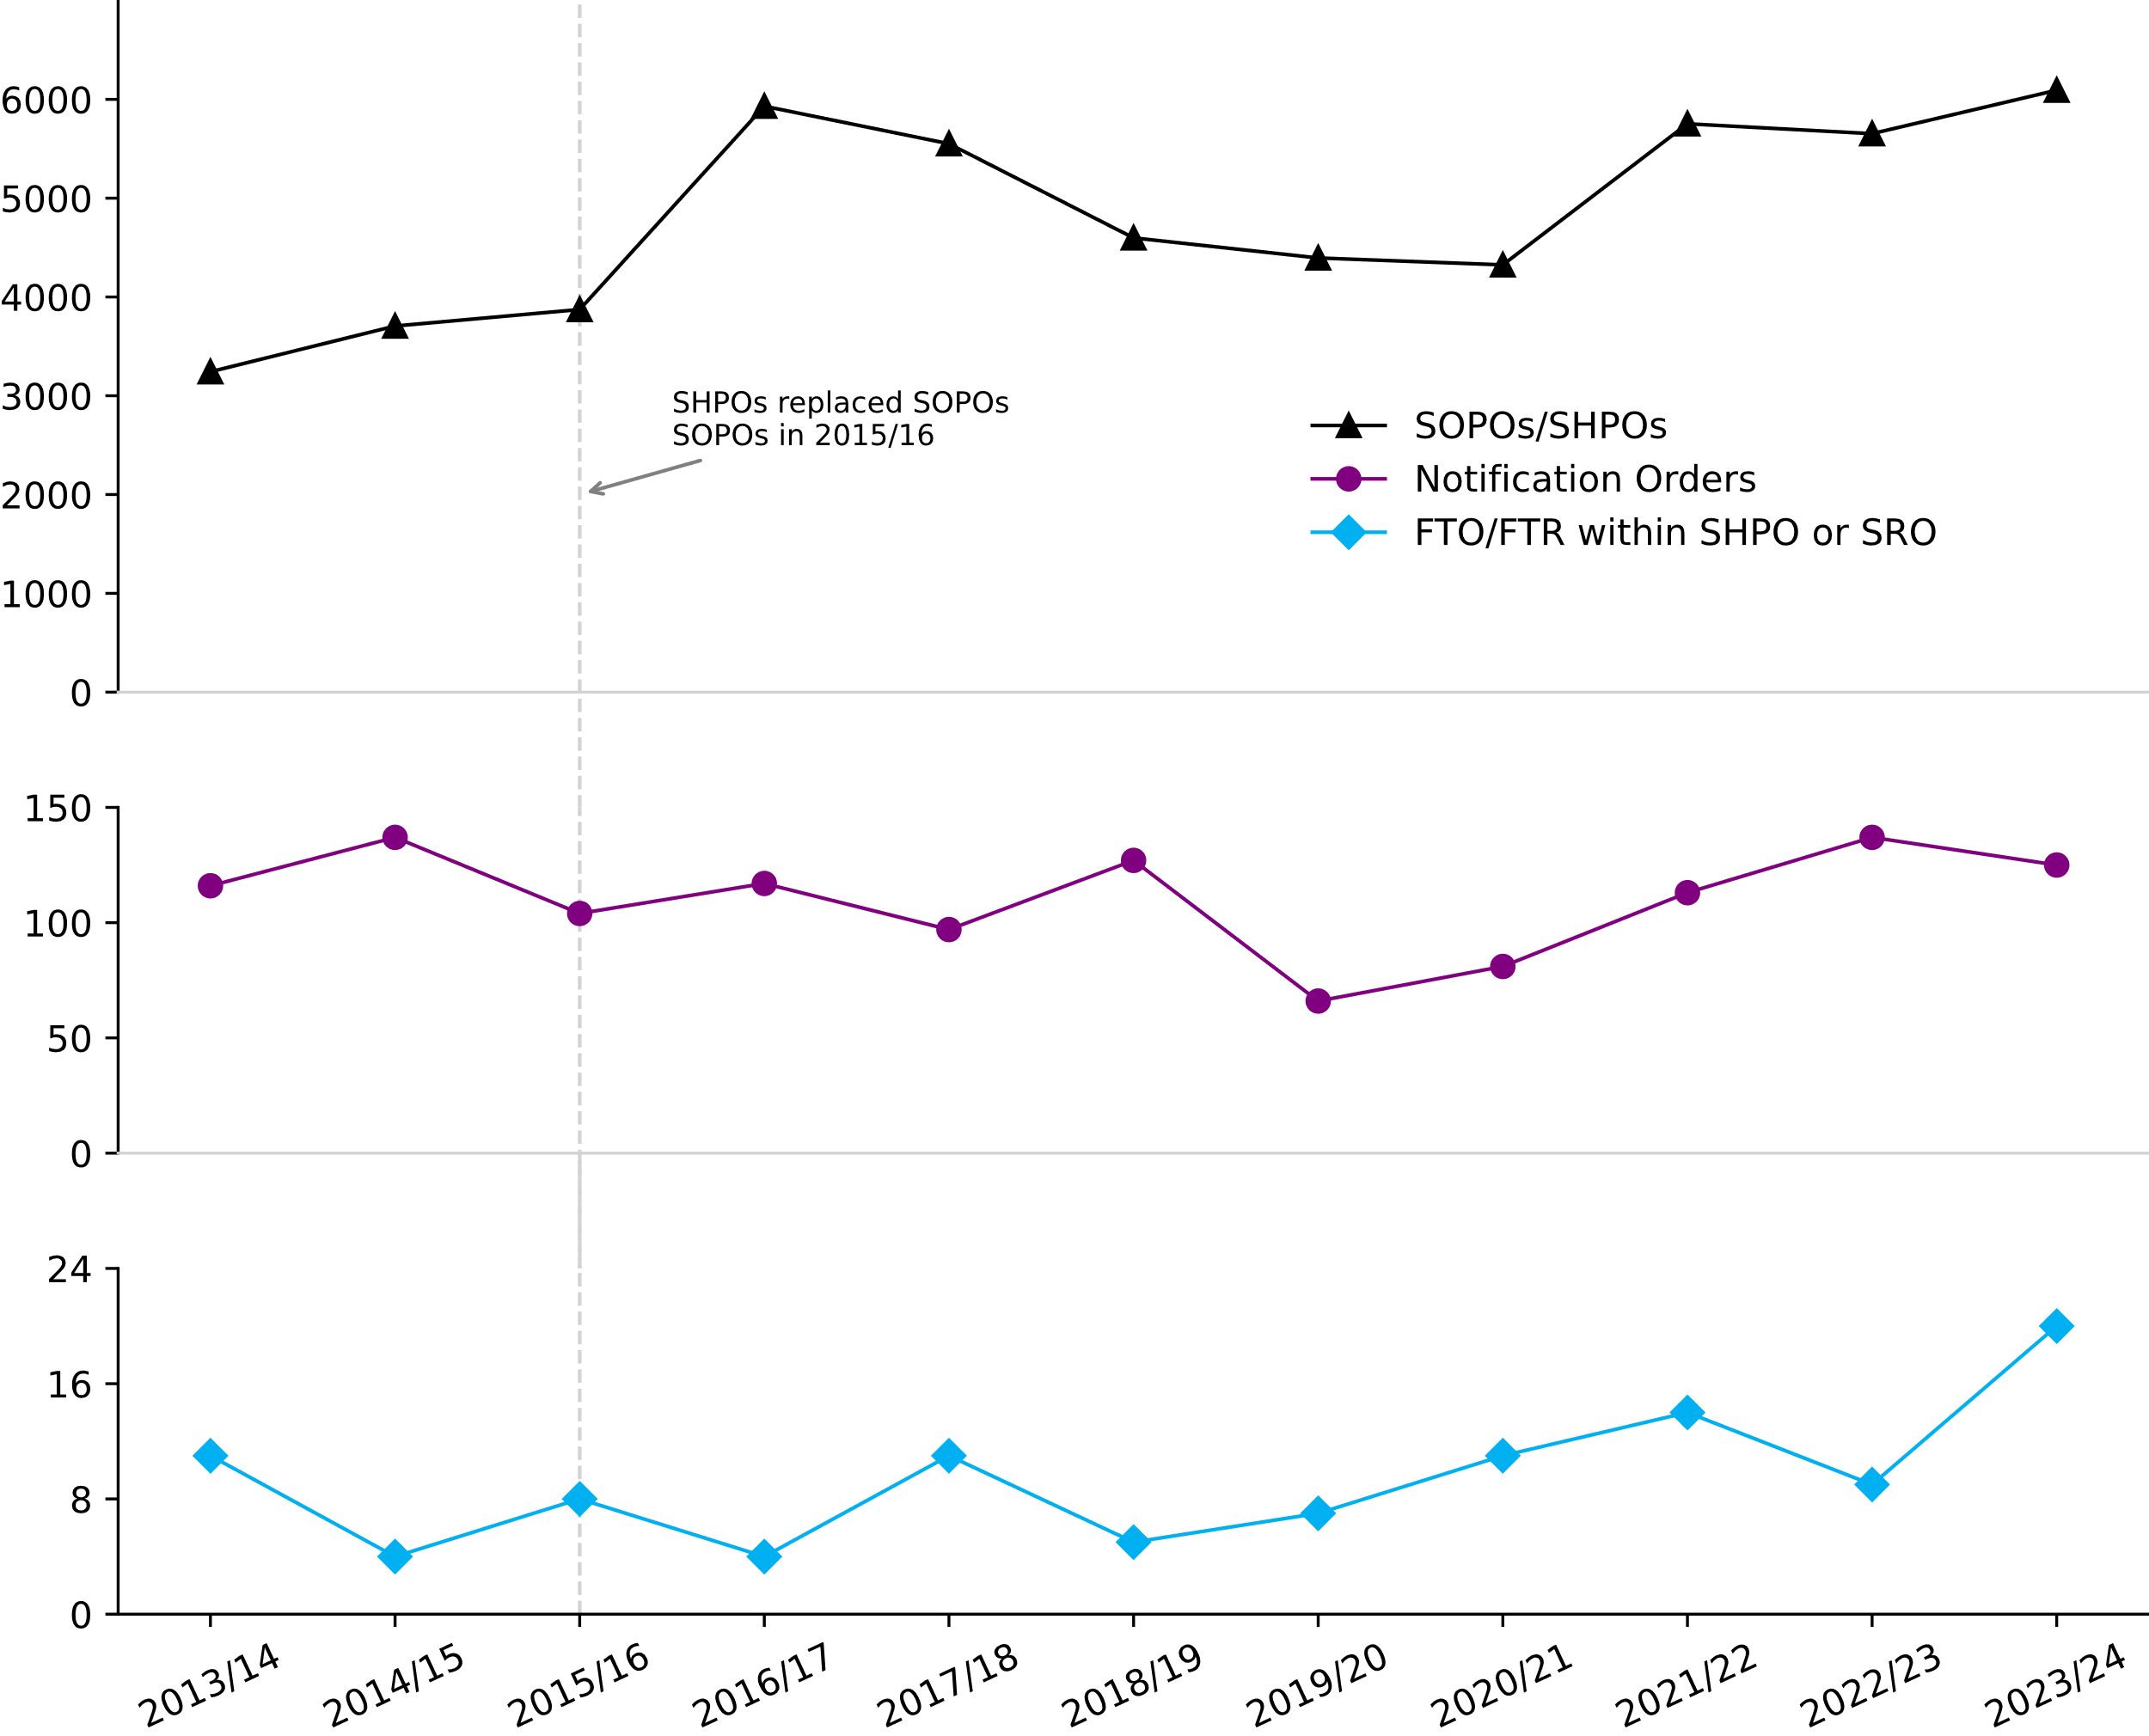

- The increase in SOPOs/SHPOs in 2016/17 is not comparable with increases in the previous years since SHPOs replaced SOPOs in 2015/16. The criteria required for Courts to grant SHPOs have a lower threshold than those for the previous SOPOs.
- In 2015/16, FTOs ceased to be a standalone order and became foreign travel restrictions within either a SHPO or Sexual Risk Order (SRO)

SHPOs account for the majority of restrictive orders. All offenders subject to a SHPO will be subject to notification requirements, though not all those subject to notification requirements will have a SHPO.
Foreign Travel Orders (FTOs) Imposed
The number of FTOs imposed as part of a SHPO increased to 20 in the latest year, the highest number since 2010/11.
Notification Orders (NOs) Imposed
A Notification Order (NO) requires those who have been convicted of a sexual offence overseas to notify the UK police and become subject to notification requirements on their return to the UK.
The number of NOs imposed yearly saw a 9% decrease in the latest year, following a run of rises since 2019/20.
Notification Requirements

Category 1 offenders are required to notify the police of certain details (sometimes referred to as “being on the sex offenders’ register”). A breach of this notification requirement is a criminal offence and can lead to a caution or conviction.

- Sexual Risk Orders (SROs) and Notification Requirements
SROs may be made in relation to a person without a conviction, but who poses a risk of sexual harm. Breaching SRO is a criminal offence and can lead an offender to become subject to notification requirements.

The number of people who became subject to notification requirements following a breach of an SRO rose to 68 in 2023/24 from 47 in 2022/23 ( see accompanying Area Tables).

- Cautions or Convictions for breaches of notification requirements

The number of offenders managed at any level subject to notification requirements who were cautioned or convicted for breaches of their notification requirement was 2,375 in the latest period, broadly similar to the previous year’s.

For Category 1 offenders managed at Level 2 or Level 3 the proportion cautioned or convicted for breaching notification requirements remained relatively small (about 7%), although until this year it had been consistently under 5% since 2008/09.

- Revocation of lifetime notification requirement

Since September 2012, a mechanism has been in place that allows qualifying offenders subject to notification requirements for life to apply for a review. Between April 2023 and March 2024, 357 Category 1 Offenders had their lifetime notification requirements revoked on application, compared to 412 in 2022/23(see accompanying Area Tables).

5. Further information on the MAPPA data

Accompanying files
As well as this bulletin, the following products are published as part of this release:
- A set of summary tables covering each section of this bulletin, including experimental data on the diversity of MAPPA offenders.
- One table of all the data provided by individual local MAPPA areas.
- Notes and definitions relating to terminology used in this publication.

Data Sources, Quality and Revisions
The data presented in this brief are drawn from MAPPA areas’ local administrative IT systems. The data are submitted by areas at summary, rather than individual level so detail on specific offenders and any subsequent focus on individuals is not possible from this dataset.

Although care is taken when processing and analysing the returns, the detail collected is subject to the inaccuracies inherent in any large-scale recording system.

The data are collected for a financial year and are submitted on an annual basis. During the data collection process, areas may identify the need to correct or amend the previous year’s data. If required, these are made in the following year’s report. A footnote on the relevant table will indicate the scale of the revision.

Release Schedule
This bulletin was published on 31 October 2024 and includes financial year statistics for the year 2023/24.
The next publication of Multi-Agency Public Protection Arrangements is scheduled to be published in October 2025.

National Statistics status

National Statistics are accredited official statistics that meet the highest standards of trustworthiness, quality and public value. Accredited official statistics are called National Statistics in the Statistics and Registration Service Act 2007.

All official statistics should comply with all aspects of the Code of Practice for Official Statistics. They are awarded National Statistics status following an assessment by the UK Statistics Authority’s (UKSA) regulatory arm. The UKSA considers whether the statistics meet the highest standards of Code compliance, including the value they add to public decisions and debate.

These accredited official statistics were independently reviewed by the Office for Statistics Regulation in July 2012. They comply with the standards of trustworthiness, quality and value in the Code of Practice for tatistics and should be labelled ‘accredited official statistics’.

It is the Ministry of Justice's responsibility to maintain compliance with the standards expected for National Statistics. If we become concerned about whether these statistics are still meeting the appropriate standards, we will discuss any concerns with the Authority promptly. National Statistics status can be removed at any point when the highest standards are not maintained and reinstated when standards are restored.

Contact points for further information

Press enquiries should be directed to the Ministry of Justice press office:

Tel: 020 3334 3536
Other enquiries about these statistics should be directed to:

Eric Nyame
Public Protection Group
HM Prison and Probation Service
8th Floor
102 Petty France
London
SW1H 9AJ

General enquiries about these MAPPA statistics can be e-mailed to: mappa@justice.gov.uk
General information about the official statistics system of the UK is available from www.statistics.gov.uk


© Crown copyright 2024

This publication is licensed under the terms of the Open Government Licence v3.0 except where otherwise stated. To view this licence, visit nationalarchives.gov.uk/doc/open-government-licence/version/3 or write to the Information Policy Team, The National Archives, Kew, London TW9 4DU, or email: psi@nationalarchives.gsi.gov.uk.

For more detailed description of MAPPA, categories of offenders and management levels, see the accompanying document on notes and definitions.
Probation Service Serious Further Offence procedures Policy Framework - GOV.UK (www.gov.uk)
https://www.gov.uk/government/collections/offender-management-statistics-quarterly
Individuals subject to indefinite notification will only become eligible to seek a review once they have been subject to the indefinite notification requirements for a period of at least 15 years for adults and 8 years for juveniles.

