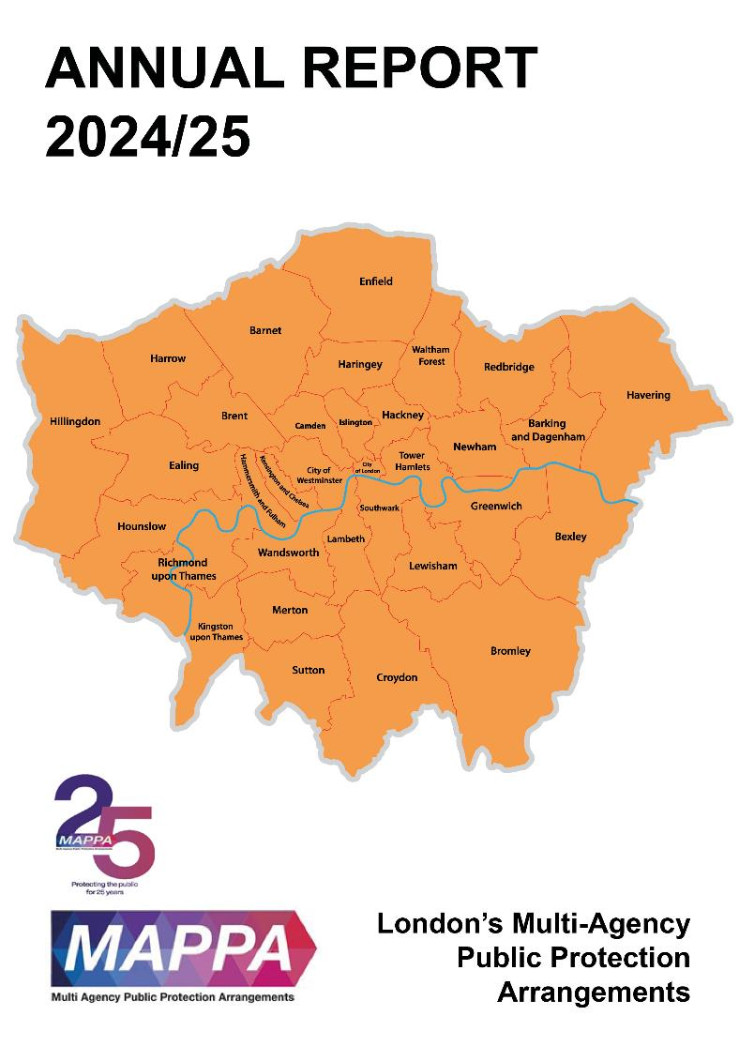
Area name here

Introduction

This annual report, presented on behalf of the London Strategic Management Board (SMB) outlines how agencies have fulfilled their statutory duties under MAPPA to minimise harm to the public.
We recognise that the crimes for which violent and sexual offenders are responsible impact enormously on the lives of victims, their families, and communities. Additionally, growing prison populations have presented significant challenges for the criminal justice system during the last 12 months and individual agencies have had to adopt news ways of working to maintain stability and keep communities safe.
This report provides statistical information about the number of offenders managed under the arrangements and how the three Responsible Authorities of Probation, Prison and Police and the Duty to Co-operate Agencies have worked together to ensure that those cases presenting the greatest risk received the required level of multi-agency management.
The SMB meets four times a year to review the quality and effectiveness of MAPPA locally and to ensure agencies discharge their responsibilities under the MAPPA framework. The SMB is committed to continuous improvement and the development of practice and local processes, ensuring all opportunities to review the work of MAPPA are taken. There is an ongoing commitment to learning from MAPPA Serious Case Reviews by implementing the recommendations and embedding the learning. Additionally, the SMB continues to focus on the professional development of Chairs through the delivery of MAPPA Chairs training and biannual development days.
This year marks the 25th anniversary of MAPPA since the Criminal Justice and Courts Act introduced multi agency working for violent and sexual offenders. The SMB will continue to work collaboratively with partners to ensure key priorities for London are developed to best protect the public.
On behalf of the SMB, I would like to take this opportunity to thank staff across London involved in the provision of MAPPA arrangements for their continued hard work managing complex and challenging individuals to ensure our communities remain safe.
I am thankful to all colleagues from Responsible Authorities and Duty to Cooperate Agencies for their contribution to MAPPA and public protection throughout 2024-25.
I also extend my thanks to our Lay Advisor whose commitment and knowledge is greatly appreciated by SMB, and our MAPPA Coordinator and Deputy MAPPA Coordinator, without whom the work of the SMB would not be effective.
Pamela Spring
Chair of London MAPPA SMB and Head of Public Protection, London Region

What are MAPPA?

MAPPA background
MAPPA (Multi-Agency Public Protection Arrangements) are a set of arrangements to manage the risk posed by individuals who have committed the most serious sexual, violent and terrorist offences (MAPPA-eligible individuals) under the provisions of sections 325 to 327B of the Criminal Justice Act 2003.
They bring together the Police, Probation and Prison Services in each of the 42 Areas in England and Wales into what is known as the MAPPA Responsible Authority.
A number of other agencies are under a Duty to Co-operate (DTC) with the Responsible Authority. These include Social Services, Health Services, Youth Offending Teams, Department for Work and Pensions and Local Housing and Education Authorities.
Local Strategic Management Boards (SMB) comprising senior representatives from each of the Responsible Authority and DTC agencies are responsible for delivering MAPPA within their respective areas. The Responsible Authority is also required to appoint two Lay Advisers to sit on each MAPPA SMB.
Lay Advisers are members of the public appointed by the Minister with no links to the business of managing MAPPA-eligible individuals who act as independent, yet informed, observers; able to pose questions which the professionals closely involved in the work might not think of asking. They also bring to the SMB their understanding and perspective of the local community (where they must reside and have strong links).

MAPPA ‘25
MAPPA ’25 is a campaign to mark the 25th anniversary of the legislation that introduced mandatory multi-agency co-operation in the management of those convicted of violent and sexual offences.
The aims of the MAPPA '25 campaign are;
- To increase awareness of, and confidence in MAPPA across a wide range of agencies, at all levels from frontline practitioners to senior leaders.
- To engage with those directly affected by MAPPA including victims and those subject to MAPPA management.
- To improve MAPPA practice across all agencies.
- To explore emerging themes in relation to public protection and encourage future investment in MAPPA by all relevant stakeholders
In February the National MAPPA Team held the first online event. The event was titled “Where did MAPPA come from and why did we need them” and featured a panel discussion with Emeritus Professor Hazel Kemshall and retired Detective Chief Inspector Tim Bryan, both of whom had been involved in the development of the arrangements in the early 2000s. The event was attended by over 800 people and has since been watched by over 1,700 proving popular with professionals from responsible authority, duty to cooperate and associate agencies, as well as the private sector who work with MAPPA individuals, who were keen to learn more about the history of MAPPA and the reasons that MAPPA remain vital to this day.
Most of the events have been/will be held in the year 2025-26 and will therefore be covered in next year’s annual report.

How MAPPA work
MAPPA-eligible individuals are identified and information about them is shared between agencies to inform the risk assessments and risk management plans of those managing or supervising them.
That is as far as MAPPA extend in the majority of cases, but some cases require more senior oversight and structured multi-agency management. In such cases there will be regular MAPPA meetings attended by relevant agency practitioners.
There are 4 categories of MAPPA-eligible individual:
- Category 1 –subject to sex offender notification requirements;
- Category 2 – mainly those convicted of violent offences and sentenced to 12 months or more imprisonment or a hospital order;
- Category 3 – individuals who do not qualify under Categories 1, 2 or 4 but whose offences pose a risk of serious harm.
- Category 4 – terrorism convicted and terrorism risk individuals
Data on Category 4 individuals is not included in this report due to data protection issues related to low numbers. This data will be aggregated and published nationally.
There are three levels of management to ensure that resources are focused where they are most needed; generally those presenting the higher risks of serious harm.
- Level 1 is where the individual is managed by the lead agency with information exchange and multi-agency support as required but without formal MAPPA meetings;
- Level 2 is where formal MAPPA meetings are required to manage the individual.
- Level 3 is where risk management plans require the attendance and commitment of resources at a senior level at MAPPA meetings.
MAPPA are supported by ViSOR. This is a national IT system to assist in the management of individuals who pose a serious risk of harm to the public. The use of ViSOR increases the ability to share intelligence across organisations and enables the safe transfer of key information when high risk individuals move between areas, enhancing public protection measures. ViSOR allows staff from the Police, Probation and Prison Services to work on the same IT system, improving the quality and timeliness of risk assessments and interventions to prevent offending.
All MAPPA reports from England and Wales are published online at: www.gov.uk

MAPPA Statistics

MAPPA-eligible individuals on 31 March 2025
 | Category 1:  Subject to sex offender notification requirements | Category 2:  Violent  offenders | Category 3:  Other dangerous  offenders | Total
Level 1 | 7368 | 3681 | - | 11049
Level 2 | 24 | 63 | 67 | 154
Level 3 | 8 | 3 | 6 | 17
Total | 7400 | 3747 | 73 | 11220

MAPPA-eligible offenders in Levels 2 and 3 by category (yearly total)
 | Category 1:  Subject to sex offender notification requirements | Category 2:  Violent  offenders | Category 3:  Other dangerous  offenders | Total
Level 2 | 153 | 301 | 298 | 752
Level 3 | 21 | 27 | 31 | 79
Total | 174 | 328 | 329 | 831

Category 1 cautioned for breach of notification requirements | 41
Category 1 convicted for breach of notification requirements | 153

Category 1 who have had their life time notification revoked on application | 36

Restrictive orders for Category 1 offenders
Sexual Harm Prevention Order (SHPO) | 559
SHPO with foreign travel restriction | 0
Notification Notices | 55

Number of individuals who became subject to sex offender notification requirements following a breach(es) of a Sexual Risk Order (SRO) | 13

Level 2 and 3 individuals returned to custody
Returned to custody for breach of licence | Category 1:  Subject to notification requirements | Category 2:  Violent  offenders | Category 3:  Other dangerous  offenders | Total
Level 2 | 19 | 22 | 31 | 72
Level 3 | 3 | 2 | 4 | 9
Total | 22 | 24 | 35 | 81

Breach of SHPO
Level 2 | 0
Level 3 | 0
Total | 0

Total number of individuals subject to sex offender notification requirements per 100,000 population | 92

This figure has been calculated using the mid-2024 estimated resident population, published by the Office for National Statistics (ONS) on 30 July 2025, excluding those aged less than ten years of age.

Explanation commentary on statistical tables

MAPPA background
The totals of MAPPA-eligible individuals, broken down by category, reflect the picture on 31 March 2025 (i.e. they are a snapshot). The rest of the data covers the period 1 April 2024 to 31 March 2025.
(a) MAPPA-eligible individuals – there are individuals defined in law as eligible for MAPPA management because they have committed specified sexual, violent or terrorist offences or they currently pose a risk of serious harm. The majority are managed at Level 1 without formal MAPPA meetings. These figures only include those MAPPA eligible individuals living in the community. They do not include those in prison or detained under the Mental Health Act.
(b) Subject to Sex Offender Notification Requirements – those who are required to notify the police of their name, address and other personal details and to notify of any subsequent changes (this is known as the “notification requirement.”) These individuals are assessed and managed by the police. They may also be managed by probation, youth justice or health services if they are subject to licence or a hospital order. Failure to comply with the notification requirement is a criminal offence that carries a maximum penalty of 5 years’ imprisonment.
(c) Violent Offenders – individuals convicted of violent offences who were sentenced to imprisonment or detention for 12 months or more, or detained under a hospital order and a small number of individuals convicted of sexual offences who are not subject to notification requirements. These individuals are assessed and managed by the Probation Service, Youth Justice Service or Mental Health Services.
(d) Other Dangerous Offenders – individuals who do not qualify under the other MAPPA-eligible categories, but have committed an offence that indicates that they pose a risk of serious harm which requires management via MAPPA meetings. These individuals are assessed and managed by whichever agency has the primary responsibility for them.
(e) Terrorism and Terrorism Risk Offenders – individuals subject to terrorism offender notification requirements; individuals convicted of terrorism or terrorism related offences who were sentenced to imprisonment or detention for 12 months or more, or detained under a hospital order; and those who have committed an offence and may be at risk of involvement in terrorism-related activity. These individuals are assessed and managed by Counter-Terrorism Police and the National Security Division of the Probation Service.
(f) Breach of Licence – individuals released into the community following a period of imprisonment will be subject to a licence with conditions (under probation supervision). If the individual does not comply with these conditions, the Probation Service will take breach action and the individual may be recalled to prison.
(g) Sexual Harm Prevention Order (SHPO) (including any additional foreign travel restriction). Sexual Harm Prevention Orders (SHPOs) and interim SHPOs are intended to protect the public from individuals convicted of a sexual or violent offence who pose a risk of sexual harm to the public by placing restrictions and/or positive obligations on their behaviour. They require the individual to notify their details to the police (as set out in Part 2 of the 2003 Act) for the duration of the order.
The court must be satisfied on the balance of probability that an order is necessary to protect the public (or any particular members of the public) in the UK, or children or vulnerable adults (or any particular children or vulnerable adults) abroad, from sexual harm from the individual. In the case of an order made on a free standing application by a Chief Police Officer, the National Crime Agency (NCA), British Transport Police (BTP) or the Ministry of Defence Police (MODP), the chief officer/NCA/BTP/MODP must be able to show that the individual has acted in a way since their conviction that makes the order necessary.
The minimum duration for a full order is five years. The lower age limit is 10, which is the age of criminal responsibility, but where the defendant is under the age of 18 an application for an order should only be considered exceptionally.
(h) Notification Order – this requires individuals convicted of qualifying sexual offences overseas to register with the police, in order to protect the public in the UK from the risks that they pose. The police in England and Wales may issue a notification order directly to an offender who is already in the UK or who is intending to come to the UK who has to notify within three days of receipt. Individuals have a right of appeal against notification.

(i) Sexual Risk Order (including any additional foreign travel restriction) –The Sexual Risk Order (SRO) replaced the Risk of Sexual Harm Order (RoSHO) and may be made in relation to a person without a conviction for a sexual or violent offence (or any other offence), but who poses a risk of sexual harm.
The SRO may be made at the magistrates’ court on application by the police, NCA, BTP or MODP where an individual has committed an act of a sexual nature and the court is satisfied that the person poses a risk of harm to the public in the UK or children or vulnerable adults overseas.
An SRO may prohibit the person from doing anything described in it, including travel overseas, or place positive obligations upon them. Any prohibition and/or obligation must be necessary to protect the public in the UK from sexual harm or, in relation to foreign travel, protecting children or vulnerable adults from sexual harm.
An individual subject to an SRO is required to notify the police of their name and home address within three days of the order being made and also to notify any changes to this information within three days.
An SRO can last for a minimum of two years and has no maximum duration, with the exception of any foreign travel restrictions which, if applicable, last for a maximum of five years (but may be renewed).
The criminal standard of proof continues to apply. The person concerned is able to appeal against the making of the order and the police or the person concerned are able to apply for the order to be varied, renewed or discharged.
A breach of an SRO is a criminal offence punishable by a maximum of five years’ imprisonment. Where an individual breaches their SRO, they will become subject to full notification requirements.
Individuals made subject of an SRO are recorded on VISOR as a Potentially Dangerous Person (PDP).

(j) Lifetime notification requirements revoked on application – Qualifying individuals may submit an application to the police to review their indefinite notification requirements. The police review the application and decide whether to revoke the notification requirements. This decision is made at the rank of Superintendent. Those who continue to pose a significant risk will remain subject to notification requirements for life, if necessary.
Individuals will only become eligible to seek a review once they have been subject to indefinite notification requirements for a period of at least 15 years for adults and 8 years for children.

London MAPPA SMB Training & Research Sub Group

Role of the Training and Research Sub-Group (TRSG)
The multi-agency London MAPPA SMB Training & Research Sub-Group (TRSG) oversee and implement the London MAPPA Training & Research Training Plan on behalf of the London MAPPA Strategic management Board (SMB).
A key objective of this plan is to ensure the delivery of regular, coordinated MAPPA training activities across London. These efforts are aimed at enhancing the quality, consistency, and effectiveness of MAPPA practice, with a particular focus on supporting the development of London MAPPA Chairs.
The TRSG also plays a critical role in ensuring that any national MAPPA developments relevant to Chair training are implemented locally. This ensures that London remains aligned with national standards and compliant with emerging requirements.
All MAPPA TRSG training activities delivered in London are systematically evaluated to assess their effectiveness. Feedback has consistently demonstrated that the training contributes positively to enhancing the skills and knowledge of London MAPPA Chairs.

MAPPA Chair Training Delivery
The training of London MAPPA Chairs is structured through an initial two-day MAPPA Chair Training course, followed by a programme of continuing professional development (CPD) events. These CPD sessions are designed to reinforce and expand upon the foundational training, ensuring Chairs remain informed of evolving best practices and developments within MAPPA. Where possible, CPD events feature input from those with lived CJS experience, enhancing the learning and professional development of MAPPA Chairs.
During the 2024–2025 period, three two-day MAPPA Chair Training events were successfully delivered, providing training to a total of 57 newly appointed MAPPA Chairs. While the training is primarily designed for MAPPA Chairs, all sessions were also made accessible to London MAPPA Administrators. This inclusive approach aims to enhance their understanding of MAPPA processes and foster stronger collaborative working relationships across roles.
In addition, the TRSG allocated dedicated time to review and refine the Chair training materials. This included working closely with presenters to revise and update content, informed by participant feedback and evaluation outcomes.

Chairs’ Forums and Wider MAPPA Training Activity
The TRSG recognise the importance of reinforcing the practical application of the Four Pillars of Risk Management within MAPPA processes including as a requirement of MAPPA meetings to underpin effective risk management. As a result, two Chairs’ Forums were convened, each focusing on a specific pillar.
- The first forum, held in June 2024, focused on the Interventions pillar.
Aim: To enhance MAPPA Chairs’ understanding of the types of interventions that can support effective risk management under the Four Pillars framework.
- The second forum, held in December 2024, addressed the Monitoring and Control pillar.
Aim: To equip London MAPPA Chairs with knowledge of the available options to support the Monitoring and Control pillar in the context of chairing MAPPA meetings.

A total of 107 participants attended the two events. Both forums were well received, with positive evaluations highlighting their relevance and impact on practice.
In addition to MAPPA Chair-specific training, further training and briefing sessions were delivered to staff across the Probation Service London Region, the Metropolitan Police Service, and London Mental Health Trusts. These sessions aimed to support the broader development of MAPPA practice across agencies, contributing to the ongoing commitment to public protection.

MPS Digital Management of

Registered Sex Offenders

Within the Metropolitan Police Service there are presently four main digital tools to assist in the monitoring and compliance of a managed registered sex offender. For these digital examination tools to be used, the MPS policy is that a power must be provided by a civil order granted by a court.

Online offending is rapidly on the increase, making these tactics so important, also supporting the MAPPA risk management plan for all agencies involved with the offender. Since 2020, 600 new offences have been detected and investigated.
The teams that manage registered sex offenders are equipped with software that enables them to screen and triage offender’s digital devices. The equipment provides the flexibility to be able to complete the examinations either at a home visit or at a Police Station. The capability of the software provides the offender manager the ability to screen and triage a broad range of digital devices, ranging from both desktop to laptop computers, tablets, mobile phones, external hard drives to USB memory sticks and many more. Once the device has been screened, the offender manager will be presented with a comprehensive triage report that can be viewed on scene to enable them to detect offences and make fast time decisions around risk management, safeguarding and the prevention of further crime.
Officers also have the ability to install remote monitoring software onto both computers and mobile phones belonging to the offender. Once installed, the device is monitored by using a combination of human and technical expertise for the early warning of breaches to civil orders as well as criminal behaviour. The monitoring software has the ability to detect images and word content in any language displayed on the offender’s device. Once content of concern is detected, a screenshot of what is displayed is taken and stored. That content is reviewed by a specialist behavioural analyst, and if deemed appropriate the offender manager is alerted and then takes the appropriate action.
Officers are equipped with the technology to examine the offender’s internet router and observe what devices are and have historically been connected to the router to access the internet. This is a vital tool in identifying internet enabled devices that have not been declared to the Police.
Police also have the option of calling upon our specialist digital media detection dog units to search for digital devices that are concealed within a premises. These dogs are specifically trained to find digital devices ranging from mobile phones to USB memory sticks.
All these tactics can be deployed solely or in partnership with each other. They have proved to be reliable, ensuring success in the digital management of Registered Sex Offenders, whether detecting further offences or evidencing the lower levels of recidivism.

DC Phil Preston –
Digital Tactical Policy Advisor
Central Jigsaw Tea


The Four Pillars of Risk Management, developed by Professor Hazel Kemshall, is a framework which all MAPPA meetings are requires to follow focusing on, Supervision, Monitoring and Control, Interventions and Treatment, Victim Safety Planning. The model aims to balance behavioural change with protective controls, ensuring that risk management strategies not only support individual change but also prioritise the safety of victims and the public.

