

Area name here

South Wales


Annual Report

2024-2025

Introduction

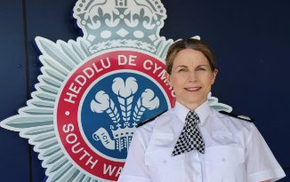

T/ACC Ceri Hughes Chair of the Strategic Management Board

As Chair of the South Wales Multi Agency Public Protection Arrangements Strategic Management Board (SMB), I introduce this year's MAPPA annual report. In the twenty fifth year since the introduction of MAPPA, these arrangements are as essential as ever. We continue to strive to keep our communities safe and to protect communities from sexual and violent offenders who pose the highest risk of harm through effective partnership working underpinned by effective sharing of information to manage dangerous individuals.

Sexual and violent crimes can have a devastating impact on victims, their families, and communities. The public rightly demands the very best service we can provide, and we will continue to focus on ways to improve our working together to achieve this.

This annual report outlines the collaborative work between the responsible authorities for MAPPA, the Police, Probation, and Prison Service are supported by a range of agencies, including health and social care as well as housing providers who have a duty to co-operate. This collaboration provides a foundation for vital information sharing and for the development of robust risk management plans to be put in place to protect our communities.

We continue to see an increase in the number of individuals becoming subject to multi agency public protection arrangements, and several complex challenges prevail; and so, the work across MAPPA and our commitment to prevent reoffending through achieving the objectives within our Business Plan are vital. Through ensuring our foundations are correct, investing in practitioners and ensuring our culture is one of reflection and continuous improvement to embed learning at every opportunity; decision making will be more robust. We will further improve risk management by using technology effectively and in holding one another to account for our performance. The increasingly important work of our lay advisors provides independent scrutiny of our activities and supports our objective to continually improve.

We are committed to improve our management of dangerous offenders to keep our communities safe. As complex issues within society continue, as an SMB, we must anticipate, prepare, and respond to the challenges ahead for MAPPA and support practitioners in their vital roles. We will overcome these challenges if every agency works together collectively.



Nicola Davies,
Wales Divisional Director Probation Service
Introduction

As the Regional Probation Director in Wales, it is a great privilege to contribute to this year’s Multi-Agency Public Protection Arrangements (MAPPA) Annual Report 2024 – 2025.

MAPPA brings together the Probation Service, Police, Prison Service, and other agencies such as Housing, Local Authorities, Youth Justice, and Health Services to protect the public and manage risks posed by serious offenders. At the heart of the Probation Service is our commitment to working collaboratively with other agencies. By working together, we aim to strengthen our approach and make a meaningful impact in keeping our communities safe.

This year has seen many changes introduced to the Probation Service with a clear direction on placing public protection at its forefront. Enabling services to maximise efforts to those within custody and the community who present the most serious risk of sexual and violent behaviour. MAPPA Strategic Management Boards are pivotal in holding all agencies to account on the effectiveness of multi-agency working arrangements. Providing assurance to victims and members of the public of the commitment of MAPPA to reduce re-offending and harm.

With MAPPA marking its twenty fifth year it illustrates the success and dedication of all agencies involved. This report provides statistics from the last year, presenting the number of individuals managed under MAPPA and how we meet our duty to address the root causes of those convicted of serious offences. There has been an increase in MAPPA this year evidencing the promise to the community to strive towards improvements and develop a culture of learning.

We appreciate all stakeholder contributions, which are vital to keeping communities safe through rigorous risk management.

South Wales Business Plan Objectives

South Wales MAPPA is committed to the protection of the public, the reduction of serious harm, and the prevention of reoffending by high-risk individuals. We strive to enhance public confidence through robust multi- agency working, continuous learning, and proactive risk management.

This year, we have also taken significant steps toward enhancing our training and stakeholder engagement, ensuring that those with a duty to cooperate understand their role in MAPPA. We are excited to introduce a forward-looking three-year strategic plan to drive improvements across our operations.



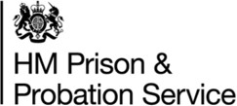
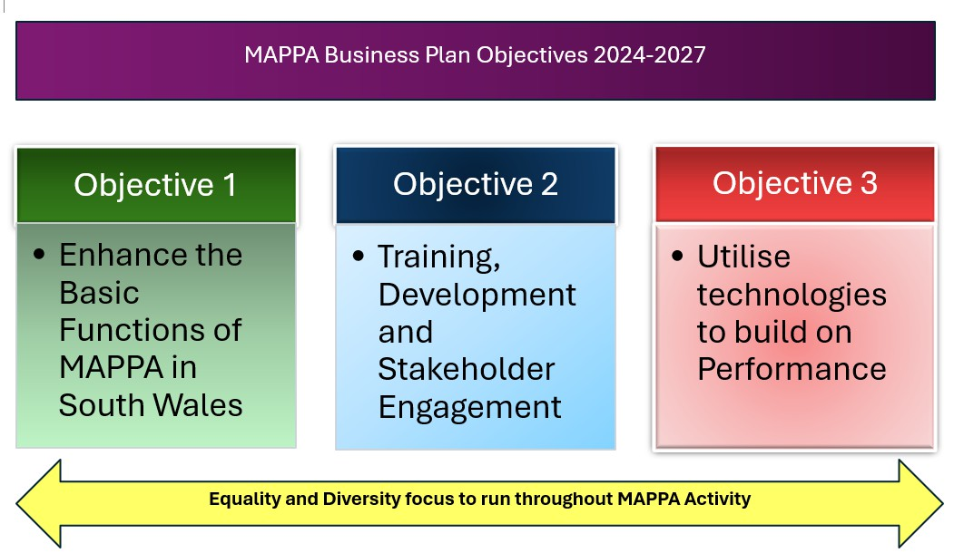

1. Enhance the Basic Functions of MAPPA in South Wales
We acknowledge the importance of getting the foundational elements right. Our focus remains on improving the efficiency and effectiveness of MAPPA, ensuring clear reporting lines and governance structures. As we move forward, our aim is to refine and strengthen MAPPA processes so that we are better positioned to protect the public and manage risk in a structured and measurable way.

2. Training, Development, and Stakeholder Engagement

Our objective is to foster a strong culture of learning, training, and engagement across all relevant agencies. By focusing on embedding MAPPA practices and learning from Serious Case Reviews (SCRs), we aim to ensure a deeper understanding of MAPPA responsibilities, resulting in better decision-making and risk mitigation.

3. Utilise Technology to Build a Meaningful Performance Framework

South Wales MAPPA is committed to leveraging technology to improve risk management and performance monitoring. By enhancing data-sharing systems and developing tools like algorithms to predict harm, we aim to build a forward-thinking approach to offender management.

What are MAPPA?

MAPPA background
MAPPA (Multi-Agency Public Protection Arrangements) are a set of arrangements to manage the risk posed by individuals who have committed the most serious sexual, violent and terrorist offences (MAPPA-eligible individuals) under the provisions of sections 325 to 327B of the Criminal Justice Act 2003.
They bring together the Police, Probation and Prison Services in each of the 42 Areas in England and Wales into what is known as the MAPPA Responsible Authority.
A number of other agencies are under a Duty to Co-operate (DTC) with the Responsible Authority. These include Social Services, Health Services, Youth Offending Teams, Department for Work and Pensions and Local Housing and Education Authorities.
Local Strategic Management Boards (SMB) comprising senior representatives from each of the Responsible Authority and DTC agencies are responsible for delivering MAPPA within their respective areas. The Responsible Authority is also required to appoint two Lay Advisers to sit on each MAPPA SMB.
Lay Advisers are members of the public appointed by the Minister with no links to the business of managing MAPPA-eligible individuals act as independent, yet informed, observers; able to pose questions which the professionals closely involved in the work might not think of asking. They also bring to the SMB their understanding and perspective of the local community (where they must reside and have strong links).

How MAPPA works
MAPPA-eligible individuals are identified and information about them is shared between agencies to inform the risk assessments and risk management plans of those managing or supervising them.
That is as far as MAPPA extend in the majority of cases, but some cases require more senior oversight and structured multi-agency management. In such cases there will be regular MAPPA meetings attended by relevant agency practitioners.
There are 4 categories of MAPPA-eligible offender:
- Category 1 –subject to sex offender notification requirements;
- Category 2 – mainly violent offenders sentenced to 12 months or more imprisonment or a hospital order; and
- Category 3 – individuals who do not qualify under Categories 1 or 2 or 4 but whose offences pose a risk of serious harm.
- Category 4 – terrorism convicted and terrorism risk individuals

There are three levels of management to ensure that resources are focused where they are most needed; generally those presenting the higher risks of serious harm.
- Level 1 is where the individual is managed by the lead agency with information exchange and multi-agency support as required but without formal MAPPA meetings;
- Level 2 is where formal MAPPA meetings are required to manage the individual.
- Level 3 is where risk management plans require the attendance and commitment of resources at a senior level at MAPPA meetings.
MAPPA are supported by ViSOR. This is a national IT system to assist in the management of individuals who pose a serious risk of harm to the public. The use of ViSOR increases the ability to share intelligence across organisations and enables the safe transfer of key information when high risk individuals move between areas, enhancing public protection measures. ViSOR allows staff from the Police, Probation and Prison Services to work on the same IT system , improving the quality and timeliness of risk assessments and interventions to prevent offending.

MAPPA and Terrorism
The government published an Independent Review of the MAPPA used to Supervise Terrorism and Terrorism-risk individuals on 2 September 2020 and published its response on 9 December. Both documents are available at https://www.gov.uk/government/publications/multi-agency-public-protection-arrangements-review. The report made a number of recommendations, the majority of which have been implemented, including via the Counter-Terrorism and Sentencing Act 2021 and the Police, Crime, Sentencing and Courts Act 2022. The Secretary of State has also revised the statutory MAPPA Guidance on terrorism offenders.
The Probation Service, via its National Security Division, has created a specialist dedicated and highly skilled workforce, which provides an enhanced level of management and intervention for the most high-risk, complex and high-profile individuals in the community. This includes the management of terrorist connected and terrorist risk offenders. The NSD and Counter-Terrorism Policing work closely with local SMBs to ensure the robust management of terrorism cases. Data on Category 4 individuals is not included in this report due to data protection issues related to low numbers. This data will be aggregated and published nationally.
All MAPPA reports from England and Wales are published online at: www.gov.uk

MAPPA Statistics

MAPPA-eligible individuals on 31 March 2024
 | Category 1:  Subject to sex offender notification requirements | Category 2:  Violent  offenders | Category 3:  Other dangerous  offenders | Total
Level 1 | 1923 | 515 | - | 2438
Level 2 | 48 | 55 | 46 | 149
Level 3 | 4 | 0 | 4 | 8
Total | 1975 | 570 | 50 | 2595

MAPPA-eligible offenders in Levels 2 and 3 by category (yearly total)
 | Category 1:  Subject to sex offender notification requirements | Category 2:  Violent  offenders | Category 3:  Other dangerous  offenders | Total
Level 2 | 138 | 85 | 66 | 289
Level 3 | 13 | 2 | 9 | 24
Total | 151 | 87 | 75 | 313

Category 1 cautioned or convicted for breach of notification requirements | 6

Category 1 who have had their life time notification revoked on application | 9

Restrictive orders for Category 1 offenders
Sexual Harm Prevention Order (SHPO) | 195
SHPO with foreign travel restriction | 0
Notification Order | 0

Number of individuals who became subject to sex offender notification requirements following a breach(es) of a Sexual Risk Order (SRO) | 3

Level 2 and 3 individuals returned to custody
Returned to custody for breach of licence | Category 1:  Subject to notification requirements | Category 2:  Violent  offenders | Category 3:  Other dangerous  offenders | Total
Level 2 | 29 | 45 | 53 | 127
Level 3 | 2 | 3 | 1 | 6
Total | 31 | 48 | 54 | 133

Breach of SHPO
Level 2 | 3
Level 3 | 0
Total | 3

Total number of individuals subject to sex offender notification requirements per 100,000 population | 161

This figure has been calculated using the mid-2024 estimated resident population, published by the Office for National Statistics (ONS) on 30 July 2025, excluding those aged less than ten years of age.

Explanation commentary on statistical tables

MAPPA background
The totals of MAPPA-eligible individuals, broken down by category, reflect the picture on 31 March 2024 (i.e. they are a snapshot). The rest of the data covers the period 1 April 2023 to 31 March 2024.
(a) MAPPA-eligible individuals – there are individuals defined in law as eligible for MAPPA management because they have committed specified sexual, violent or terrorist offences or they currently pose a risk of serious harm. The majority are managed at Level 1 without formal MAPPA meetings. These figures only include those MAPPA eligible individuals living in the community. They do not include those in prison or detained under the Mental Health Act.
(b) Subject to Sex Offender Notification Requirements – those who are required to notify the police of their name, address and other personal details and to notify of any subsequent changes (this is known as the “notification requirement.”) These individuals are assessed and managed by the police. They may also be managed by probation or health services if they are subject to licence or a hospital order. Failure to comply with the notification requirement is a criminal offence that carries a maximum penalty of 5 years’ imprisonment.
(c) Violent Offenders – individuals convicted of violent offences who were sentenced to imprisonment or detention for 12 months or more, or detained under a hospital order and a small number of individuals convicted of sexual offences who are not subject to notification requirements. These individuals are assessed and managed by the Probation Service, Youth Offending Team or Mental Health Services.
(d) Other Dangerous Offenders – individuals who do not qualify under the other MAPPA-eligible categories, but have committed an offence that indicates that they pose a risk of serious harm which requires management via MAPPA meetings. These individuals are assessed and managed by whichever agency has the primary responsibility for them.
(e) Terrorism and Terrorism Risk Offenders – individuals subject to terrorism offender notification requirements; individuals convicted of terrorism or terrorism related offences who were sentenced to imprisonment or detention for 12 months or more, or detained under a hospital order; and those who have committed an offence and may be at risk of involvement in terrorism-related activity. These individuals are assessed and managed by Counter-Terrorism Police and the National Security Division of the Probation Service.
(f) Breach of Licence – individuals released into the community following a period of imprisonment will be subject to a licence with conditions (under probation supervision). If the individual does not comply with these conditions, the Probation Service will take breach action and the individual may be recalled to prison.
(g) Sexual Harm Prevention Order (SHPO) (including any additional foreign travel restriction). Sexual Harm Prevention Orders (SHPOs) and interim SHPOs replaced Sexual Offence Prevention Orders are intended to protect the public from individuals convicted of a sexual or violent offence who pose a risk of sexual harm to the public by placing restrictions and/or positive obligations on their behaviour. They require the individual to notify their details to the police (as set out in Part 2 of the 2003 Act) for the duration of the order.
The court must be satisfied on the balance of probability that an order is necessary to protect the public (or any particular members of the public) in the UK, or children or vulnerable adults (or any particular children or vulnerable adults) abroad, from sexual harm from the individual. In the case of an order made on a free standing application by a Chief Officer, the National Crime Agency (NCA), British Transport Police (BTP) or the Ministry of Defence Police (MODP), the chief officer/NCA/BTP/MODP must be able to show that the individual has acted in a way since their conviction that makes the order necessary.
The minimum duration for a full order is five years. The lower age limit is 10, which is the age of criminal responsibility, but where the defendant is under the age of 18 an application for an order should only be considered exceptionally.
(h) Notification Order – this requires individuals convicted of qualifying sexual offences overseas to register with the police, in order to protect the public in the UK from the risks that they pose. The police in England and Wales may issue a notification order directly to an offender who is already in the UK or who is intending to come to the UK who has to notify within three days of receipt. Individuals have a right of appeal against notification.

(i) Sexual Risk Order (including any additional foreign travel restriction) –The Sexual Risk Order (SRO) replaced the Risk of Sexual Harm Order (RoSHO) and may be made in relation to a person without a conviction for a sexual or violent offence (or any other offence), but who poses a risk of sexual harm.
The SRO may be made at the magistrates’ court on application by the police, NCA, BTP or MODP where an individual has committed an act of a sexual nature and the court is satisfied that the person poses a risk of harm to the public in the UK or children or vulnerable adults overseas.
An SRO may prohibit the person from doing anything described in it, including travel overseas, or place positive obligations upon them. Any prohibition and/or obligation must be necessary to protect the public in the UK from sexual harm or, in relation to foreign travel, protecting children or vulnerable adults from sexual harm.
An individual subject to an SRO is required to notify the police of their name and home address within three days of the order being made and also to notify any changes to this information within three days.
An SRO can last for a minimum of two years and has no maximum duration, with the exception of any foreign travel restrictions which, if applicable, last for a maximum of five years (but may be renewed).
The criminal standard of proof continues to apply. The person concerned is able to appeal against the making of the order and the police or the person concerned are able to apply for the order to be varied, renewed or discharged.
A breach of an SRO is a criminal offence punishable by a maximum of five years’ imprisonment. Where an individual breaches their SRO, they will become subject to full notification requirements.
Individuals made subject of an SRO are recorded on VISOR as a Potentially Dangerous Person (PDP).

(j) Lifetime notification requirements revoked on application – Qualifying individuals may submit an application to the police to review their indefinite notification requirements. The police review the application and decide whether to revoke the notification requirements. This decision is made at the rank of Superintendent. Those who continue to pose a significant risk will remain subject to notification requirements for life, if necessary.
Individuals will only become eligible to seek a review once they have been subject to indefinite notification requirements for a period of at least 15 years for adults and 8 years for juveniles.






