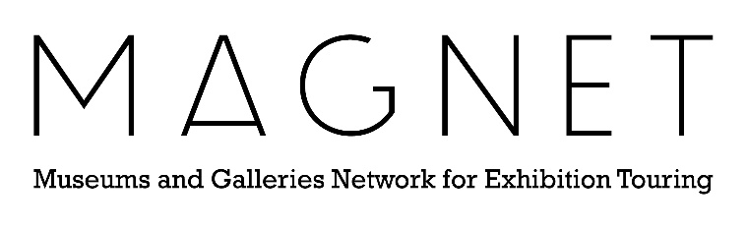

Network Partnership Agreement - Template

This overarching agreement helps you to formalise the relationship between a group of museums. It ensures all partners are aware and supportive of the project, its outputs, modes of delivery and management of change.

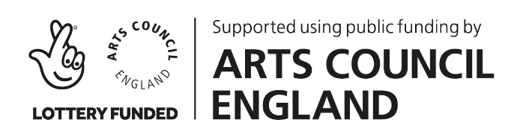


NETWORK PARTNERSHIP AGREEMENT

This Partnership Agreement is dated [date] and serves to formalise the agreement between each institution (‘Member’) that governs the terms of membership to the [name] (‘Network’) and participation in the [name] project.

Network Members:
[List the partner museums who are signatories of this agreement]
It should be considered alongside the following documents:
- [Add as necessary]

Introduction
This Partnership Agreement (‘The Agreement’) explains the nature of the partnership between the Member organisations and the resources, commitments and outputs expected in relation to delivering the aims of the project.

It is intended that the document be available to all key staff of the member organisations to ensure a clear understanding of the aims, structure, lines of communication, roles and responsibilities and the procedures utilised to deliver the aims of the project successfully.

[Add any additional headline responsibilities, deliverables or terms and conditions as a result of fundraising activity]

Project description (the ‘Project’)

[Add a succinct overview of the project]

Overall aims of the Network:

- [List overall aims]

This Agreement also endorses the following:

- The Members agree to support each other in the delivery of all aspects of the Project
- The Members agree to work in the best interest of the Network
- The Members agree to share best practice within the partnership
- The Members will work together with mutual respect
- The Members will uphold the standards outlined in the Museums Association Code of Ethics
- The Members recognise their responsibilities to each other – a failure or significant error by one Member reflects upon and may affect the other Members and the wider Project
- [Add/remove as necessary]

Project Aims and Governance

Duration of project

[Outline the strategic context and overarching plan for the Project, including the specific aims and outputs, as well as detailing the expected endpoint and legacy of the Project.]

Environmental responsibility

[Add a statement of how the Network intends to plan and operate with environmental responsibility at the forefront of all decision-making processes. How the Network will be held accountable, and whether this approach has been informed by sector standards, for example, the 2023 Bizot Green Protocol. Potential to include any collective targets or milestones.]

Roles, responsibilities and management structure

[Describe how the Network Members will operate and support each other, including a list of the base requirements, resources and prerequisites expected of each Member. Include any additional responsibilities held by certain Members or individuals in support of the aims and outputs. Detail what governance structures will be put in place and who holds overall responsibility for the success of the Project e.g. a Steering Committee, Oversight Board or Advisory Panel.]

Financial and contractual arrangements

[Detail what financial and contractual processes need to be followed and whether they have been agreed as a Network or set by an external funder. Include details of how budgets will be managed, invoices expensed and Museums and Galleries Exhibition Tax Relief maximised upon.]

Communication structure and approvals

[Explain how progress against key milestones, budget and risks updates will be communicated to the Network. Detail the process by which decisions and approvals will be made, including any significant changes to the Project.]

Policies and procedures

Members agree to follow all policies and procedures that are required by law or relevant to the project, such as public liability insurance, health and safety, GDPR, equal opportunities and the protection of children, young people and vulnerable adults.

Branding

[Explain how branding decisions and guidelines will be agreed as a Network, including when and how this will be communicated to Members.]

Confidentiality

[Add a statement on agreed approach to confidentiality and permissions.]

Evaluation and reporting

[Detail the obligations Members need to satisfy to deliver timely and effective evaluation and reporting. What structures will be put in place to support this process, and who will be responsible for organising it? Include a note on the retention of data and documents upon completion of the Project.]

Publicity and images

[Explain how Members will represent and promote the Network, including any production and approval processes.]

Terms of membership

[List specifics of membership including the duration, any fees and resource requirements.]

Changes and disputes

[Explain that information about any events that could jeopardise the implementation of the Agreement will be shared with the Network. Highlight the consequences should the non-fulfilment of obligations occur, and how any actions will be agreed. Explain how any conflicts or differences will be resolved and how any modifications to this Agreement will be made and processed.]

Project directory

Organisation name and address | Representative name, job role and contact details | Role on the project

Record of signatories

Organisation | Name and role | Signature | Date

Record of revision

Revision | Date | Comments

