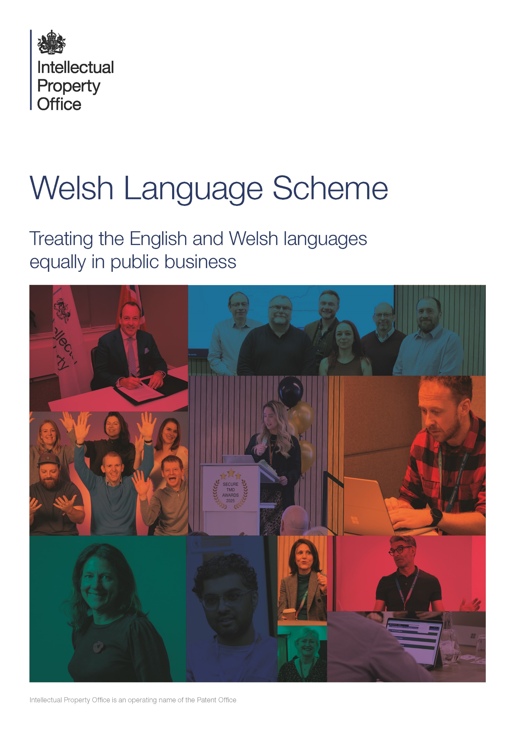

Introduction
This scheme has been prepared under the Welsh Language Act 1993. The UK Intellectual Property Office (IPO) has embraced the principle of treating the English and Welsh languages equally in public business, so far as is both appropriate to the circumstances and reasonably practicable.
In this scheme, the term ‘public’ means individuals and legal persons. It can mean the public as a whole, or a section of the public, as well as individual members of the public. The term includes voluntary organisations and charities. Directors and others representing limited companies are also captured within the meaning of the term. However, ‘public’ is not intended to include persons who are acting in a capacity which is representative of the Crown, Government or the State. Persons who fulfil official functions of a public nature, even though they are legal persons, are not covered by the definition of the term ‘public’, even when they are fulfilling those official functions.
The commitments below set out how the IPO will apply the principles of the scheme in line with our Action Plan. When setting commitments, we have considered what is reasonable and proportionate within the IPO.
This scheme has been prepared under Section 21 of the Act and in accordance with guidelines issued by the former Welsh Language Board under Section 9 of the Act. This revised version was approved on 02 March 2026.
About the Intellectual Property Office (IPO)
The UK IPO is an Executive Agency of the Department of Science, Innovation and Technology with Trading Fund status. We are based in Newport, South Wales and have a small office in London. We employ around 1,600 staff, with the majority based in Newport where the core of our work is carried out.
We’re responsible for:
- IP policy
- educating businesses and consumers about IP rights and responsibilities
- supporting IP enforcement
- granting UK patents, trade marks and design rights
Our priorities are to help people and businesses grow the UK economy by providing an IP system that encourages investment in creativity and innovation. We deliver this through:
- high-quality, efficient and accessible services; and
- policy which supports innovation and the wider economy; through
- a high-performing organisation with skilled people connected by shared purpose
Further information about the IPO can be found on our website:
https://www.gov.uk/government/organisations/intellectual-property-office/about

Foreword from our Director of People, Communications and Workplace and Welsh Language Lead


The Welsh language is an integral part of our identity and heritage at the IPO. For over 35 years, we have been proudly rooted in Wales, and this connection shapes who we are and how we work.
Our vision is clear: Welsh and English should be treated equally across our services and workplace. Whether customers interact with us online, by phone, or by email, we want them to feel confident and supported in using Welsh. This commitment applies to our transformed digital services and every other way customers choose to engage with us.
In our offices, we aim to create a space where Welsh is visible and valued—through bilingual signage, learning opportunities, and a culture that encourages everyone to engage with the language. To date, we have supported over 100 colleagues to learn Welsh, and we will continue to expand these opportunities. By doing so, we strengthen our Welsh language community and create more ways for customers to connect with us in Welsh. We want our Welsh-speaking colleagues to feel proud and confident, and for all colleagues to feel part of our shared heritage.
Our Welsh Language Scheme Action Plan sets out how we will deliver these commitments and celebrate our bilingual identity as we move forward. By showing that we value and support the Welsh language, we hope our Welsh speakers, learners, and customers will feel more connected to us and proud of the services we provide.

Service Planning and Delivery

We are committed to ensuring that our policies, initiatives, and services support the use of the Welsh language.

Our staff will be given guidance on how the Scheme may impact on policy making and we will ask them to consider the Welsh language as part of policy development.

We will provide an equally high-quality service in both Welsh and English and offer customers the opportunity to conduct business in Welsh where reasonably practicable.

Engaging with the Public

Receiving a response

We are committed to responding to feedback or queries within 10 working days where an answer is required.

If we are unable to respond within 10 working days, a holding reply will be issued in Welsh.
Written correspondence

If we receive a letter or email in Welsh, we will reply in Welsh.

We will send a holding reply in Welsh if there is likely to be a delay in responding to a written request.

We will use a bilingual electronic signature when replying to an email in Welsh and will encourage all staff to use it for general correspondence.
Telephone

We welcome telephone callers who wish to conduct their business in Welsh.

When contacting the IPO via the switchboard, a bilingual greeting will be given.

If the customer wishes to conduct their conversation in Welsh, the operator will route the call to a Welsh speaking member of staff who is able to deal with the query where possible.

If a customer dials directly to one of the operational sections and wishes to speak Welsh, the person answering the call will, if they do not speak Welsh, transfer them to a Welsh speaking member of staff.

If a Welsh speaking member of staff is not available, we will give the customer the choice of continuing in English, or being called back by a Welsh speaker as soon as one is available.

If a query is particularly complex, it may not be possible to deal with it over the telephone as we may need to seek technical or legal guidance. If this happens, then we will deal with the enquiry in writing and will reply in Welsh if the customer wishes.
Face-to-face

In-person meetings at our office in Newport require an appointment. For customers who want to converse with us in Welsh, we will arrange for a Welsh speaking member of staff to be present.

If a Welsh speaking member of staff is not available, customers will be given the choice of an appointment in English or written correspondence in Welsh.
Hearings

In the case of an unresolved dispute about a particular patent, trade mark or design application, the applicant is entitled to present their case at a hearing. The hearing can be conducted in Welsh if this is requested in advance.

If no advance notice is given, then there may be no legally and technically competent Welsh speaker immediately available. The applicant will then be given the choice, without prejudice, of continuing with the hearing in English or adjourning it until a Welsh speaker is available.
Public meetings

We do not currently hold public meetings in Wales.
Surveys

Public surveys undertaken in Wales can be provided and responded to in Welsh, where reasonably practicable.
Seminars

The need for seminars, training courses or similar events for the public in Wales to be held in Welsh will be assessed, and we will consider the preferred language of those attending and the availability of Welsh speaking trainers.
Events

We participate in exhibitions to raise awareness of IP and promote the services we offer. When these exhibitions are held in Wales, we will use bilingual stands and materials.

We will make copies of UK Intellectual Property Office publications and information available at events in Welsh and English when in Wales.

We will ensure that a Welsh speaking member of staff is available at events in Wales to assist with Welsh speaking customers.

Social media

When we are contacted in Welsh via social media and a response is required, we will reply in Welsh and in line with existing English language protocols.

We will increase our Welsh language content in our social media messages. This will initially involve content that is relevant to Wales only and will increase over time

FOI

The Freedom of Information Act 2000 requires that we respond to requests within 20 working days of receipt. Translations are excluded from the 20-day maximum however, we will aim to respond within 20 working days of receipt. Website, digital & publications
Online services

Our Transformation programme will enable applicants to apply for a patent, trade mark or design in Welsh. Delivery of these bilingual services will be phased starting first with patents, and with trade marks and designs to follow at a later date.

A new tool is being developed to allow customers to search for existing patents, trade marks and designs. Users will be able to search in Welsh for patents initially, trade marks and designs to follow at a later date.

Our Transformation programme will also enable users to manage their IP within an IPO account. Users of the account will be able to access the content in Welsh.
Online guidance

We are dedicated to enhancing the Welsh language content available on our website. We will create Welsh language equivalents for appropriate pages on our website and will assess the need for translating web pages through our internal processes.
Advertising and Publicity, Official Notices & Press Releases

We will issue any advertisements, recruitment notices, publicity or official notices in Welsh and English for publications principally circulating in Wales.

Press releases to the Welsh language press and broadcasting media in Wales will be issued in Welsh, where deadlines allow.

Our People and our Estate

Workforce

The need for a postholder to speak Welsh will be determined by monitoring the demand for services in Welsh that the post provides.

If the demand for employees to speak Welsh increases, we will identify the level of proficiency required and fill the position appropriately.
Language Training & Development

We will provide staff with the opportunity to learn Welsh during working hours. Staff will be able to attend a weekly 2-hour training course provided by an external provider.

We will encourage Welsh speaking staff to volunteer to assist with dealing with Welsh speaking customers.

We will maintain our internal directory of Welsh speaking staff who are able to help our Welsh speaking customers.

We will conduct an annual linguistic audit to measure our language proficiency and identify areas for improvement.
Recruitment

When fluency in Welsh is desirable or essential this will be stated in job advertisements.

If a suitable Welsh speaking candidate cannot be found for a post where Welsh is desirable, the person appointed will be encouraged to learn Welsh.

If a suitable Welsh speaking candidate cannot be found for a post where Welsh is essential, we will make alternative arrangements to fulfil our commitments under the scheme.
Corporate identity

We will adopt a bilingual corporate style and identity (e.g. for corporate items such as emails, letterheads and business cards), when responding to correspondence in Welsh.

We will enhance our corporate identity on our website to allow users to complete an end-to-end transaction in Welsh.

We will create a page on our Intranet that will give our staff resources, training notes and guidance on how they will help us deliver our commitments to the scheme.
Office signage

All of our public signage at our Newport office will be bilingual and will be equal in terms of size, quality, legibility and prominence.

Delivery of Statutory Documents and Prescribed Forms

We accept applications on prescribed forms in Welsh for patents, trademarks and designs. These forms will be available on our website.

We will commission a translation of filings in Welsh into English for placing on the public record alongside the original. This translation and any subsequent amendments will be agreed with the applicant in advance of publication. The agreed translations will be considered equivalent to the Welsh originals.

In our capacity as a Receiving Office for international or European patent applications, applications may be filed in Welsh but must be followed by a translation into English by the applicant (or, in the case of European applications, into either French or German).

Third party agreements

All future agreements with third parties for public services in Wales will align with this Scheme. This commitment extends to contracted services.

We will communicate the Scheme requirements to contractors where applicable. It will be outlined in all tender documents and contracts, with ongoing monitoring to ensure compliance.

When we are the strategic and financial leader within a partnership, we will ensure that any public service aspects comply with this scheme.

When we join a partnership which another organisation is leading, our input to the partnership will comply with this scheme and we will encourage the other partners to comply.

When we are a partner in a consortium, we will encourage the consortium to comply with this scheme. When acting in the name of the consortium, we will operate in accordance with this scheme.

Scheme Development

Reviewing and Amending the Scheme

We may need to reassess this scheme based on changes within our organisation and amend the scheme to reflect these changes.

Any proposed amendments to the Scheme will be submitted to the Welsh Language Commission (WLC) for consideration.

We will review this Scheme at least every four years.

Monitoring the scheme

Our Welsh Language Officer will monitor our progress in implementing the Scheme every 6 months, and report findings to our Board annually.

Our Action Plan outlines what we need to do, who is responsible for delivering it and when we will deliver it by.

We will report to the WLC on our progress in delivering this scheme on an annual basis.
Feedback & complaints

Feedback and complaints should be directed to CEUMailbox@ipo.gov.uk. The complaint will be acknowledged, and customers will receive a reply within 10 working days. If there is likely to be a delay, a holding reply will be sent.

If the response to the complaint is not satisfactory, complaints can be referred to the WLC’s Office.’
Administrative arrangements

The commitments and arrangements set out in the Scheme have been approved by the relevant Board Director with responsibility for the Welsh language The responsibility for coordinating and facilitating the Scheme will be the responsibility of our Welsh Language Officer, with individual managers given the responsibility for implementing those aspects of the Scheme which apply to them directly.

The Scheme and any internal instructions needed to provide a high-quality service for Welsh speaking customers will be available to every customer facing member of staff.

When we use external translation or interpretation services, for example for the translation of official documentation, we will use qualified translators or interpreters.


