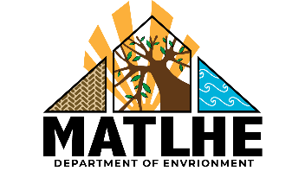


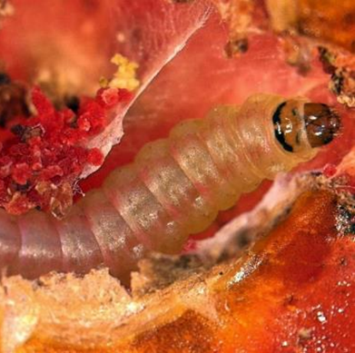
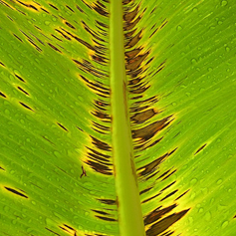
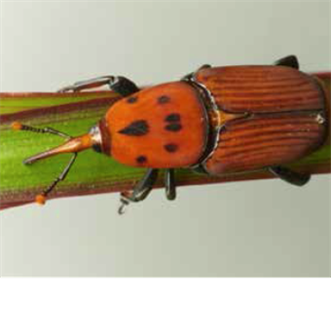
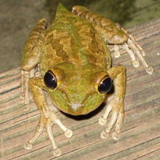
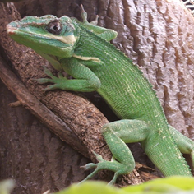
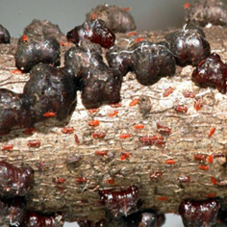
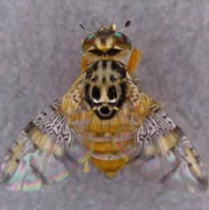
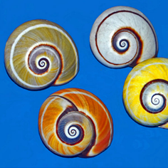
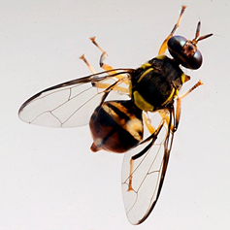
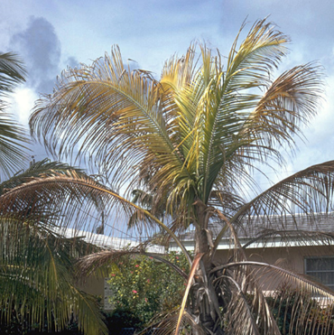
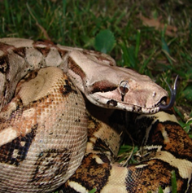
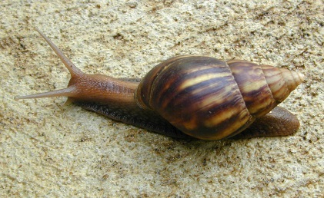
Image: USDA Forest Service - Region 8 Archive, USDA Forest Service, Bugwood.org
Image: Jeffrey W. Lotz/Florida Dept. of Agriculture & Consumer Services/Bugwood.org
Pest Alert: Have you seen these species?
There are a number of invasive species which are detrimental
to crops and wildlife.

1664 491 2075
[insert website address]

If you suspect you have found these or any similar species please call:
© Chris Malumphy
Giant African land snail
Black sigatoka disease of bananas
Tomato leaf miner
Red palm weevil
Lethal yellowing of palms
Knight anole
Boa constrictor
Cuban snail
Cuban tree frog
Mediterranean fruit fly
Carambola fruit fly
Lobate lac scale
Image: Hectonichus
Image: Viwat Wornoayporn / IAEA
Image: Fera
Image: Stevenj
Image: Tod Baker
Image: Munkel
Image: Dr Scott Nelson
Image: Fera
Image: Marja van der Straten / NVWA Plant
Protection Service / Bugwood
Image: Marshman

