Appeals Data
Hints & Tips to search the data
Filters
If you only wish to look at data which fits certain criteria then you can to use the ‘filters’. Filters are already set up on the 'Data set' sheet so you will find a drop-down option to the right-hand side of every column title. If you wish to switch off the filters instructions are given at the end of this document.

drop down option
To filter click on the drop-down arrows next to the relevant column titles and you'll be able to choose which rows you wish to show.
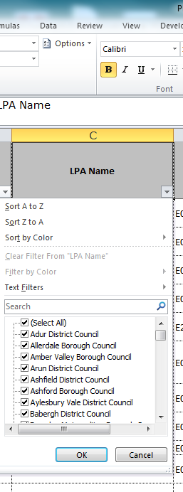
In the filter option you can either:
- Click on the '(Select All)' option which will untick every data item. You can then tick the data items and click OK. This will then only return rows containing the selected data.
- Don't click on the '(Select All)' option. Instead you can untick the data items and click OK so that you do not view unselected items. This will also only return rows containing the selected data.
You can add several filters at the same time to help you narrow down what you are looking for. For example you could filter on LPA name, Development Type and Procedure, by applying a filter to each of these columns.
Text string search
You can search for certain words within Excel. This may be useful if searching for a particular address.
Click on the drop down (filter) option next to the relevant column title,
drop down option
Hover over the 'Text Filter' and select the most appropriate option. To search for a particular word, you can type this straight the ‘search box. For more complex searches, you can use other options such as 'Contains'.
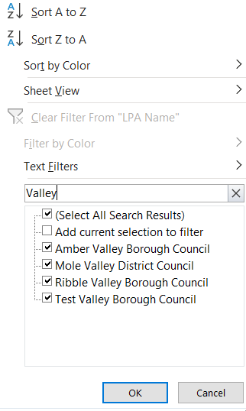
Type in the text you wish to search.
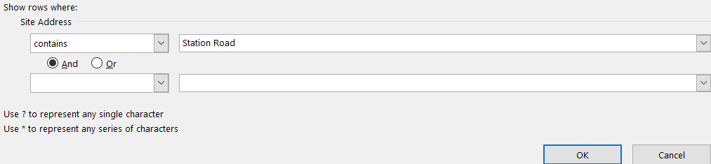
If you wish to search for two text items, select 'Contains' in the second line and type the second text item.
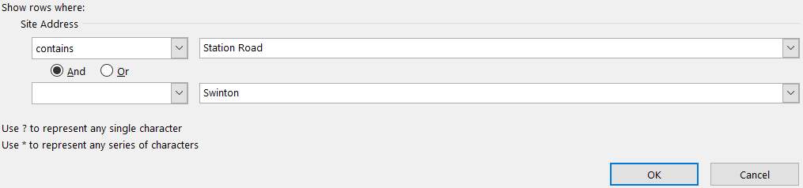
When searching for two text items there is the option of selecting 'And' or 'Or' between the two lines. Use 'And' if you only wish your results to contain both text items otherwise use 'Or'.
Pivot Tables
Pivot Tables can be used to automatically organise data into a table.
For example if you wanted to know how many appeals decisions have been made by each type of appeal;
- Click Insert (at the top)
- Click PivotTable
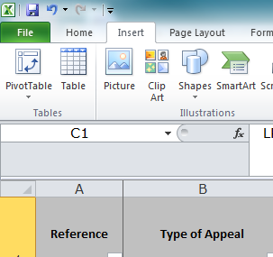
Excel will open the 'Create PivotTable' box (see below) and automatically select all the data.
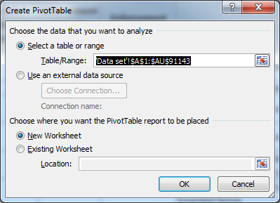
Click on OK and Excel will create a blank grid on a new worksheet (see below).
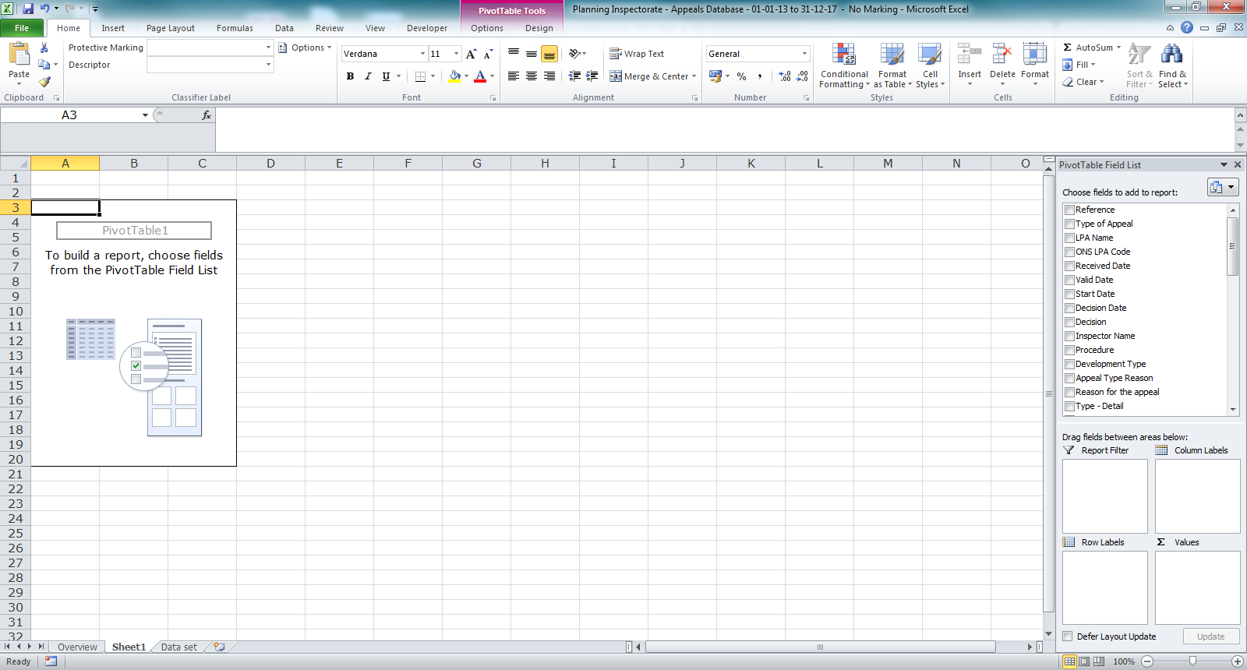
You now need to assign the relevant fields into the table. To do this you need to drag each chosen PivotTable Field (top right-hand corner) into one of the four drop zone areas (bottom right-hand corner), see above.
EXAMPLE
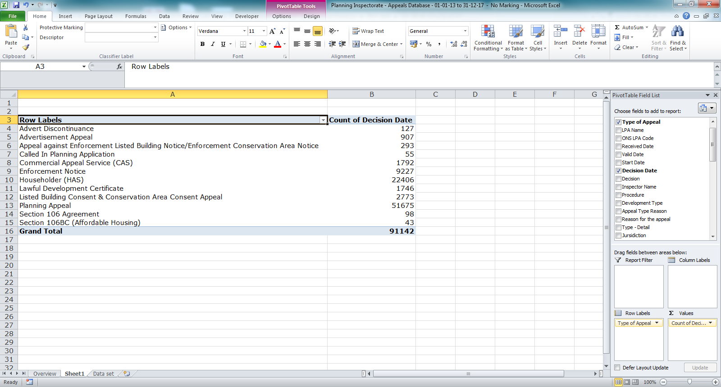
Please note that the screen shot above comes from an old appeals database and that the numbers above won’t match those in the current appeals database.
For more detailed instructions on using Pivot Tables you can search the internet. Please note that this spreadsheet is using Excel 2010.

Switching Filters Off
Sometimes you may wish to remove the filters. Removing filters will not mean losing any data from the spreadsheet.
In the Data Set click into cell A1.
Click on Data in ribbon at the top of the page and then click on the filter icon.
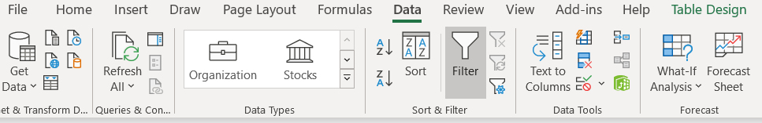
The filters will now be removed from the top row of the spreadsheet.
To replace he filters just repeat the above.

